Analysis on Fragile States Data

**Department of Computer Science**

**University of North Carolina Charlotte, NC, USA**

**Instructor Dr. Zbigniew W. Ras**

Project Team Members:

1. Aishwarya Maram Reddy
2. Anusha
3. Gokul Nithin Kumar Rajakumar (801082252)
4. Ragini Ranganathan (801075448)
5. Srisanmathi Ramachandran
6. **Introduction:**

The motive of this project is to perform Action-Rule mining for given Fragile State Index Datasets with new extended features added to the data set and further analyze how the action rules change over the years. Using action rules, we assess how a Country can transfer from the state of Alert to Stable State. This report also discusses about the importance of each attribute in data set and how they are responsible for deciding the state for the country. Discretization and Classification of data is also done for further analysis.

1. **Fragile State Index:**



The Fragile States Index (FSI) is an annual ranking of 178 countries based on the different pressures they face that impact their levels of fragility. The Index is based on The Fund for Peace’s proprietary Conflict Assessment System Tool (CAST) analytical approach. Based on comprehensive social science methodology, three primary streams of data quantitative, qualitative, and expert validation - are triangulated and subjected to critical review to obtain final scores for the FSI. Millions of documents are analyzed every year, and by applying highly specialized search parameters, scores are apportioned for every country based on twelve key political, social and economic indicators and over 100 sub-indicators that are the result of years of expert social science research.

The FSI is the sum of scores of twelve distinctive features (namely, Demographic pressures, Refugees and IDPs, Group Grievance, Human Flight, Uneven Development, Poverty and Economic Decline, State Legitimacy, Public Services, Human Rights, Security Apparatus, Factionalized Elites, External Intervention) indicative of state’s stability. These features are broadly categorized into social, economic & political groups. Each feature has its value defined within the span of 0 and 10, with a higher value demonstrating a higher degree of fragility, thus creating a scale ranging 0−120. Each of these features is explained below:

1. **DataSet**
2. **Dataset Features:**

* **Social Indicators**

1. Demographic Pressures (DP):

Defined by the relative ratio of high population density and other life perpetuating resources like food, water etc.

1. Refugees and IDPs:

Defined by the immigration of general population that can affect security and other resources.

1. Group Grievance:

Defined by the existing violence between communities that can threaten the country's security.

1. Human Flight:

Defined by migration per capita especially immigration of educated people who moves out of countries for better opportunity.

* **Economic** **Indicators**

1. Poverty and Economic Decline:

Defined by the economic decline of the society as a whole that in return affects the country's ability to provide better outcome.

1. Uneven Development:

Defined by the inequality in different genres like work, education, financial that impact negatively on the social contract of a country.

* **Political Indicators**

1. State Legitimacy:

Defined by the corruption in the higher level of a state's community.

1. Public Services:

Defined by the lack of important services like healthcare, education, cleanliness, transportation that affects the performance of a state.

1. Human Rights:

Defined by the weak protection of basic rights indicates the failure of a state to perform its primary responsibility.

1. Security Apparatus:

An emergence of elite or praetorian guards that operate with impunity challenges the security apparatus' monopoly on the use of force, 4 weakening the social contract. Measurements include internal conflict, riots/protests, military coups, rebel activity.

1. Factionalized Elites:

Measured by power input from elite groups and corrupted elections.

1. External Intervention:

Measured by foreign assistance, presence of peacekeepers or UN missions, foreign military intervention, sanctions, and credit ratings.

1. **Extended Features:**
2. Homeless People due to Natural Disaster:

This feature represents the number of people who lacks shelter and carry their possessions along with them because of Natural Disasters like Cyclone, Earthquake etc., which is expressed per million people.

1. Life expectancy at birth:

Number of years a newborn infant is expected to live assuming that the existing patterns of age-specific mortality rates during his infant’s stay same throughout the infant’s life.

1. Total unemployment rate:

This feature represents the total number of people who are unemployed in the country.

1. Environmental Performance Index (EPI):

This feature defines the condition of a country’s environment. It can be also defined as a measure of the environment’s health quality.

1. Infant mortality rate:

The probability that an infant might die exactly within 1 year of his birth, which is expressed per every 1,000 live births.

1. Education Index:

In general, Education Index is calculated as the Number of expected years a child spends in a given level of education to the Average number of completed years of education of people. This feature is vital because Education is the vital criteria in assessing the development of a country.

1. **Data Extraction**

The values for these extended features have been extracted from various websites and added to the original FSI dataset. The data for four consecutive years, i.e, 2013-2016 is compiled and stored as an Excel sheet for further processing & analysis.

Values for the extended features were gathered from various websites which are listed below:

* <http://hdr.undp.org/en>
* <https://data.worldbank.org/>

1. **Data Cleaning and Preprocessing**

The data obtained from the FSI website was not clean and hence some pre-processing was done before using it for classification. Following were the steps taken for Data Cleaning.

1. Special Characters like !,% etc. were removed so that the sheets can be parsed by WEKA tool.
2. Missing numeric values were filled by their mean values.
3. Outliers were removed and replaced by mean values.
4. Rows having lot of empty values were removed from the analysis.
5. Converting each numeric column value in the range of 0 to 10.
6. Numeric values of Decision Variable Total was replaced by Nominal Values based on the following table values.

**DISCRETIZATION:**

Discretization refers to the process of converting or partitioning continuous attributes, features or variables to discretized or nominal attributes/features/variables. The decision attribute TOTAL has various values throughout the dataset, we have used discretization to replace numeric values of TOTAL by the following concepts.

1. Alert (union of Very High Alert, High Alert, Alert)

2. Warning (union of High Warning, Elevated Warning, Warning).

3. Stable (union of Stable, More Stable, Very Stable).

4. Sustainable (union of Sustainable, Very Sustainable).

1. **YEAR-2016**

**MISSING VALUES:**

**FILTER-** ReplacingMissingValues

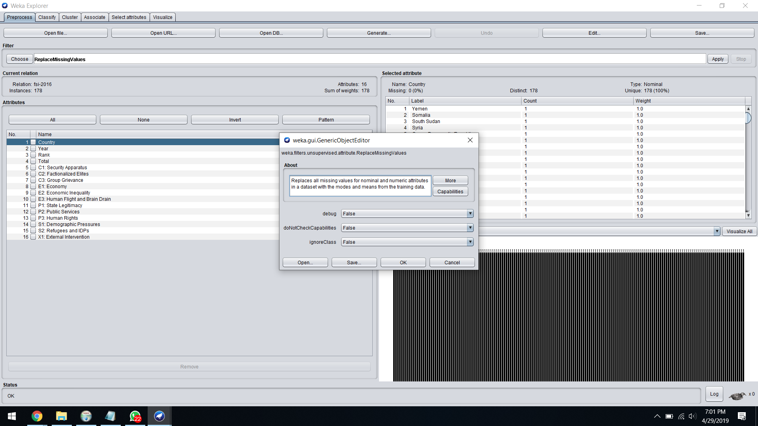

**OUTLIER REMOVAL:**

**FILTER-** InterQuartileRange

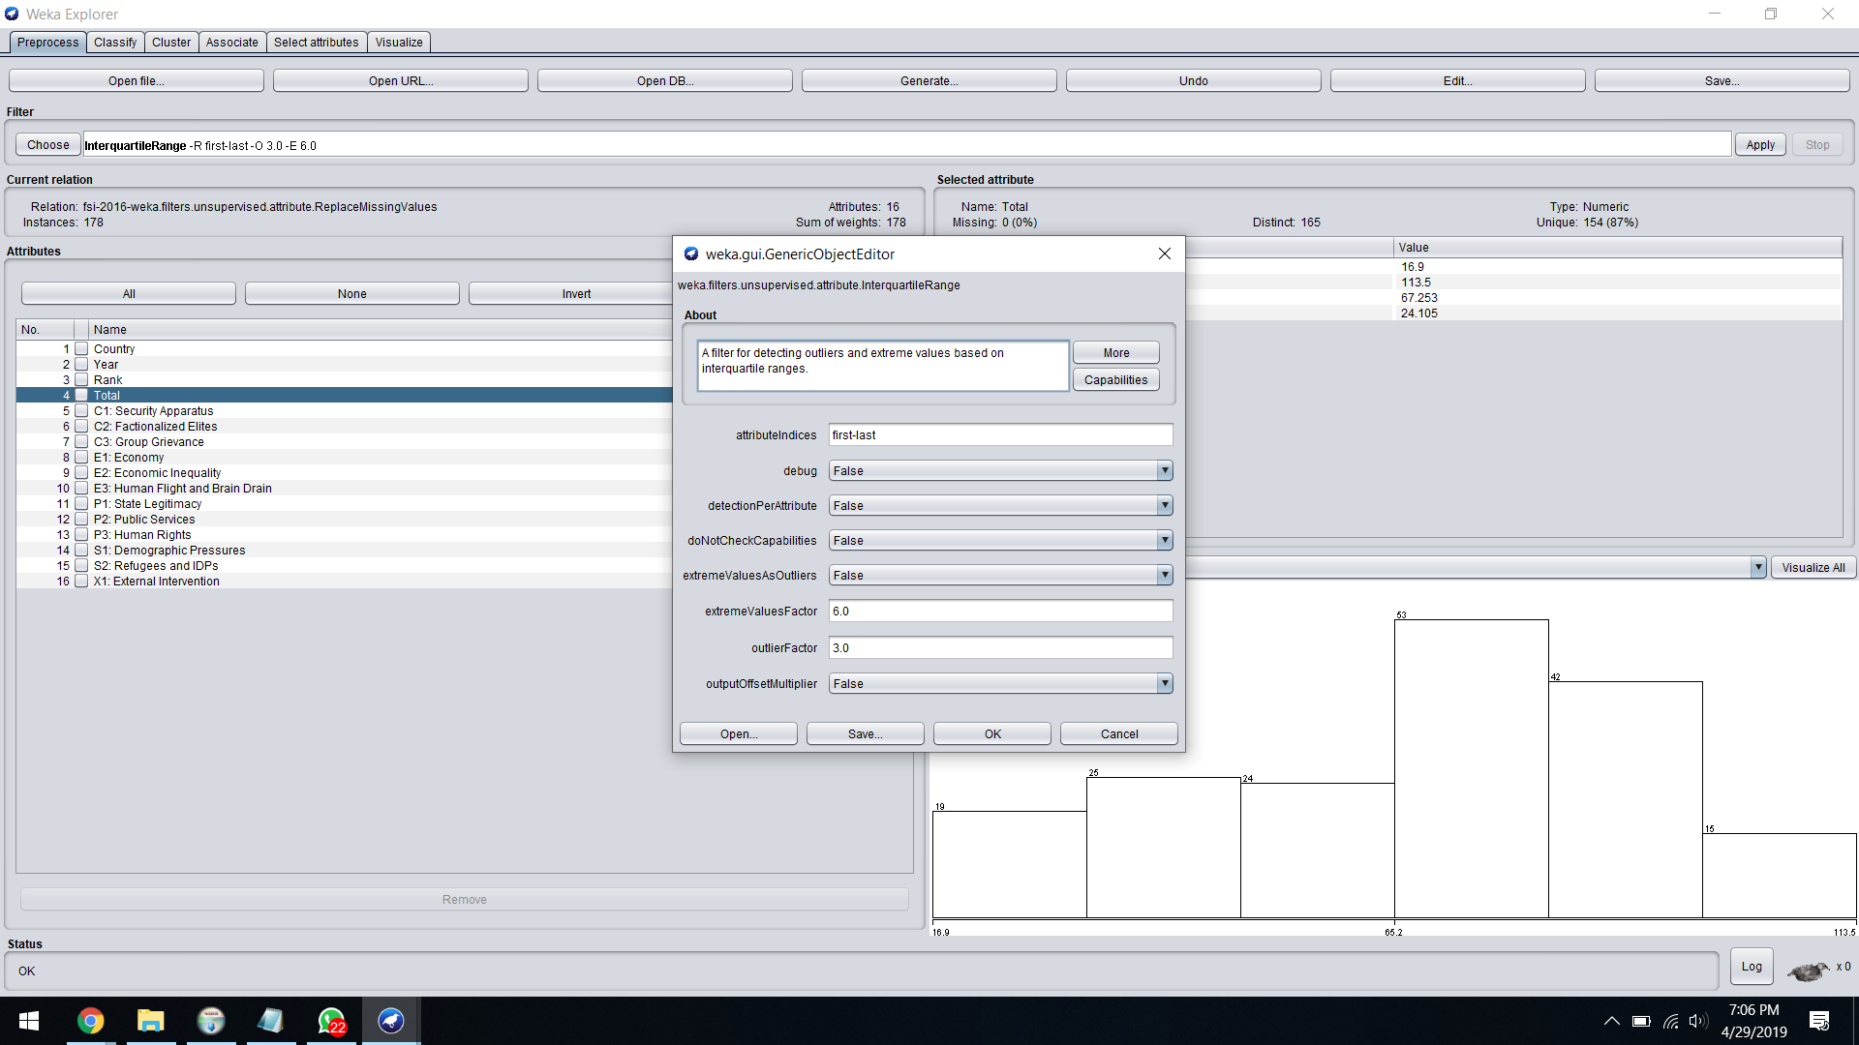

**DISCRETIZATION:**

**FILTER-** Discretize

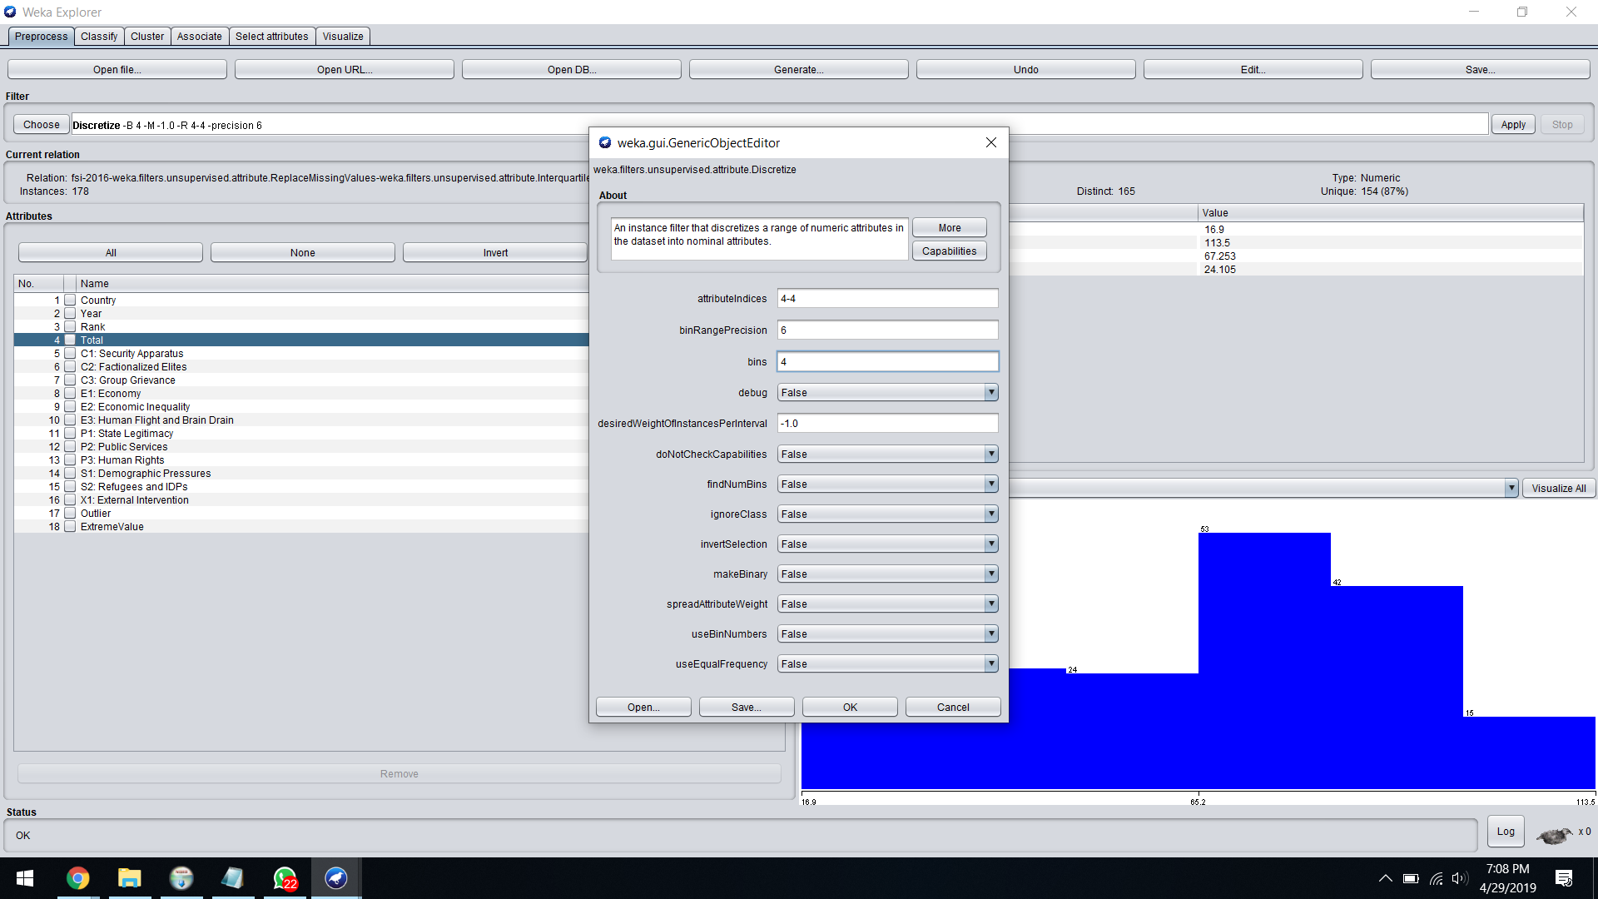

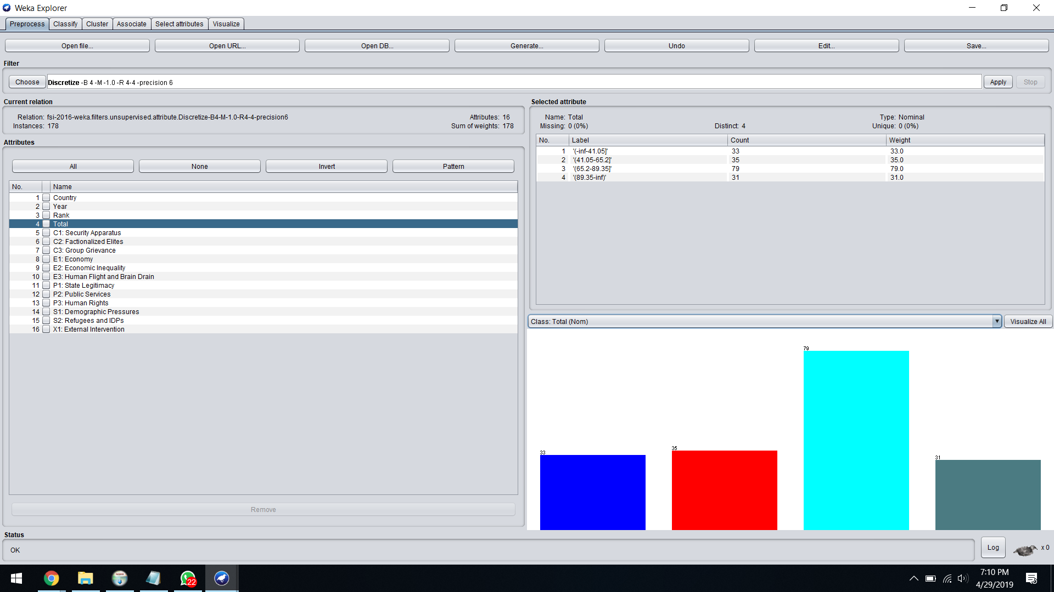

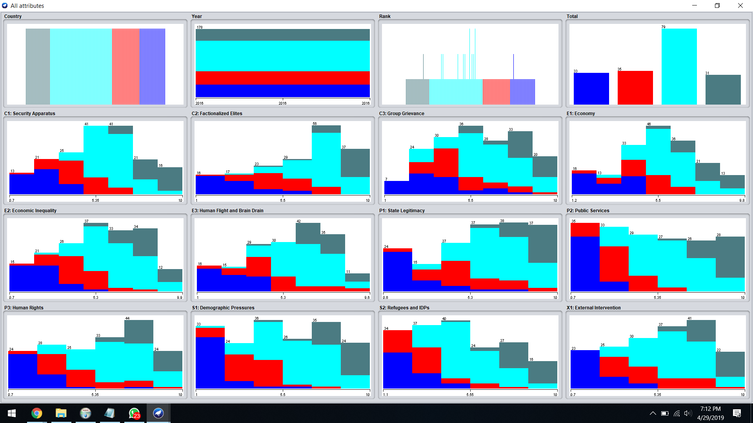

**Final Save to csv file:**

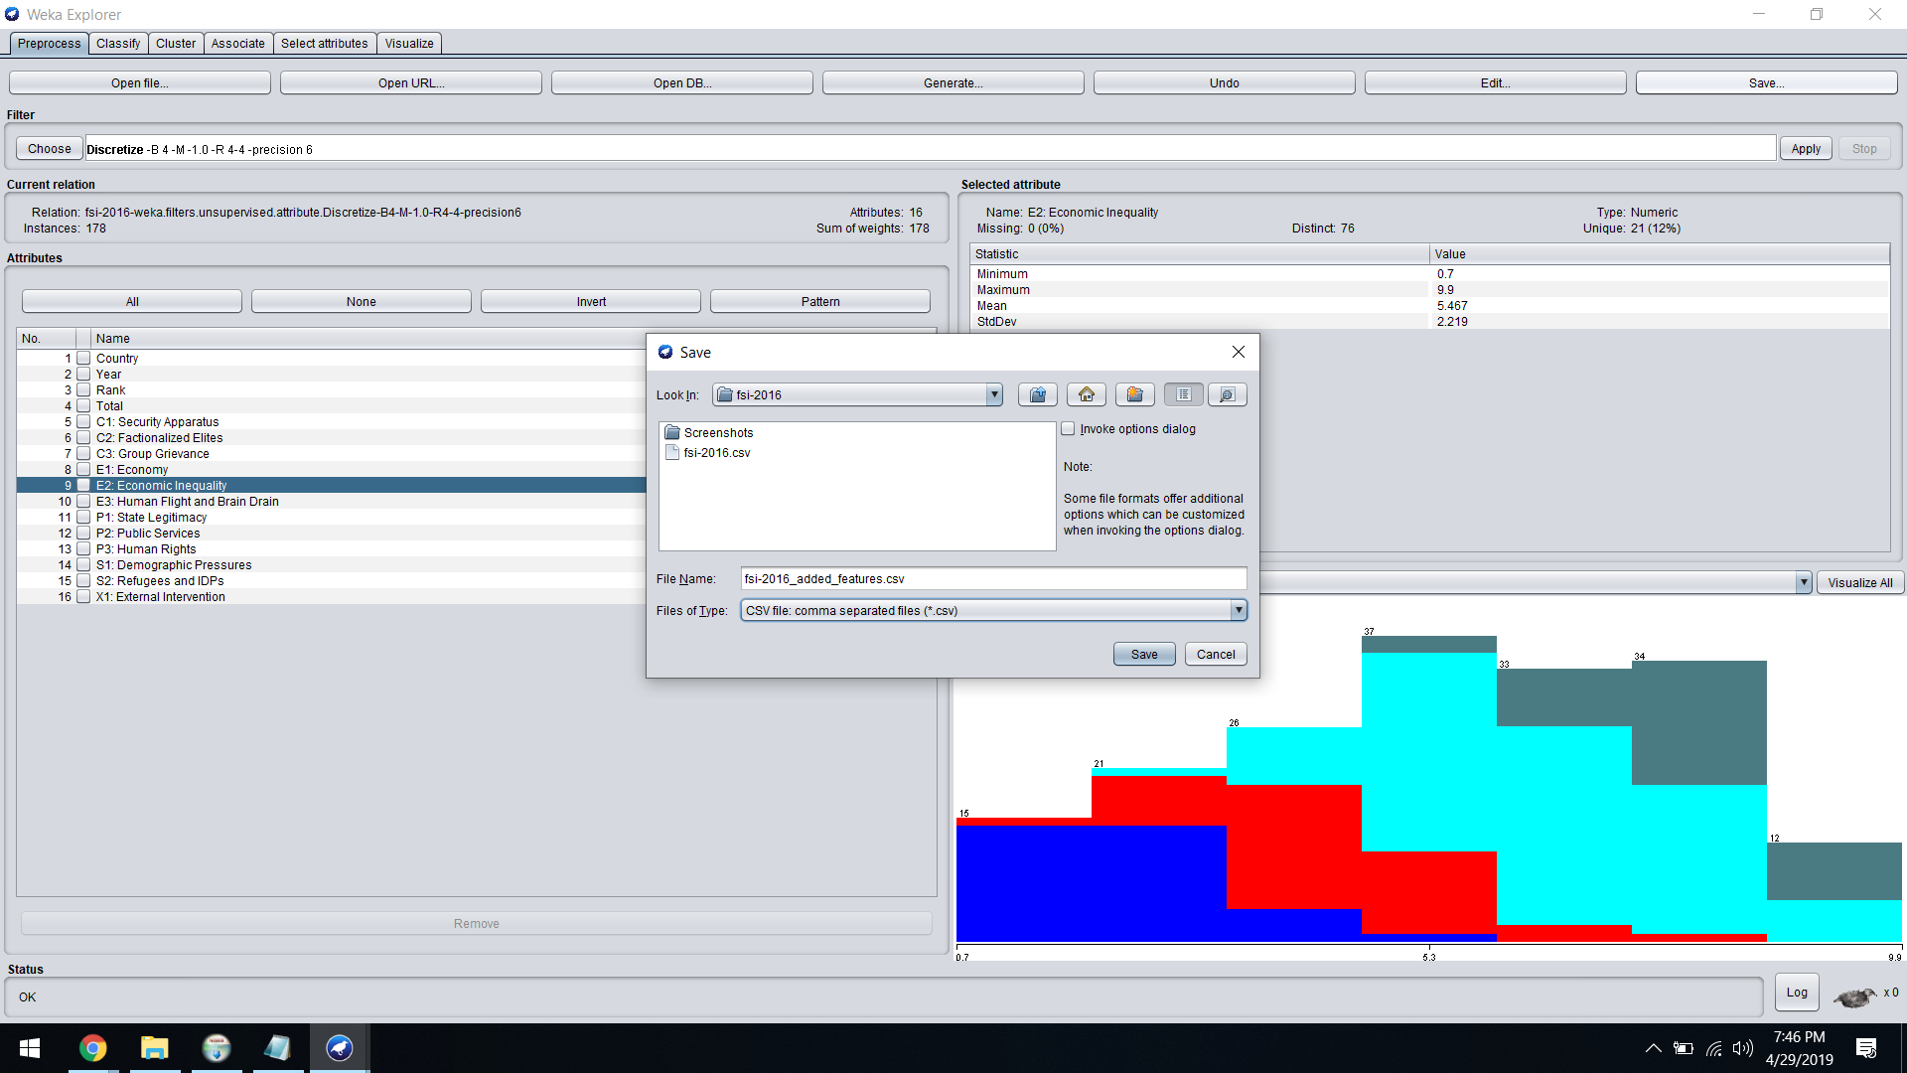

1. **YEAR-2017**

**MISSING VALUES:**

**FILTER-** ReplacingMissingValues

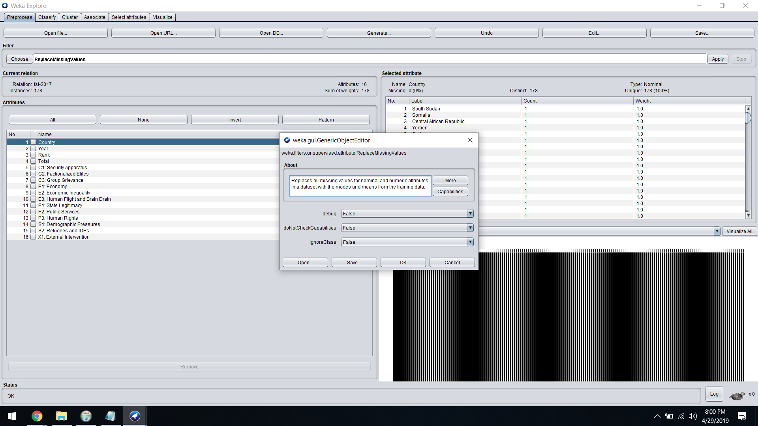

**OUTLIER REMOVAL:**

**FILTER-** InterQuartileRange

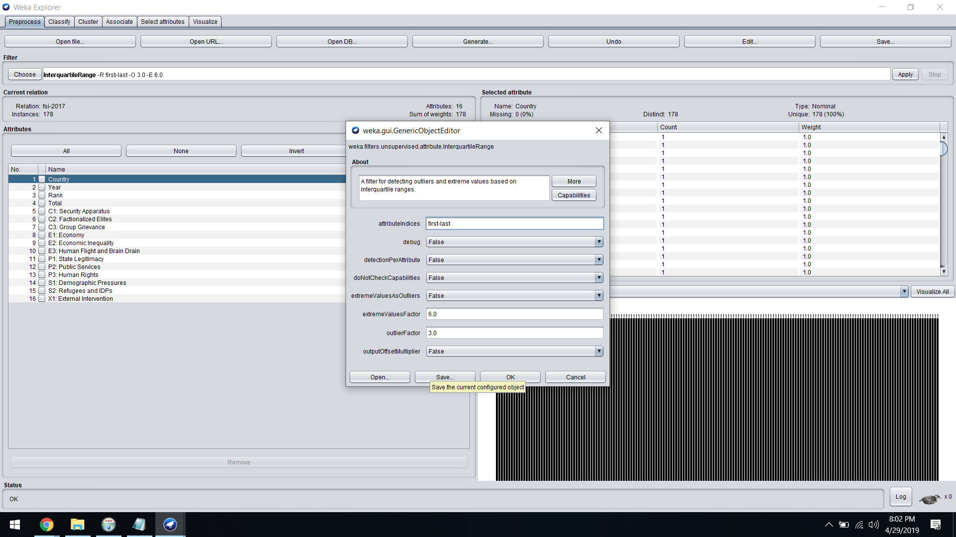

**DISCRETIZATION:**

**FILTER-** Discretize

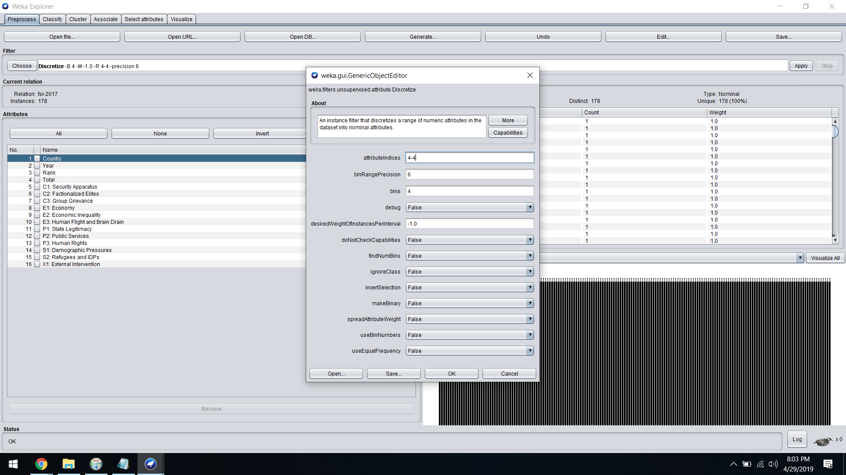

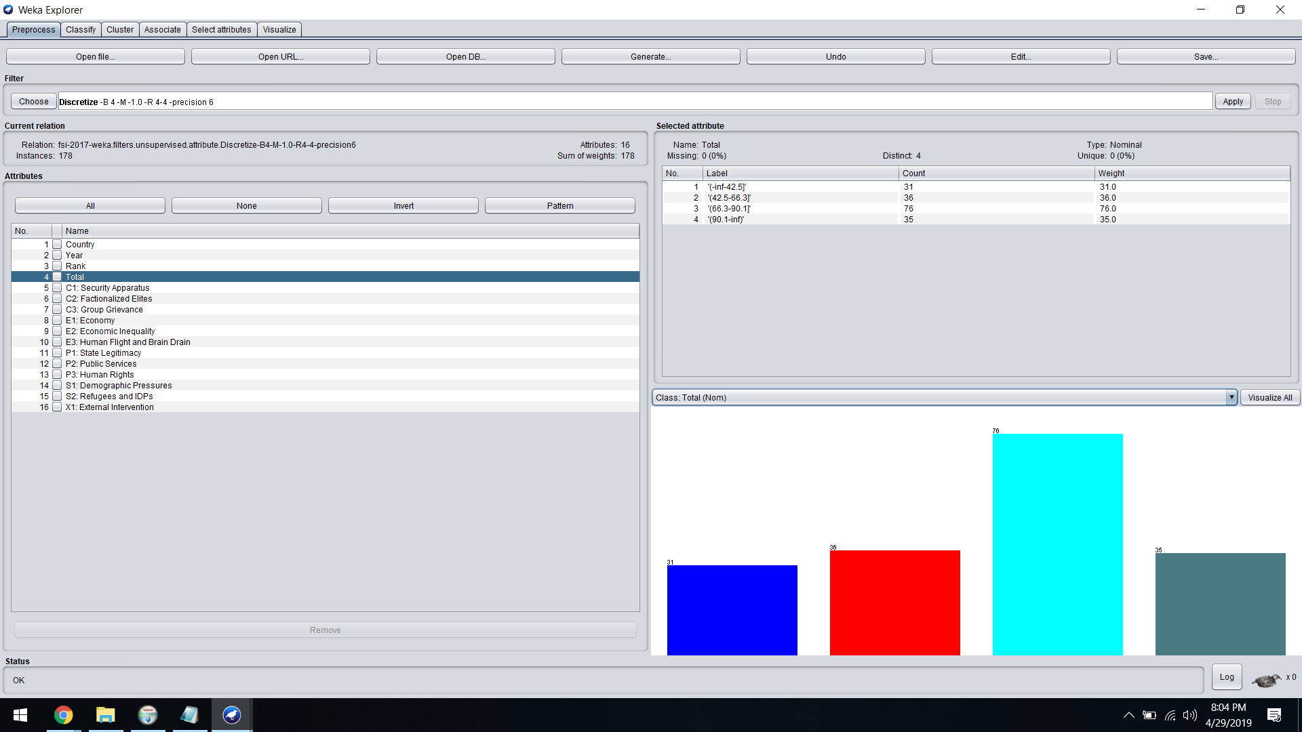

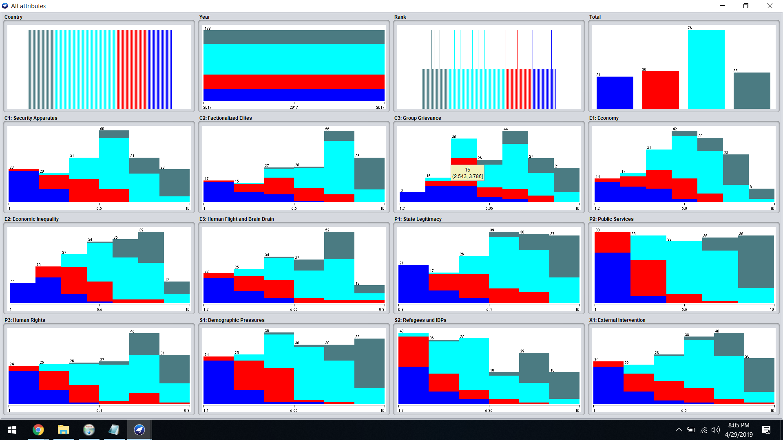

**Final Save to csv file:**

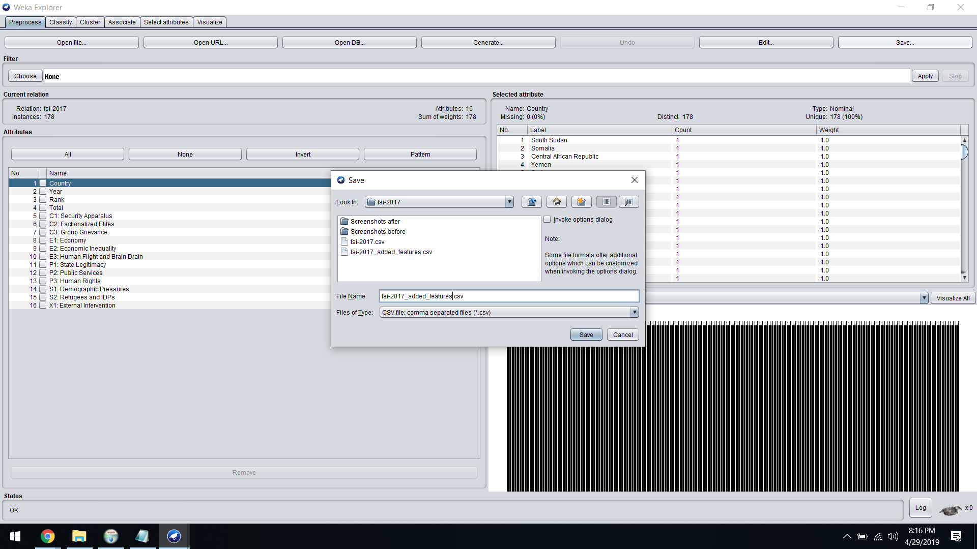

1. **YEAR-2018**

**MISSING VALUES:**

**FILTER-** ReplacingMissingValues

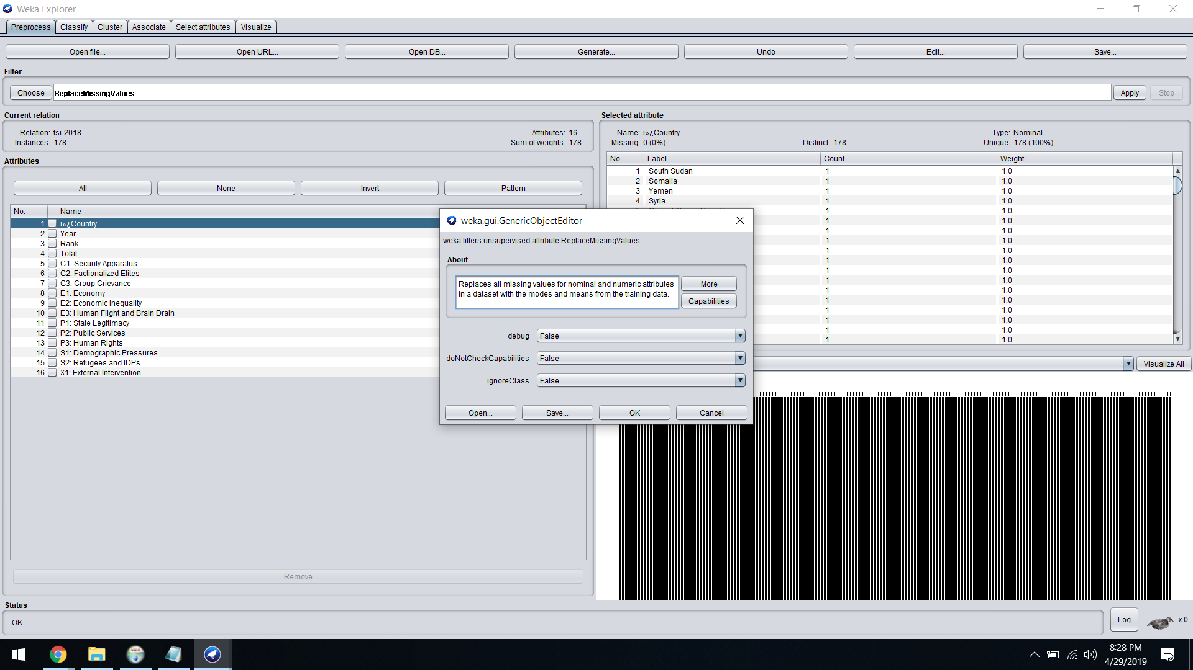

**OUTLIER REMOVAL:**

**FILTER-** InterQuartileRange

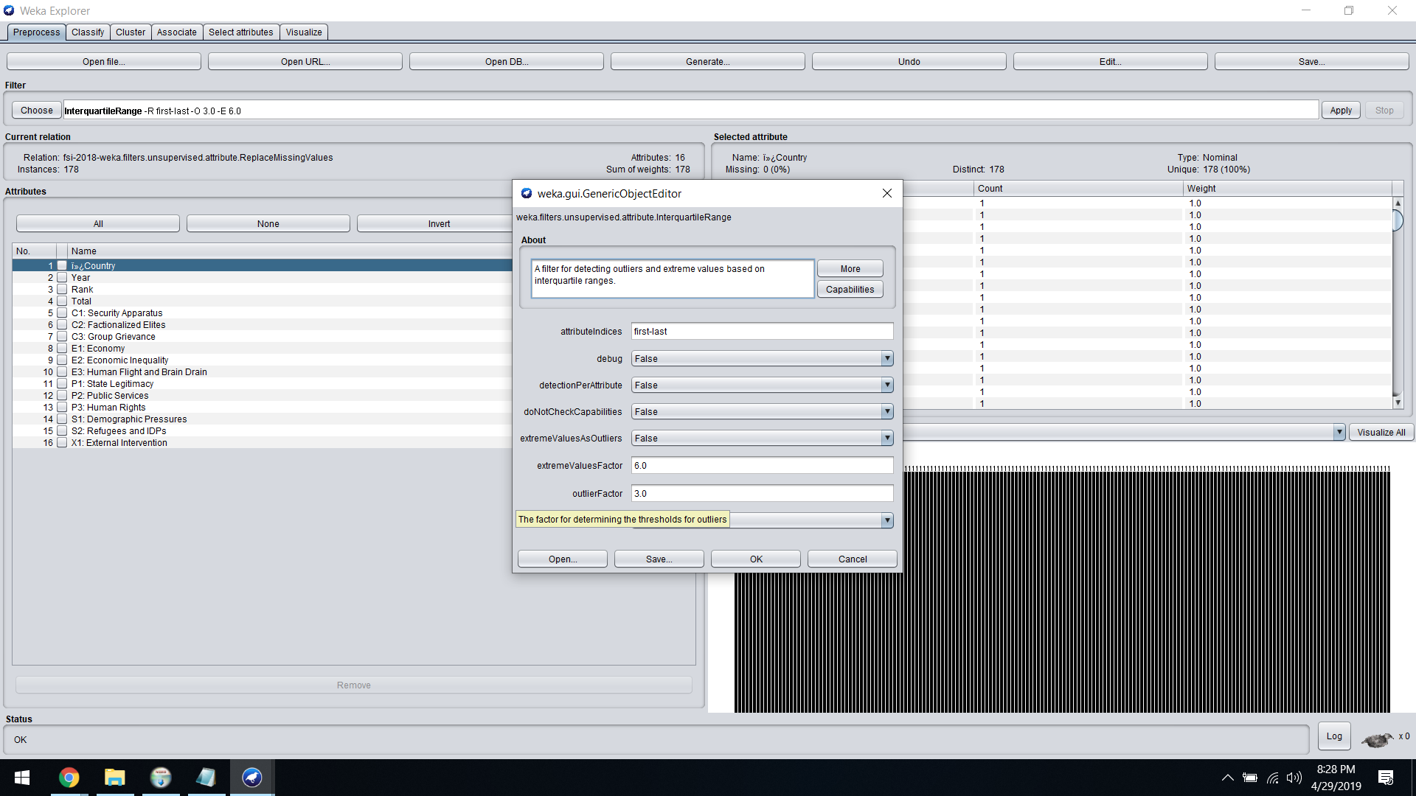

**DISCRETIZATION:**

**FILTER-** Discretize

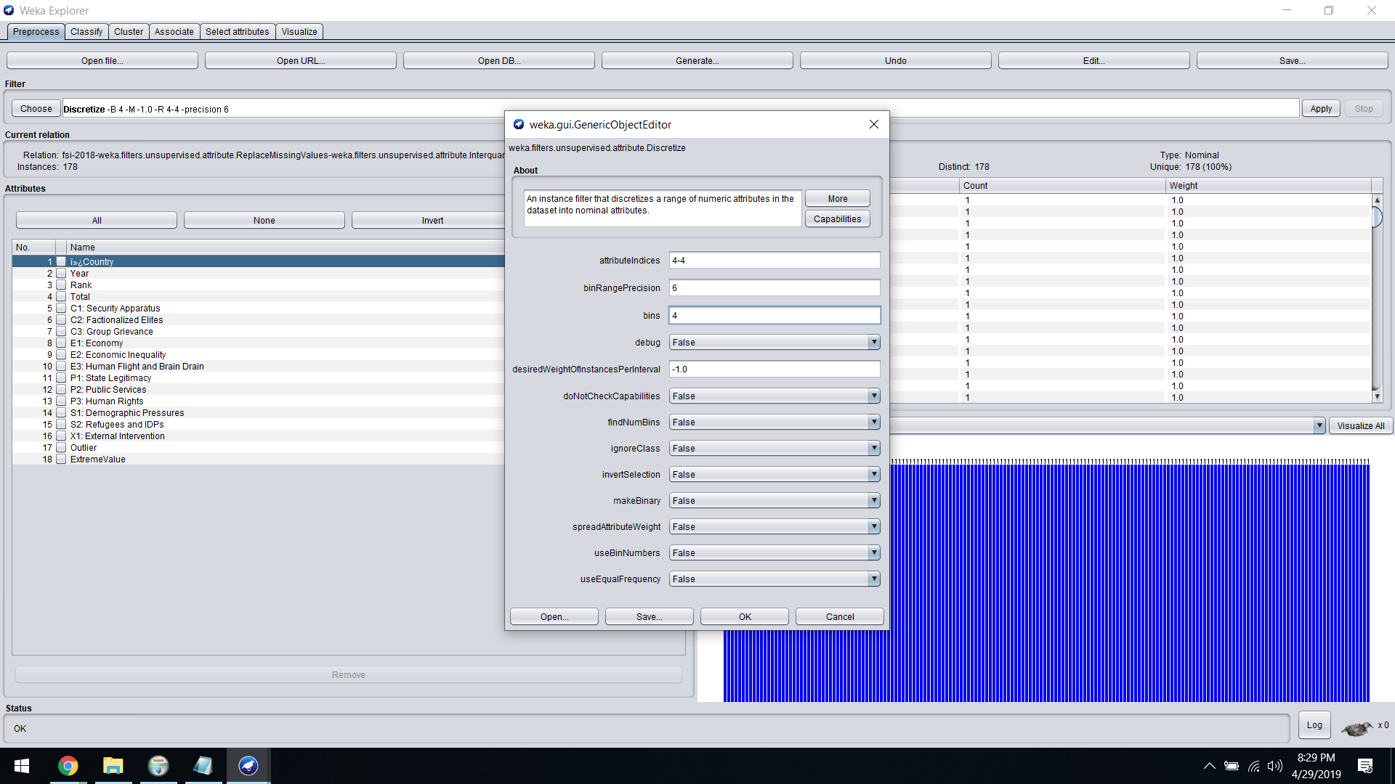

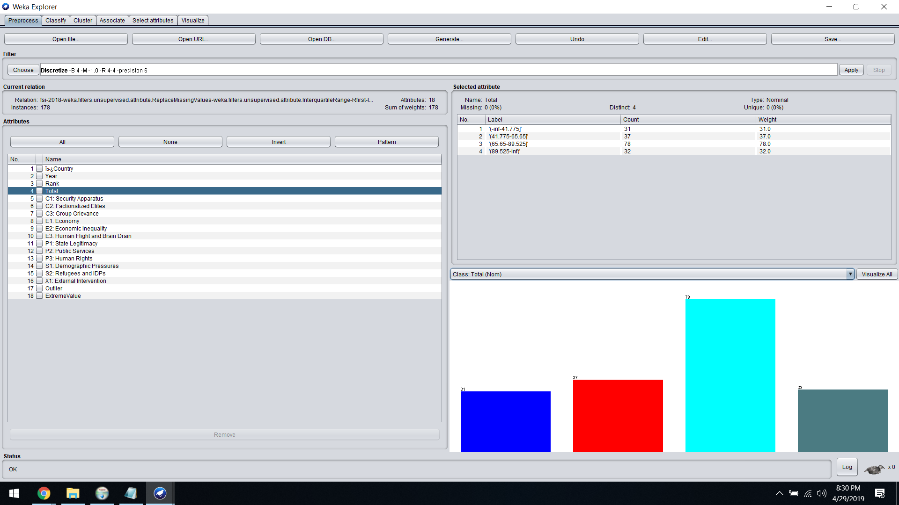

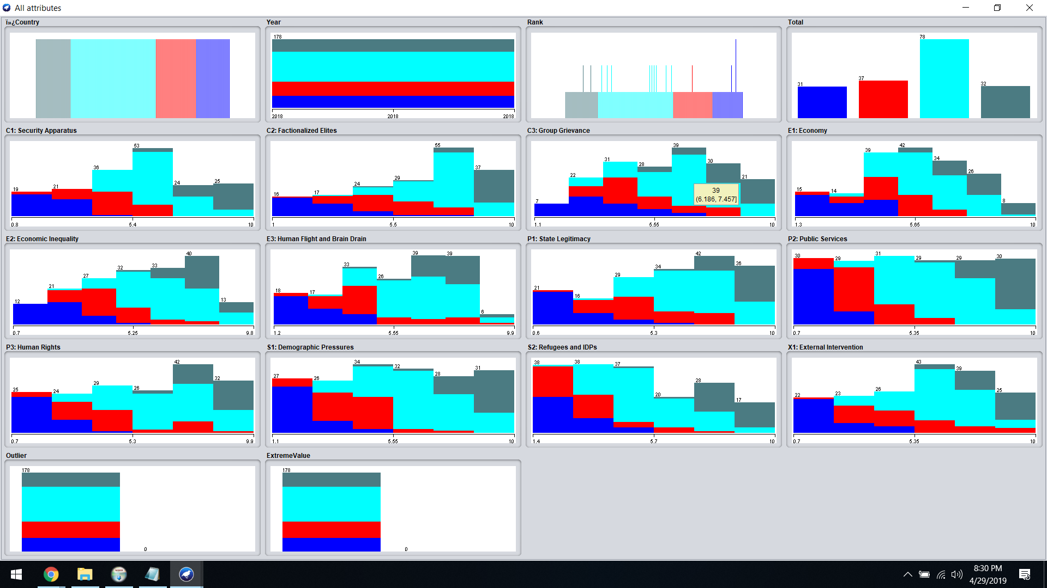

**Final Save to csv file:**

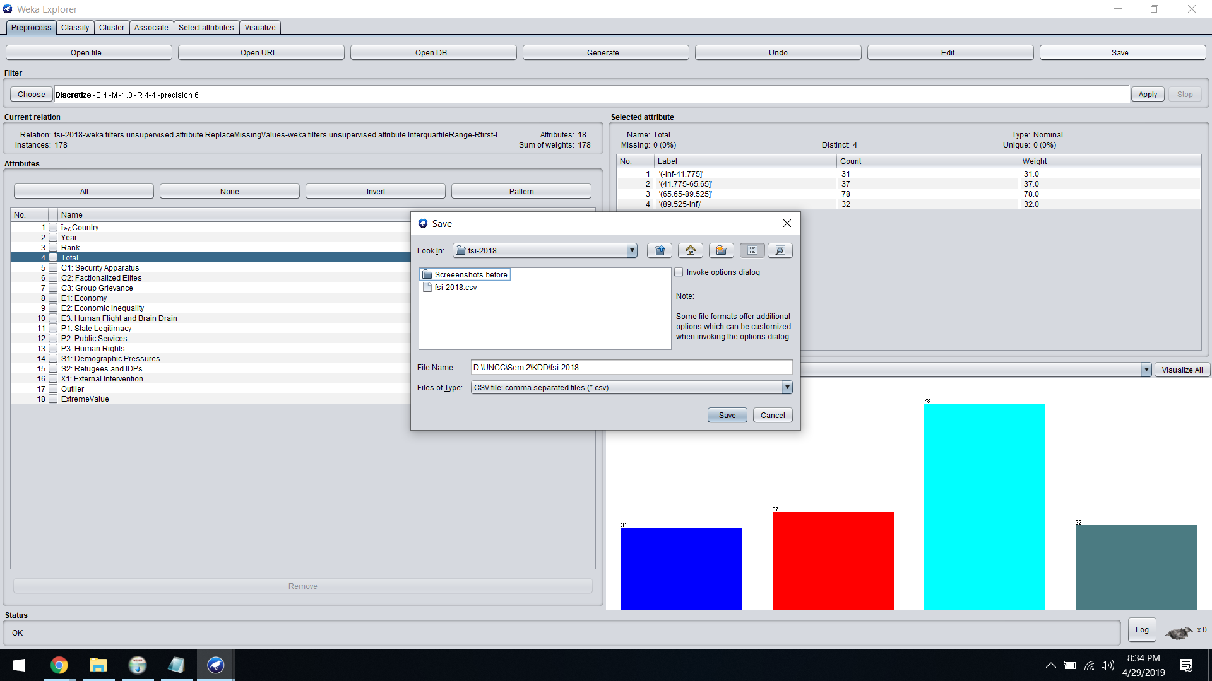

1. **Classification**

For Classification, we have used the following classifiers. Each classifier is run for the dataset from the year 2013 to 2016.

Also, we have calculated the accuracy for each classifier for the datasets before adding the extra-features and after adding the extra-features to compare the efficiency of both types of datasets. Following are the Algorithms used for Classification:

1. **Naïve Bayes:**

Class for a Naive Bayes classifier using estimator classes. Numeric estimator precision values are chosen based on analysis of the training data. For this reason, the classifier is not an Updateable Classifier (which in typical usage are initialized with zero training instances) -- if you need the Updateable Classifier functionality, use the NaiveBayes Updateable classifier. The NaiveBayes Updateable classifier will use a default precision of 0.1 for numeric attributes when buildClassifier is called with zero training instances.

1. **J48:**

The C4.5 algorithm for building decision trees is implemented in Weka as a classifier called J48. Classifiers, like filters, are organized in a hierarchy: J48 has the full name weka.classifiers.trees.J48. 10

1. **JRip:**

This class implements a propositional rule learner, Repeated Incremental Pruning to Produce Error Reduction (RIPPER), which was proposed by William W. Cohen as an optimized version of IREP.

The algorithm is briefly described as follows:

Initialize RS = {}, and for each class from the less prevalent one to the more frequent one, DO:

**a). Building stage:**

Repeat 1.1 and 1.2 until the description length (DL) of the ruleset and examples is 64 bits greater than the smallest DL met so far, or there are no positive examples, or the error rate >= 50%.

* 1. **Grow phase:**

Grow one rule by greedily adding antecedents (or conditions) to the rule until the rule is perfect (i.e. 100% accurate). The procedure tries every possible value of each attribute and selects the condition with highest information gain: p(log(p/t)-log(P/T)).

* 1. **Prune phase:**

Incrementally prune each rule and allow the pruning of any final sequences of the antecedents;The pruning metric is (p-n)/(p+n) -- but it's actually 2p/(p+n) -1, so in this implementation we simply use p/(p+n) (actually (p+1)/(p+n+2), thus if p+n is 0, it's 0.5).

**b). Optimization stage:**

After generating the initial ruleset {Ri}, generate and prune two variants of each rule Ri from randomized data using procedure 1.1 and 1.2. But one variant is generated from an empty rule while the other is generated by greedily adding antecedents to the original rule. Moreover, the pruning metric used here is (TP+TN)/(P+N).Then the smallest possible DL for 11 each variant and the original rule is computed. The variant with the minimal DL is selected as the final representative of Ri in the ruleset.After all the rules in {Ri} have been examined and if there are still residual positives, more rules are generated based on the residual positives using Building Stage again.

c). Delete the rules from the ruleset that would increase the DL of the whole ruleset if it were in it. and add resultant ruleset to RS.

**a). YEAR 2016**

**Snapshots of the Classification Results for Data before adding New Features:**

1. **Naïve Bayes**

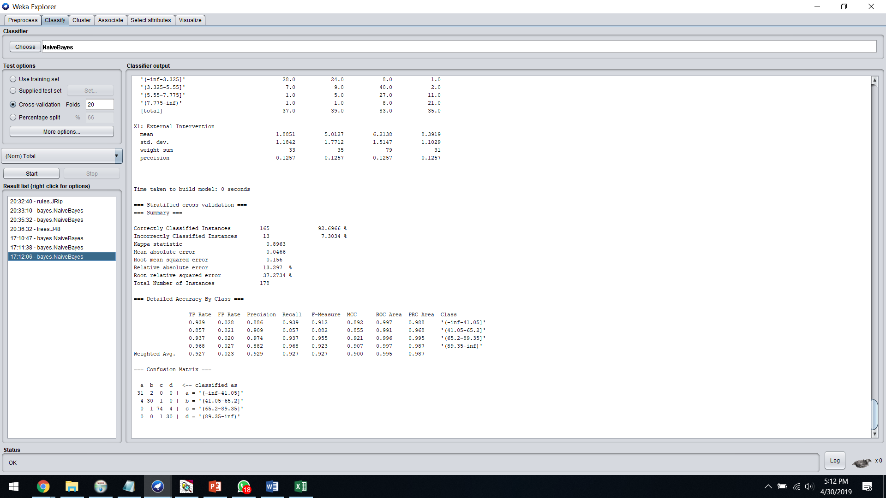

1. **J48**

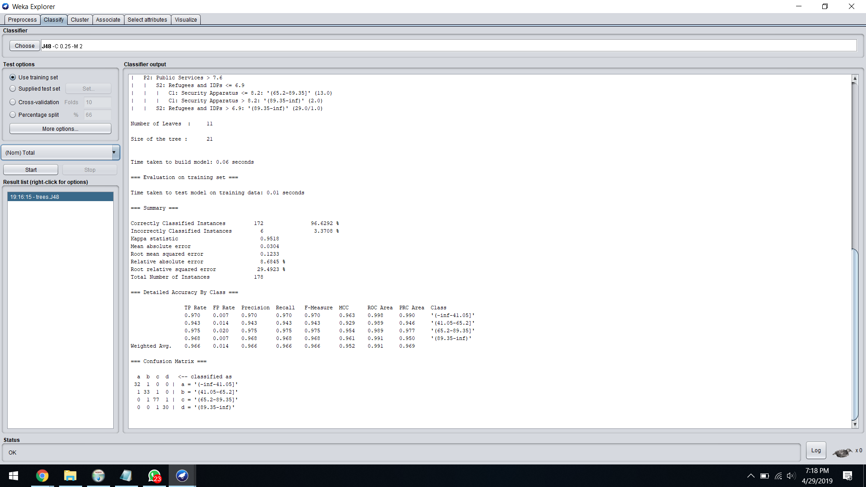

1. **JRip**

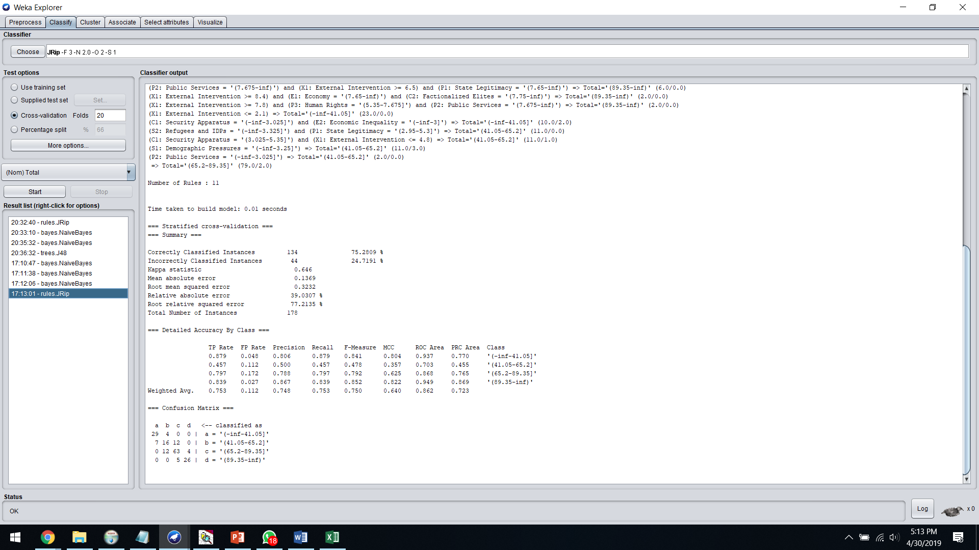

**Snapshots of the Classification Results for Data after adding New Features:**

1. **Naïve Bayes**

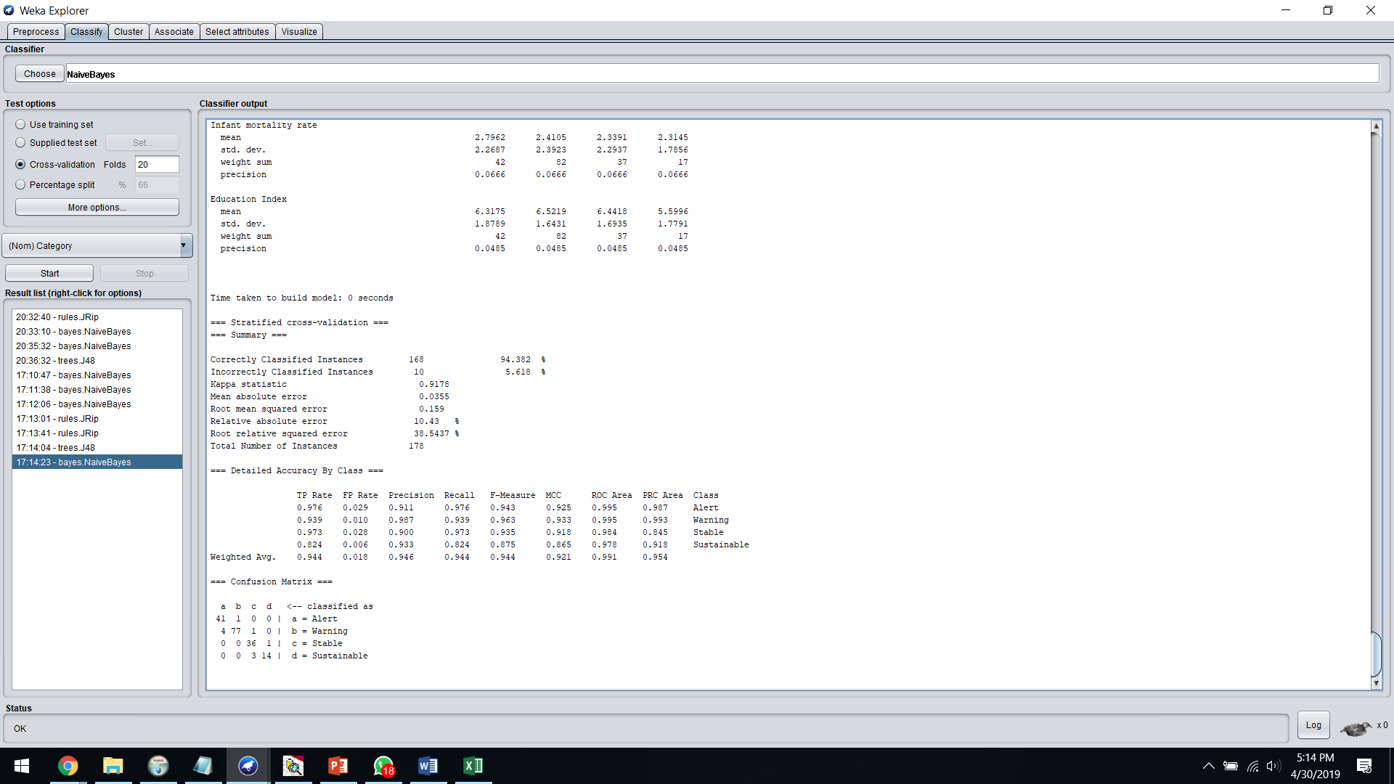

1. **J48**

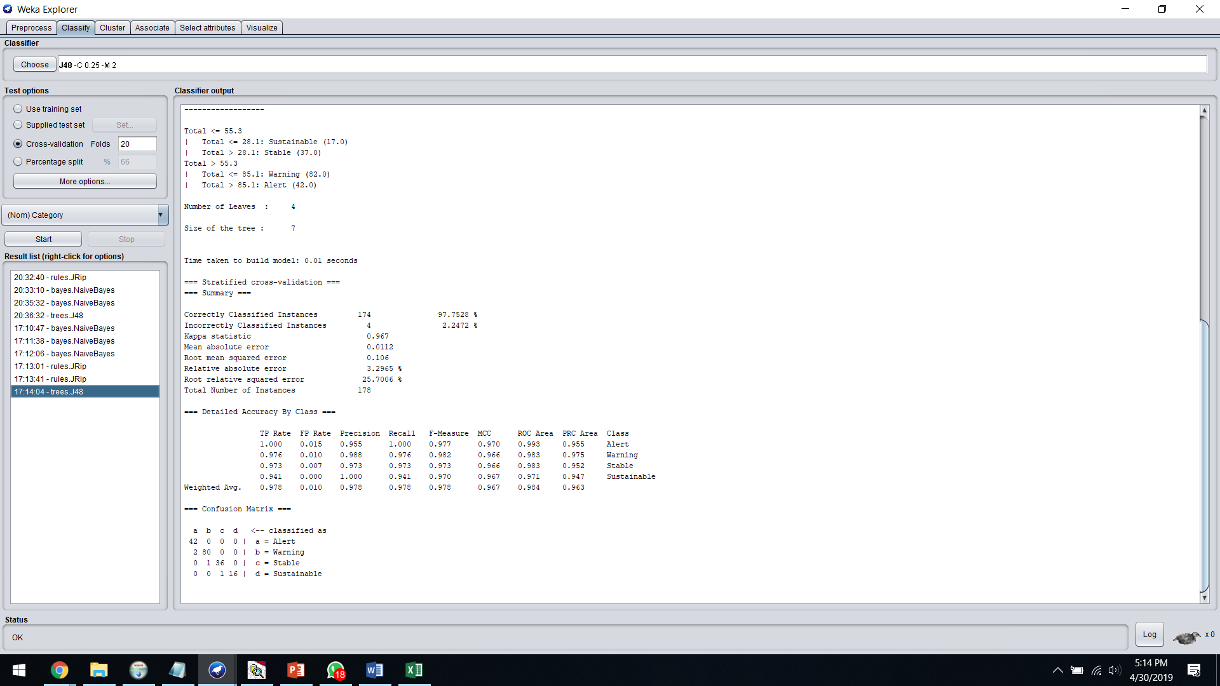

1. **JRip**

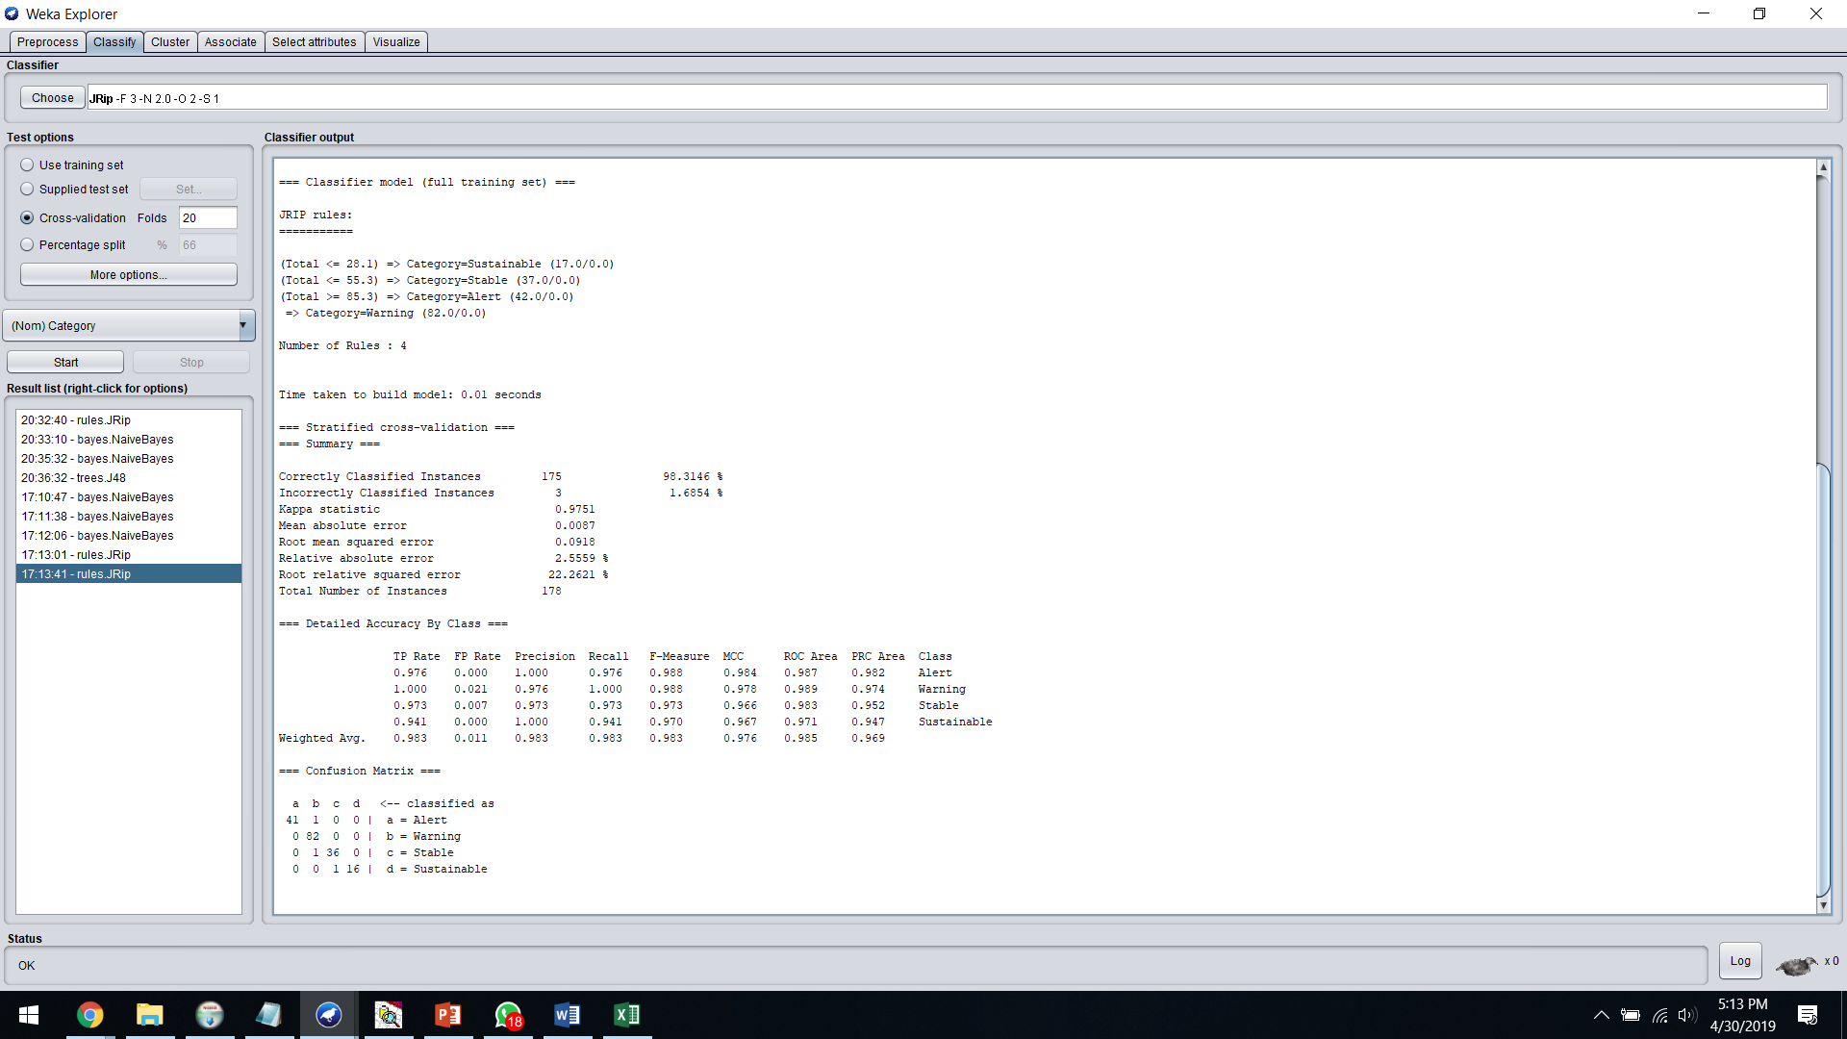

**b). YEAR 2017**

**Snapshots of the Classification Results for Data before adding New Features:**

1. **Naïve Bayes**

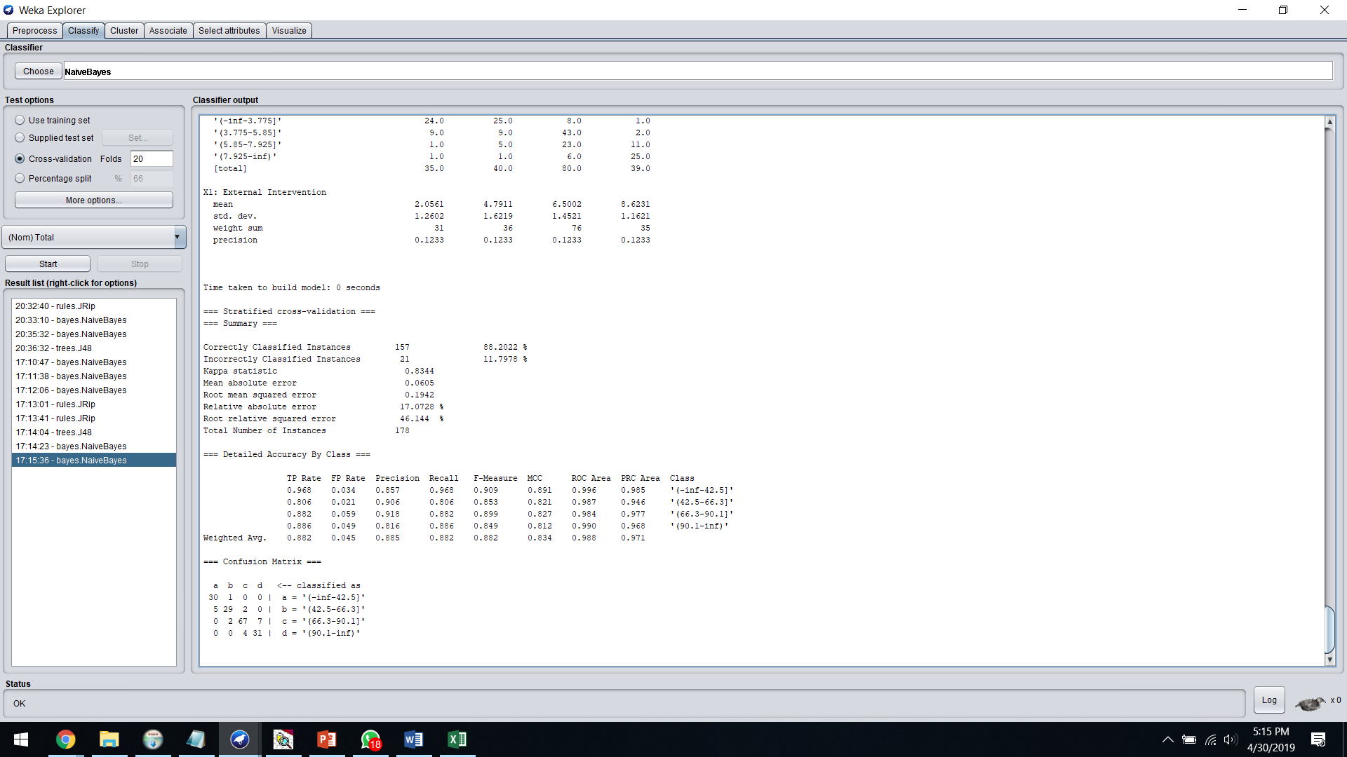

1. **J48**

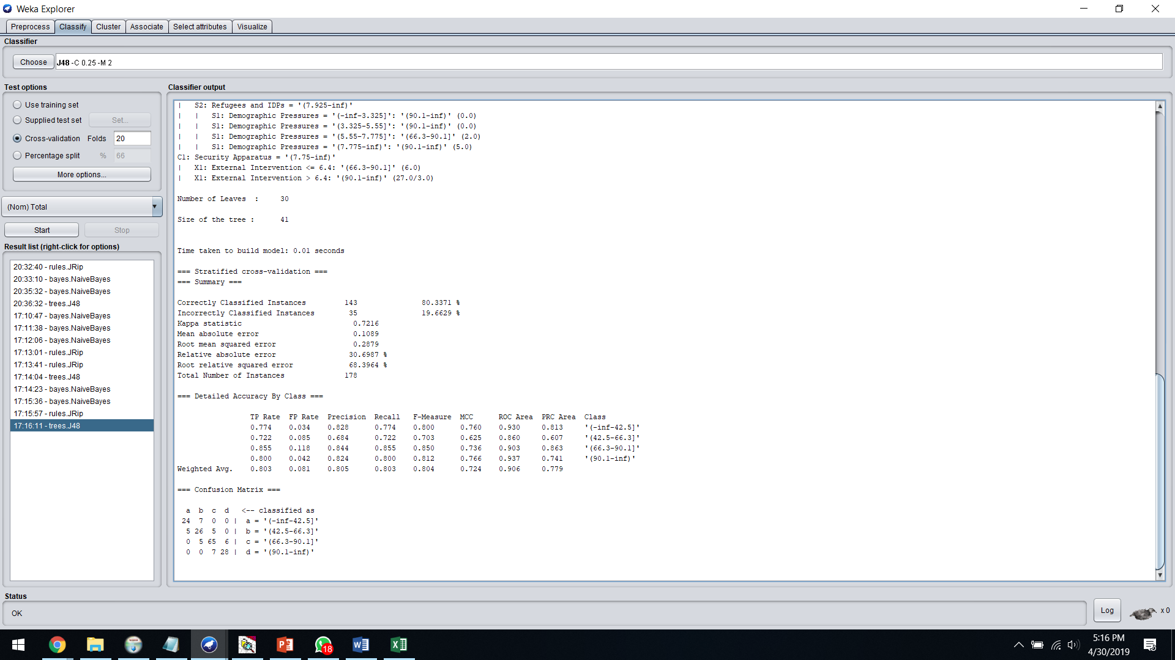

1. **JRip**

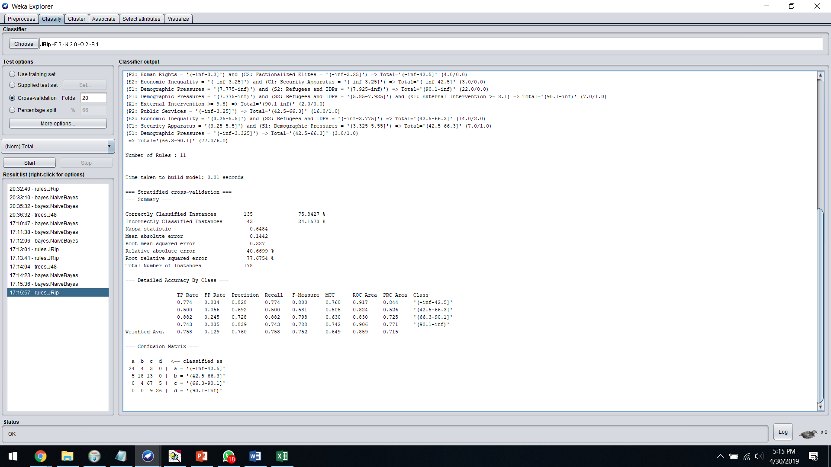

**Snapshots of the Classification Results for Data after adding New Features:**

1. **Naïve Bayes**

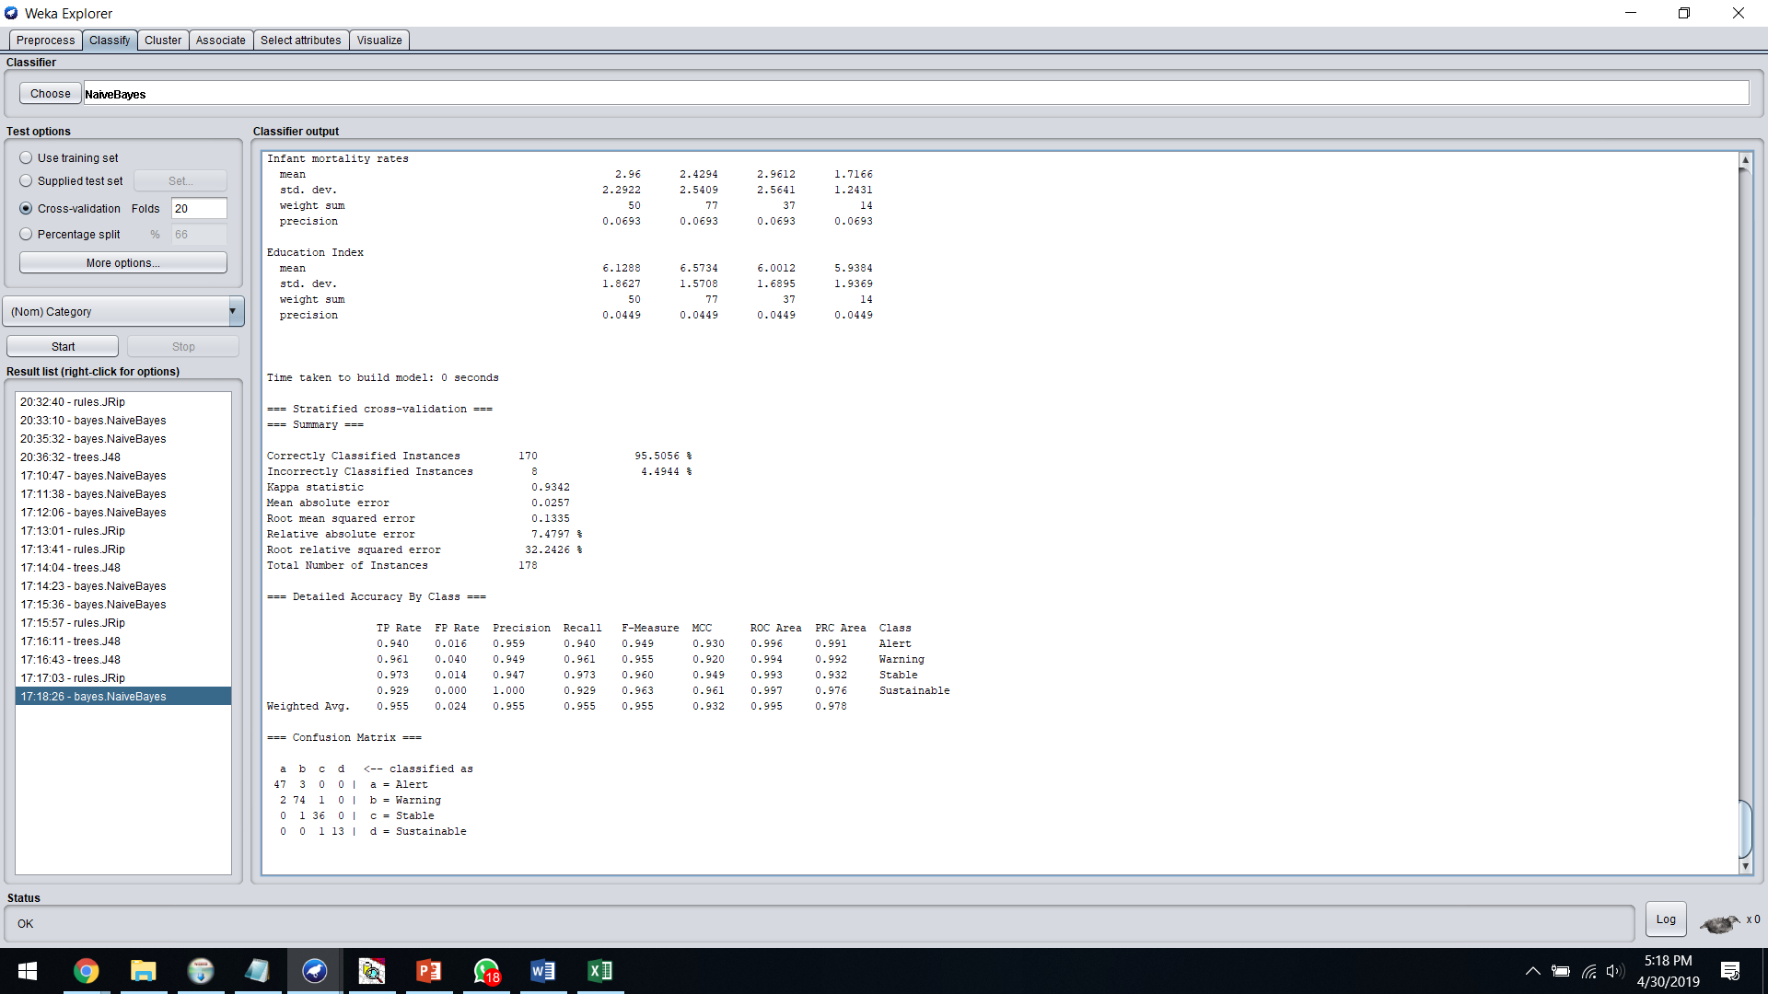

1. **J48**

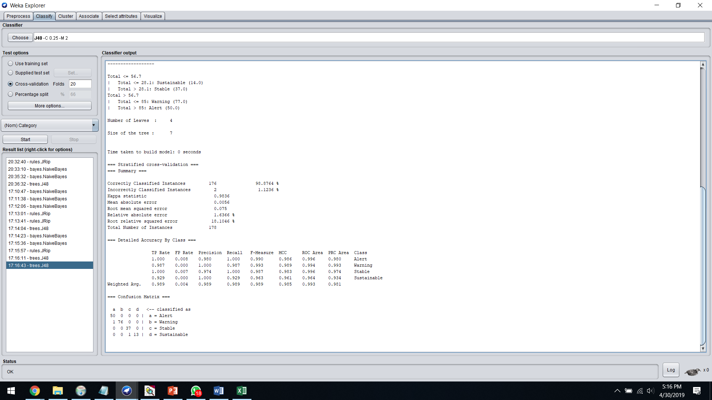

1. **JRip**

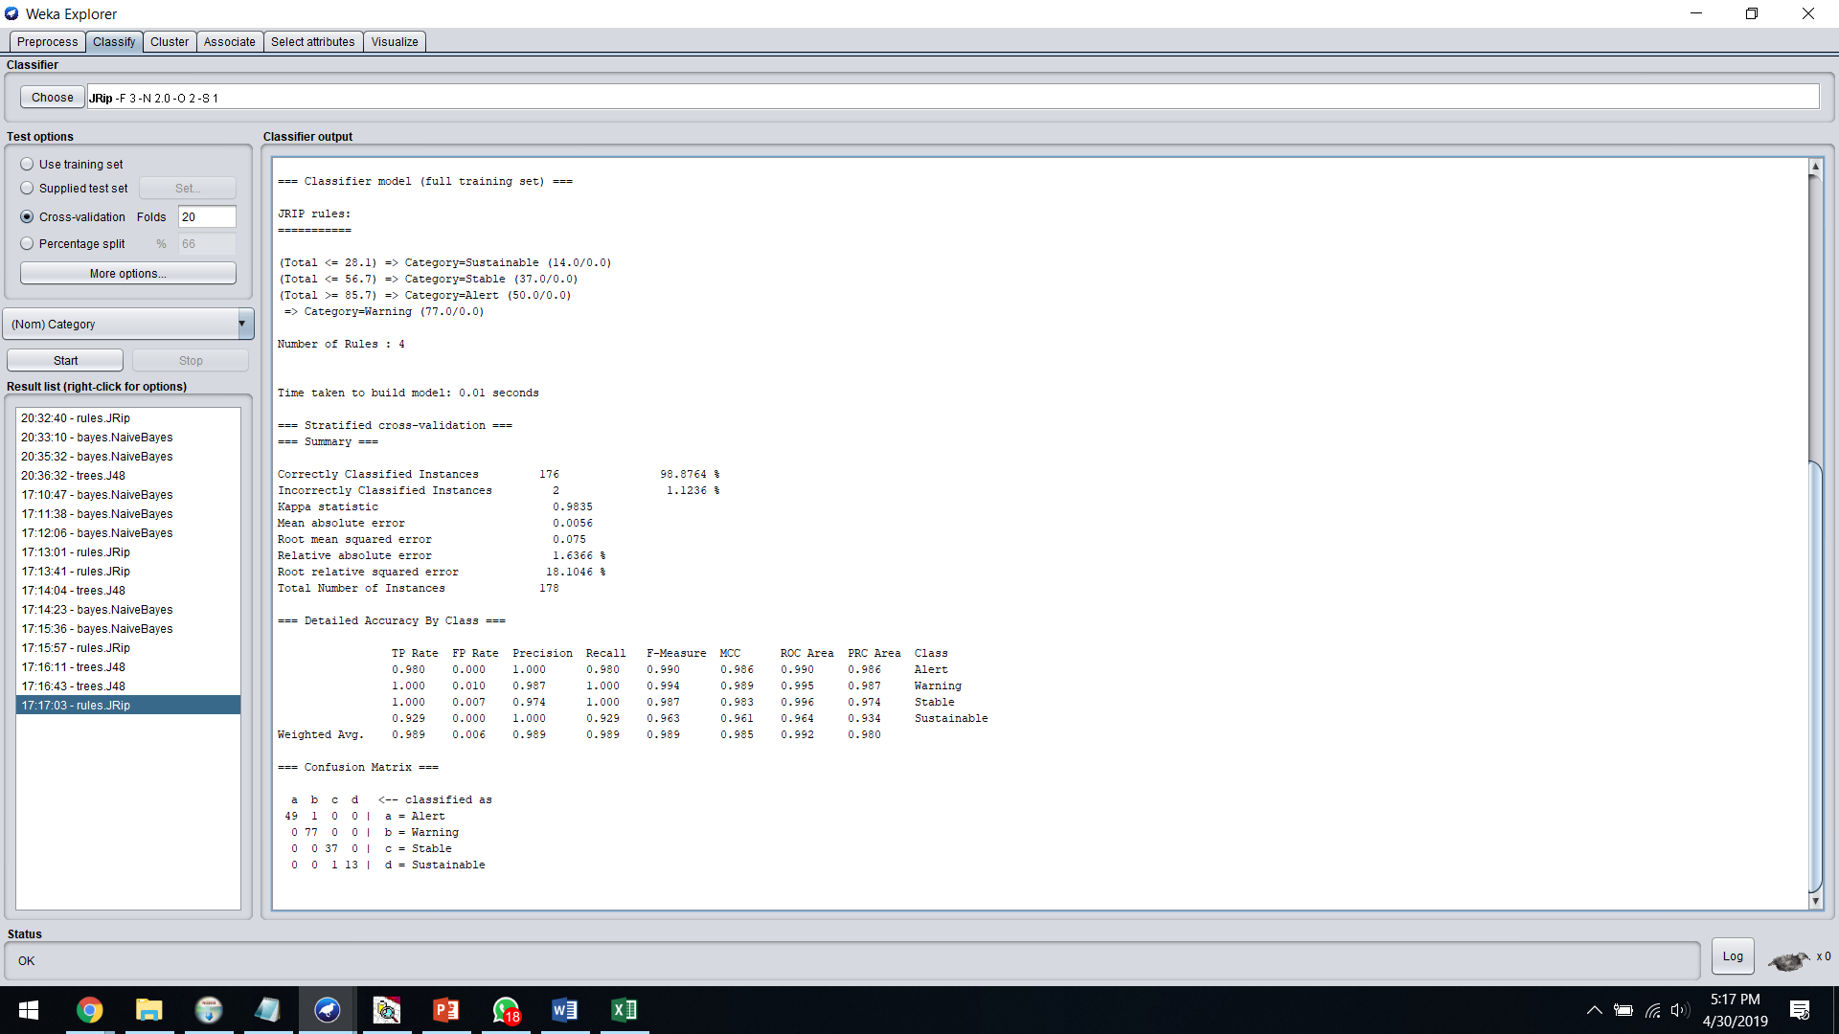

**c). YEAR 2018**

**Snapshots of the Classification Results for Data before adding New Features:**

1. **Naïve Bayes**

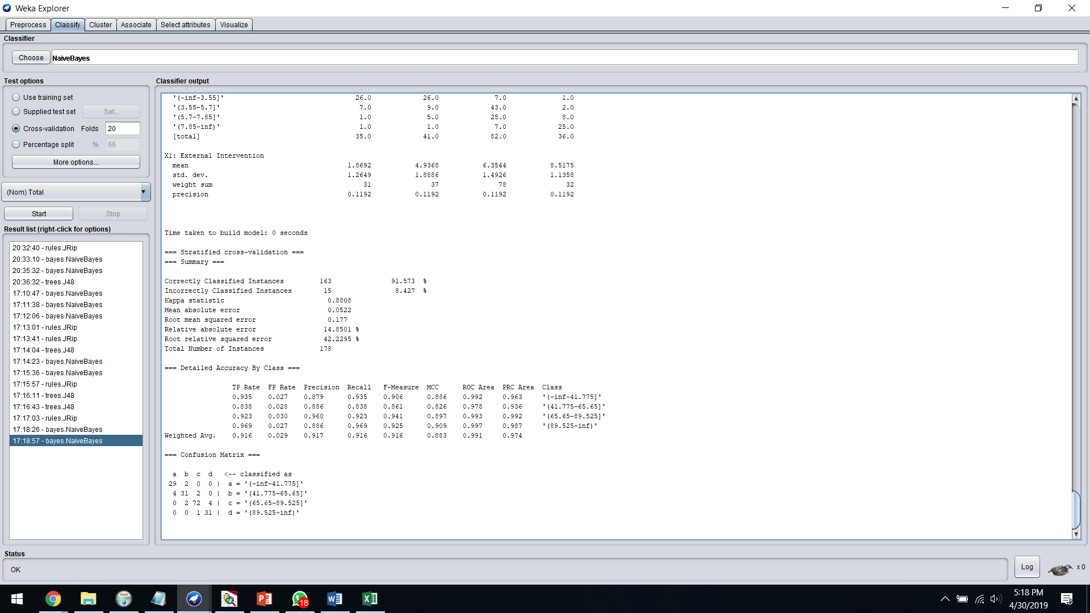

1. **J48**

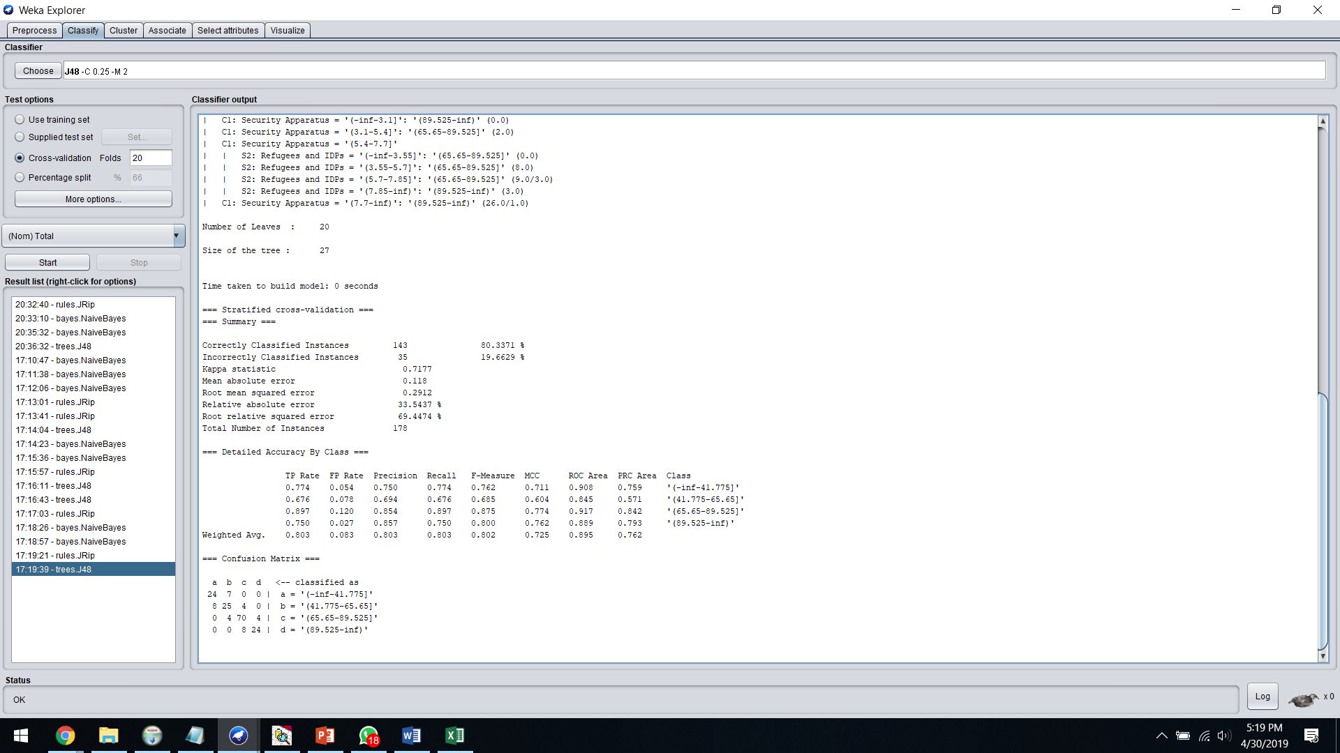

1. **JRip**

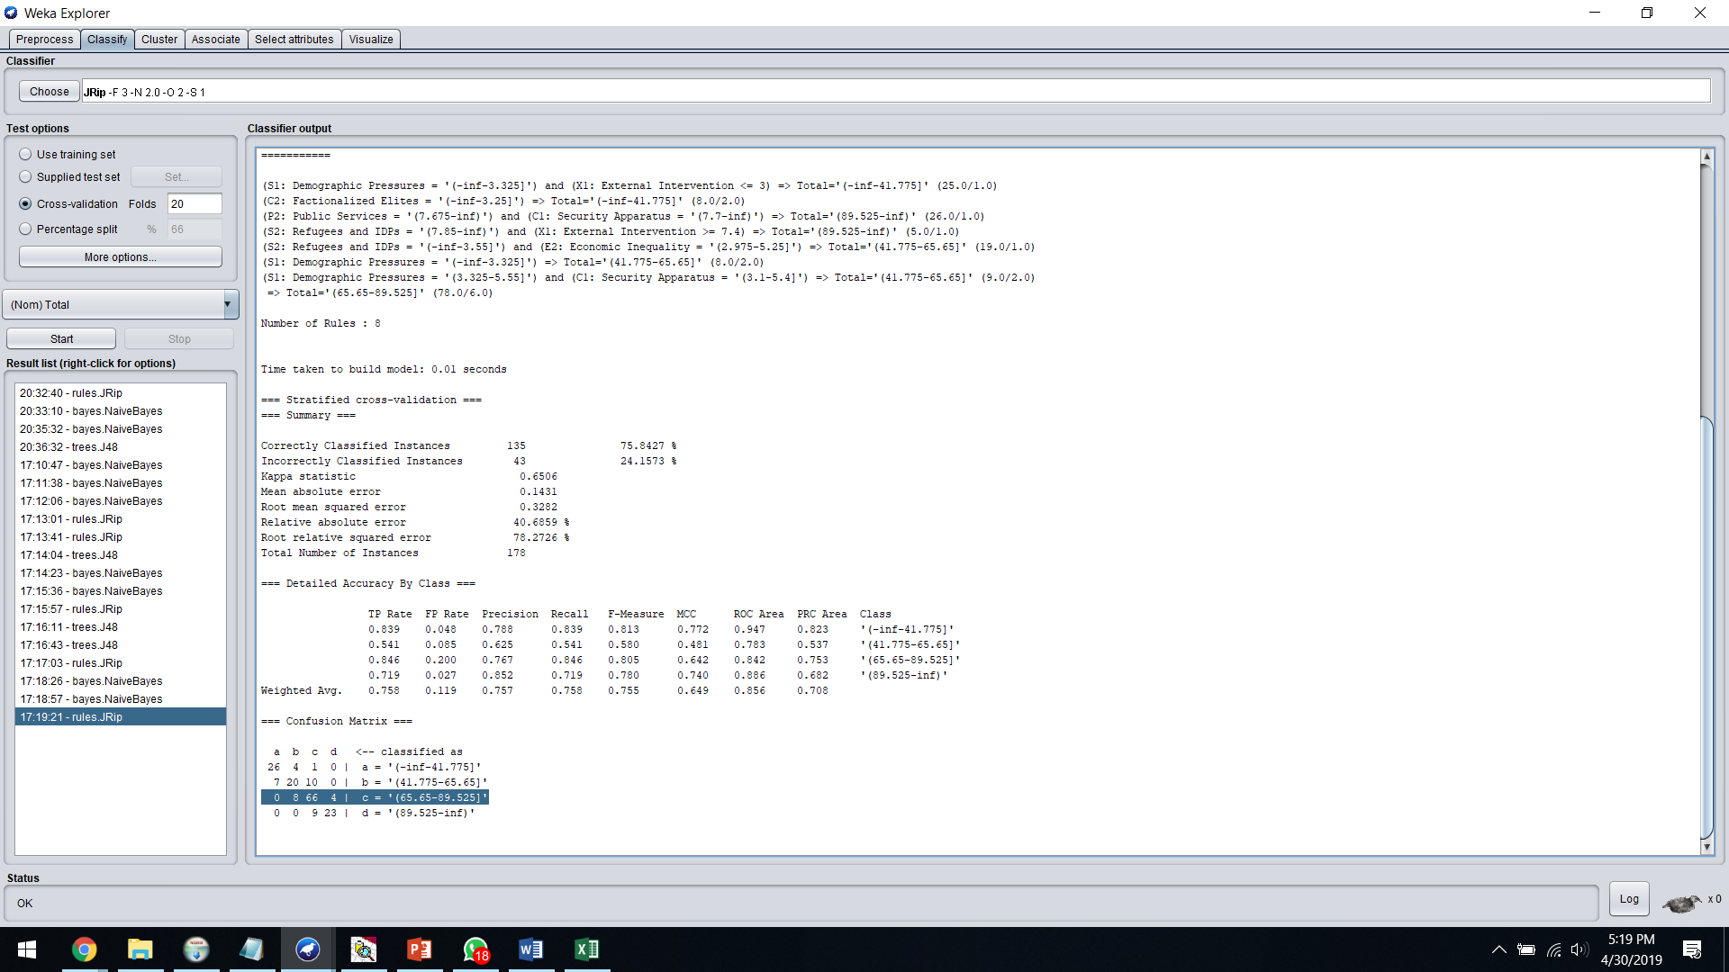

**Snapshots of the Classification Results for Data after adding New Features:**

1. **Naïve Bayes**

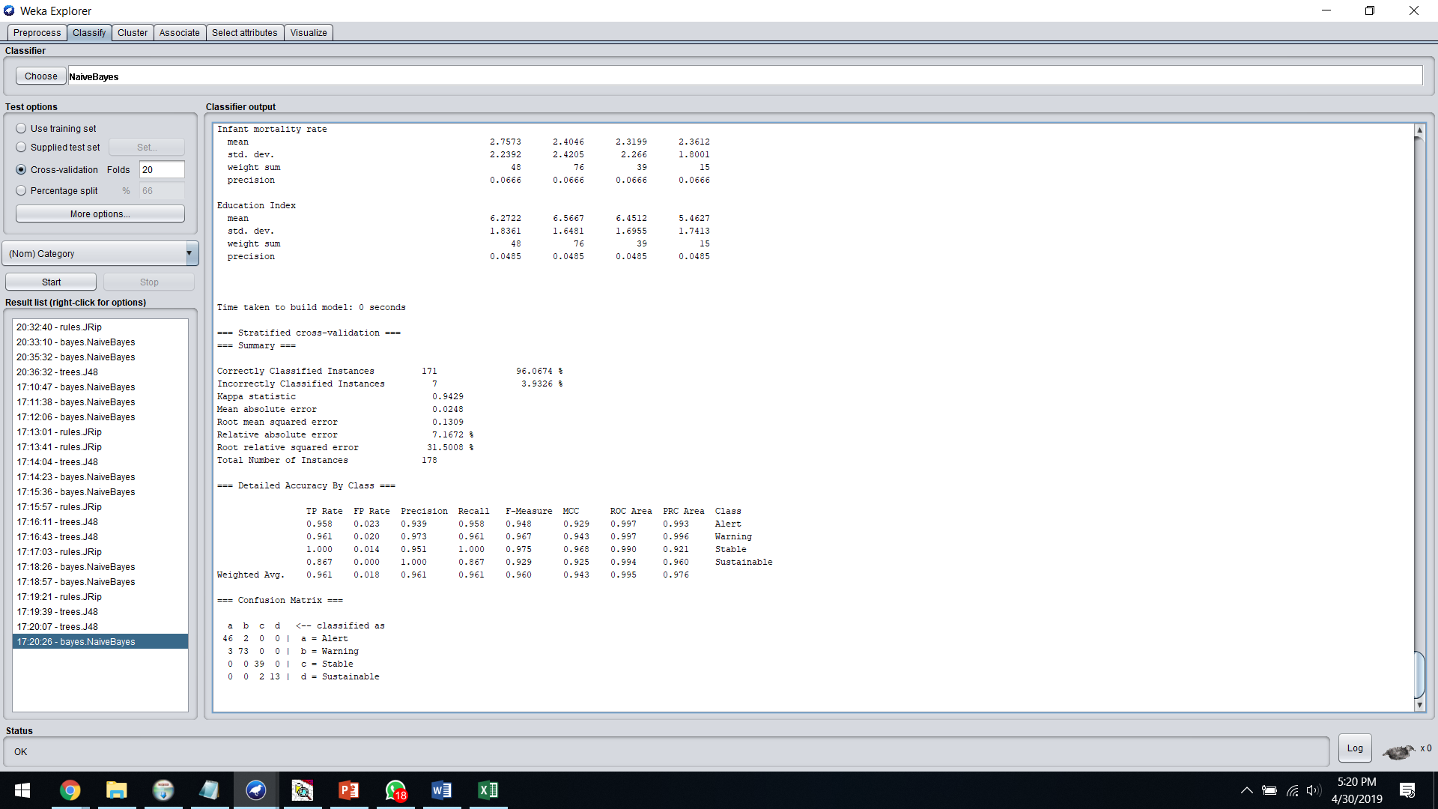

1. **J48**

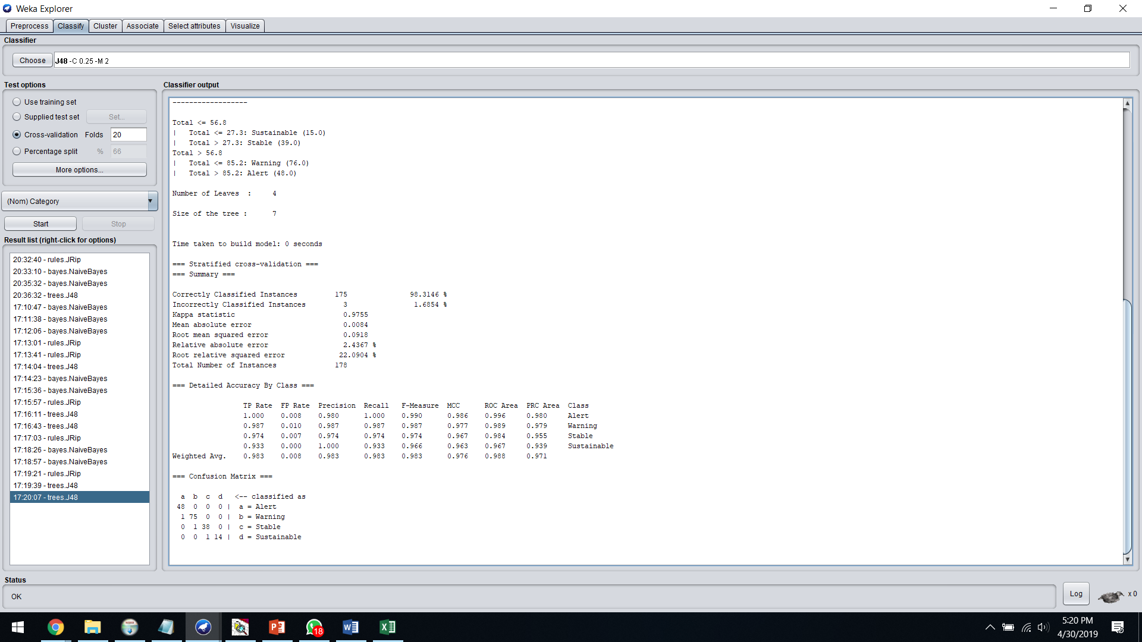

1. **JRip**

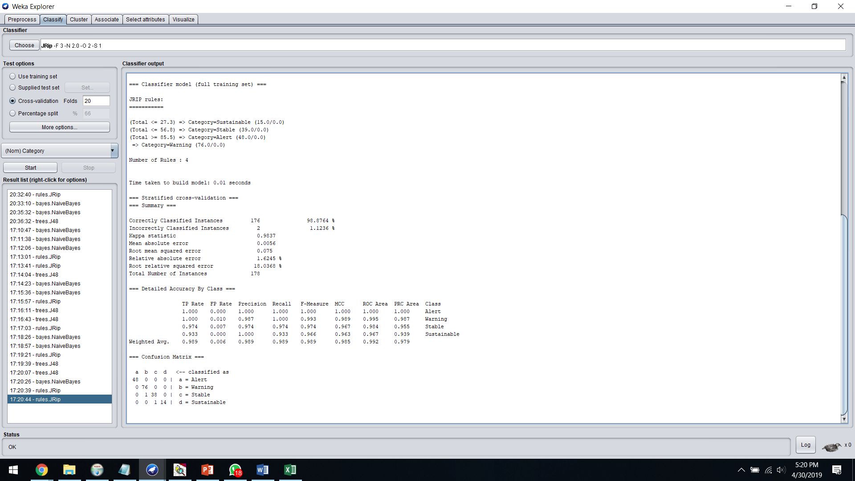

1. **Generation of Action Rules using LISP Miner**

**Attributes:**

We​ ​have​ ​classified​ ​our​ ​attributes​ ​into​ ​3​ ​categories​ ​–​ ​

1. Stable
2. Flexible​ ​
3. Decision​

**Stable​ ​Attributes​:**

​ ​ 1. Country

1. ​​Rank

​ ​ 3. Year

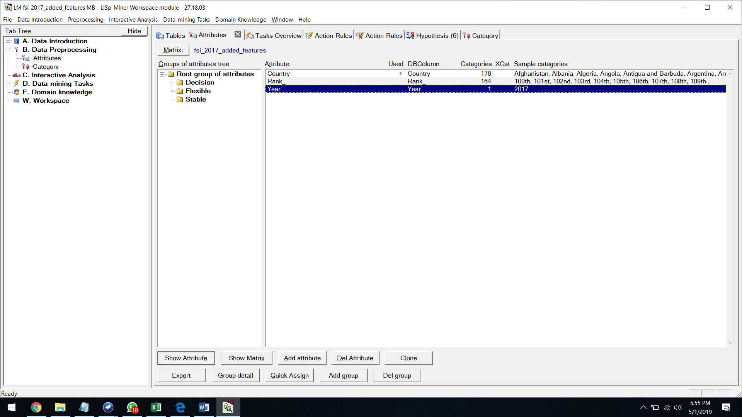

**Flexible​​ Attributes​ ​​:**

1. Homeless​ ​people​ ​due​ ​to​ ​natural​ ​disaster
2. Life expectancy at birth (years)
3. Public Services
4. Total unemployment rate (% of labour force)
5. External Intervention

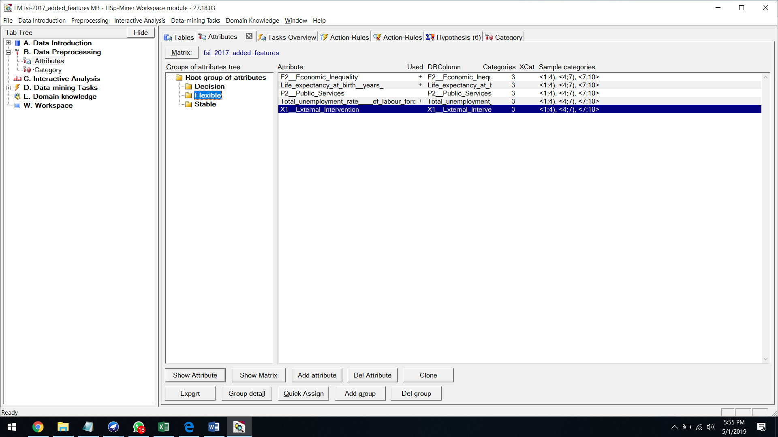

**​ Decision​ Attributes​​:**

Category

1. Sustainable
2. Stable
3. Warning
4. Alert

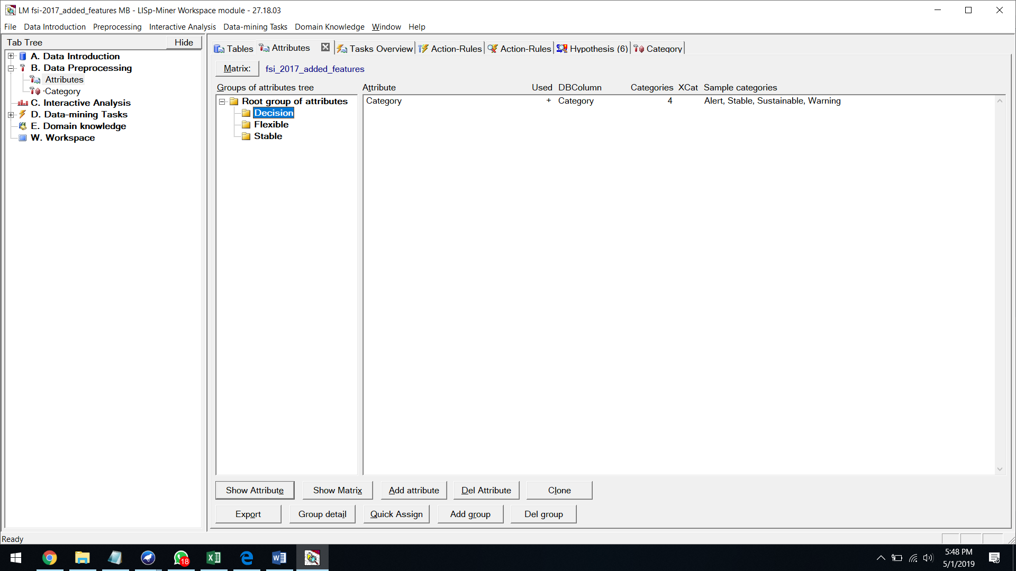

**Antecedent​ ​stable​ ​part​ ​:**

We​ ​assign​ ​all​ ​the​ ​stable​ ​attributes​ ​to​ ​this​ ​set.

**Antecedent​ ​variable​ ​part​ ​:**

We​ ​assign​ ​all​ ​the​ ​flexible​ ​attributes​ ​to​ ​this​ ​set.

**Succedent​ ​variable​ ​part​ ​:**

We​ ​assign​ ​the​ ​decision​ ​variable​ ​to​ ​this​ ​set.

Attribute​ ​type​ ​=​ ​Nominal

Coefficient​ ​type​ ​=​ ​One​ Category

**Quantifiers​ ​:**

a(BASE)Before​ ​:​ ​5

a(BASE)After​ ​:​ ​5

**ACTION​ ​RULES​ ​FOR​ ​2016​ ​:  [Alert to Sustainable]**

First​ ​we​ ​set​ ​the​ ​decision​ ​attribute​ ​as​ ​alert​ ​to​ ​Sustainable

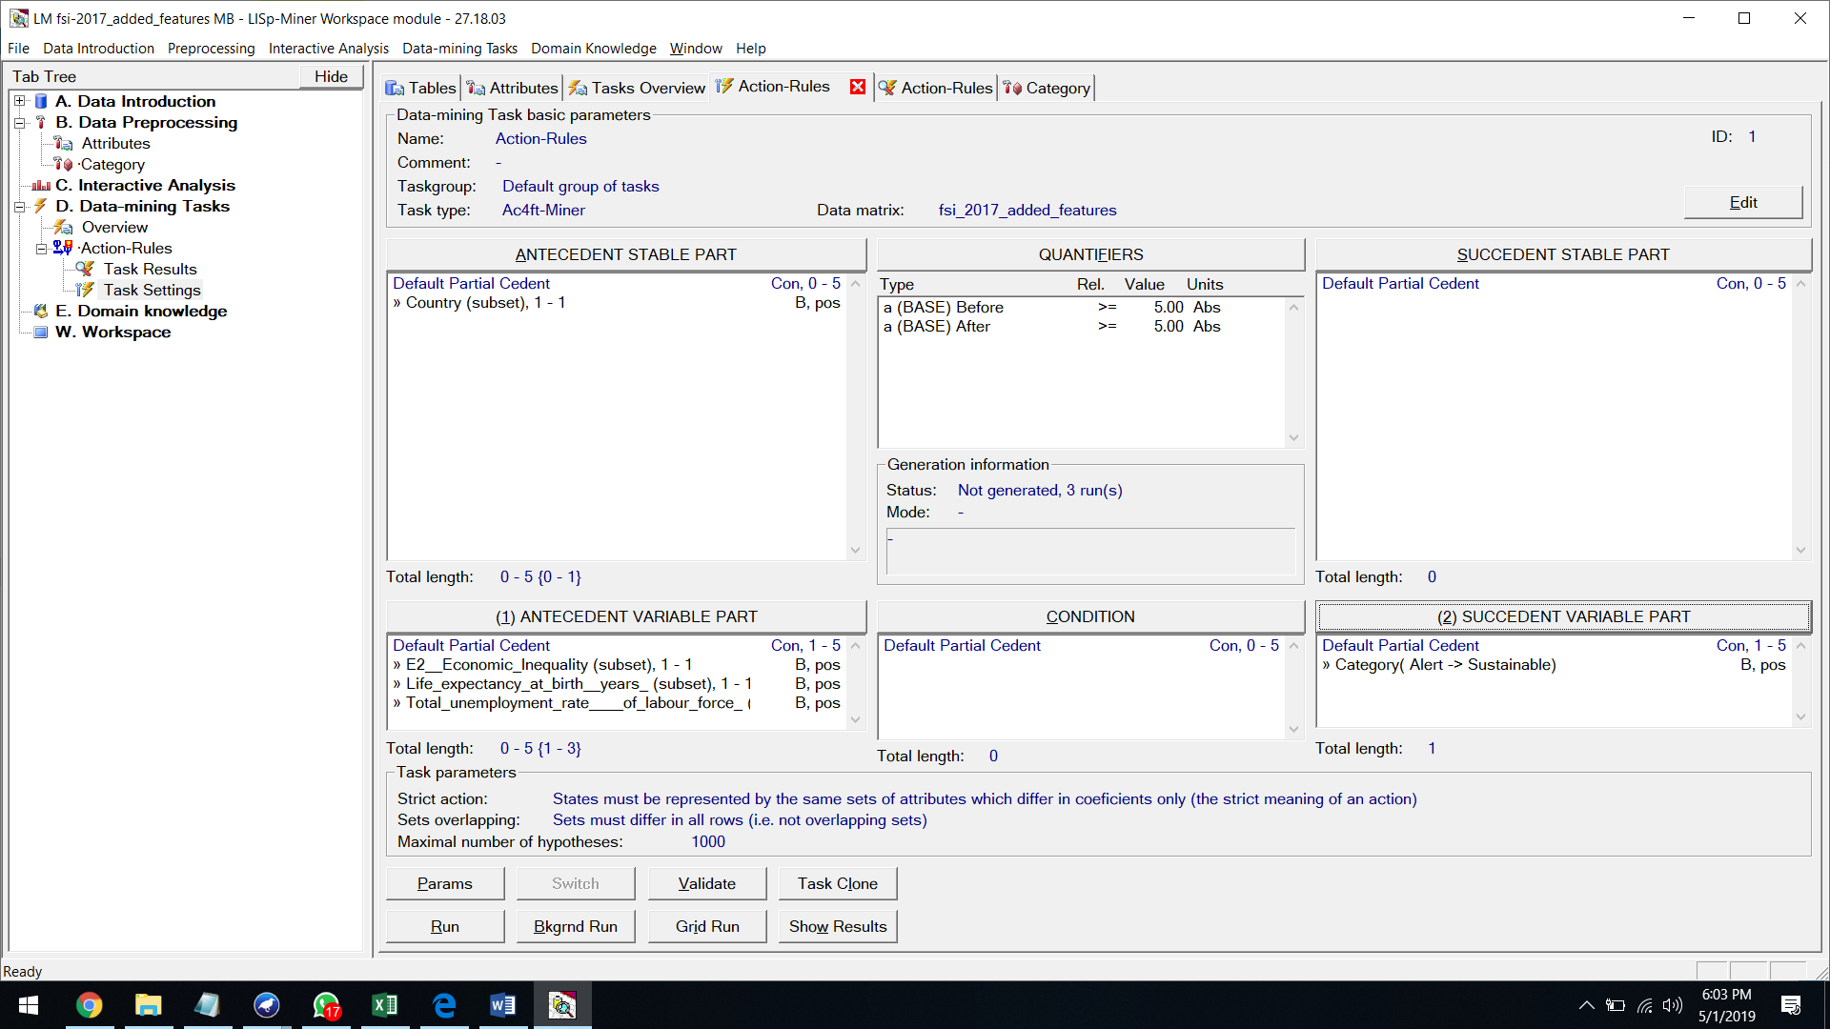

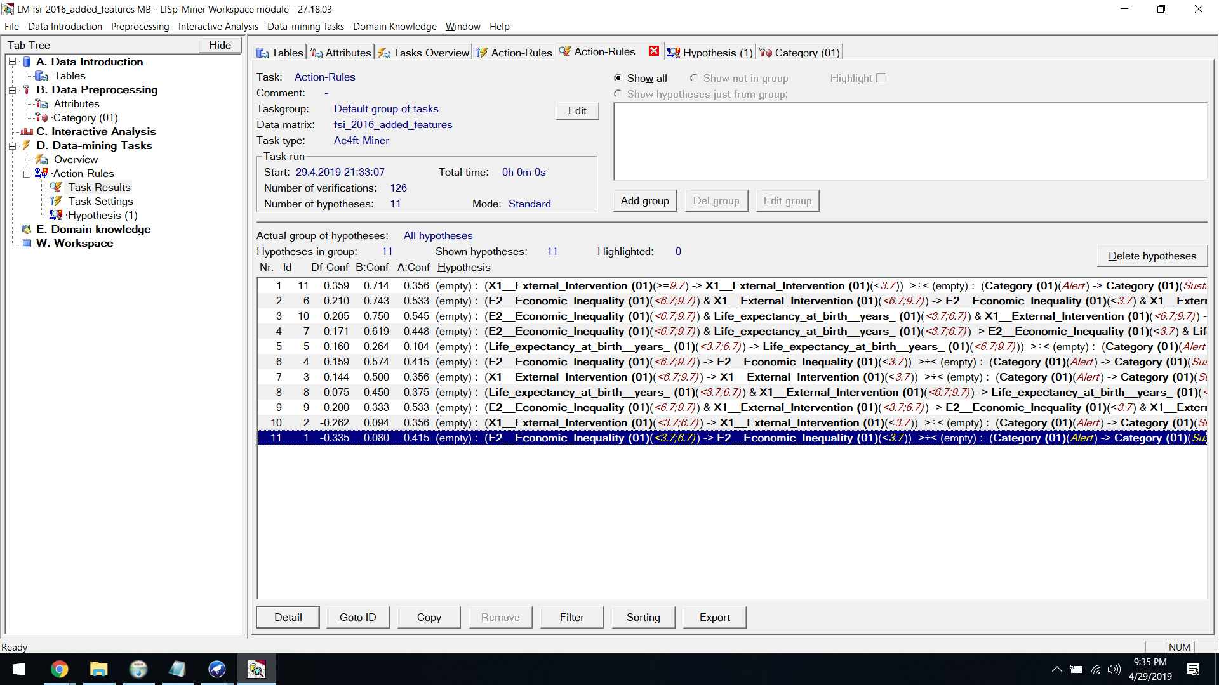

**Hypothesis:**

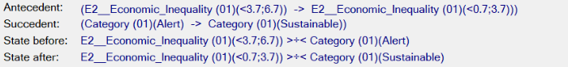

**State Before:**

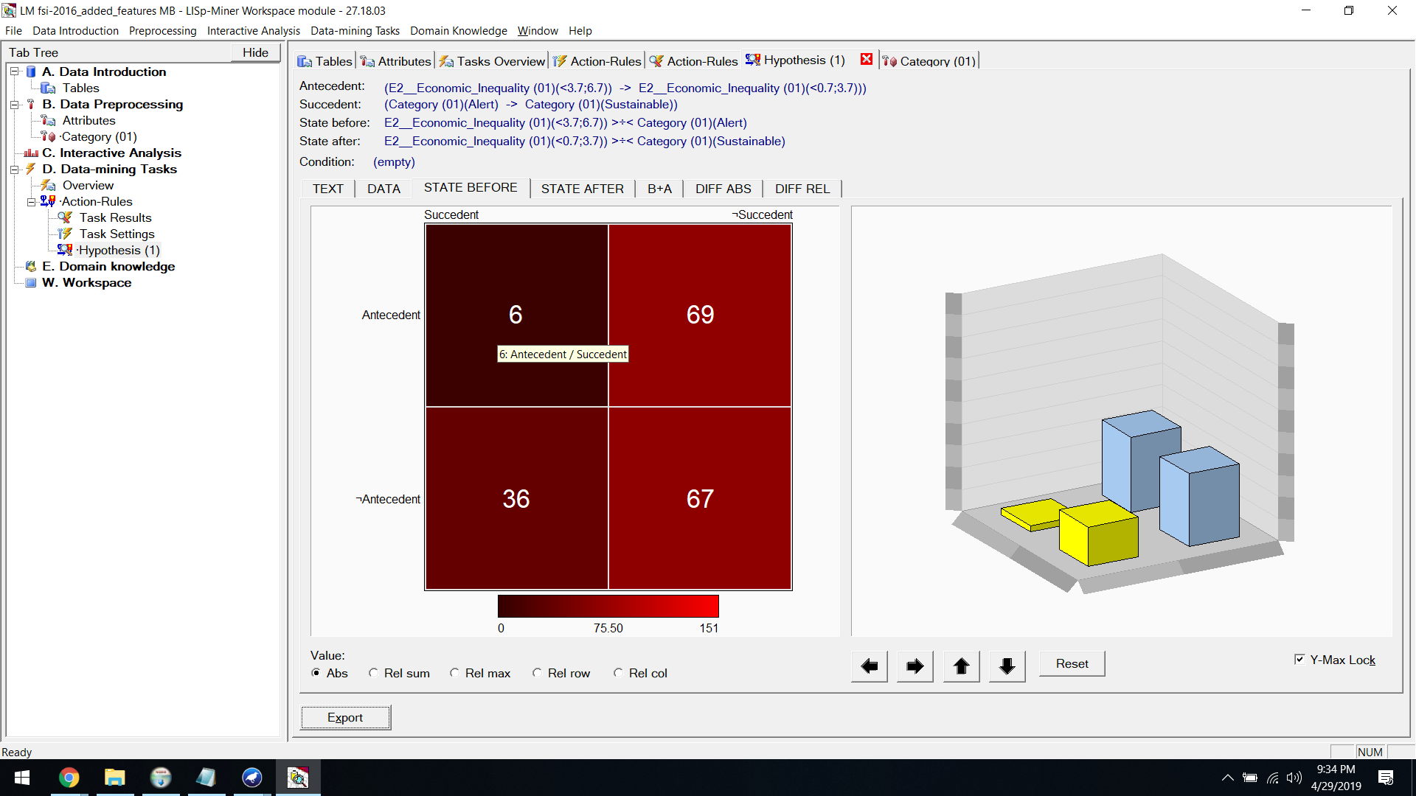

**State After:**

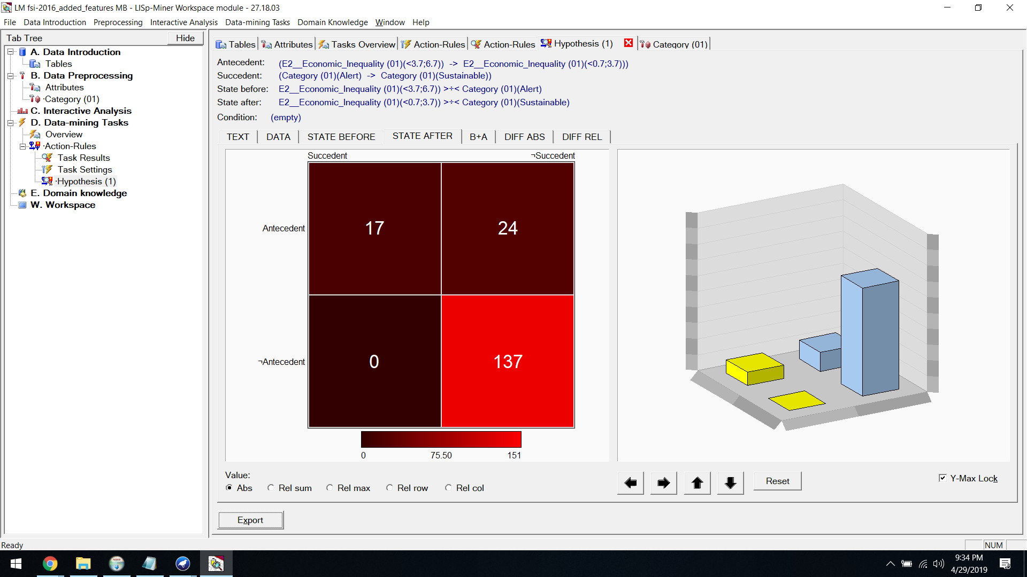

**B+A:**

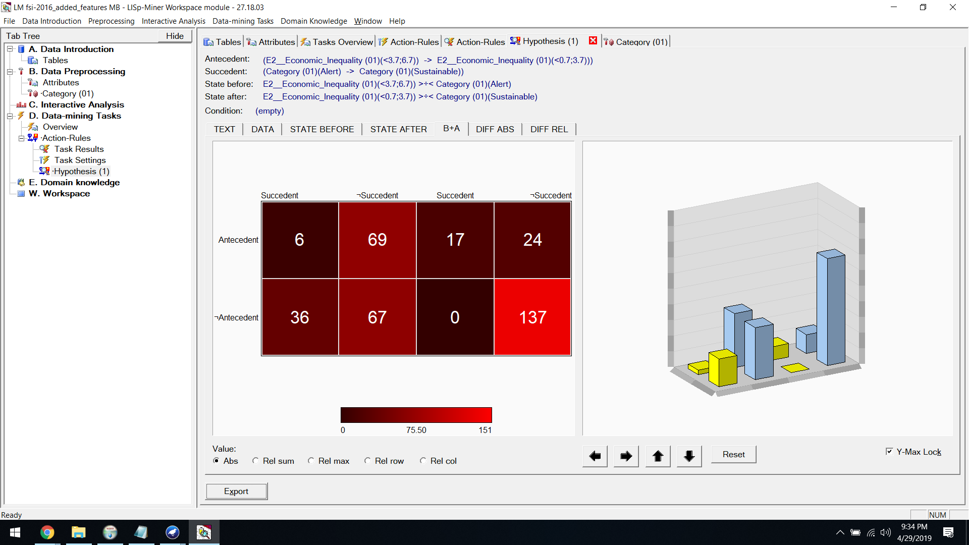

**Diff Abs:**

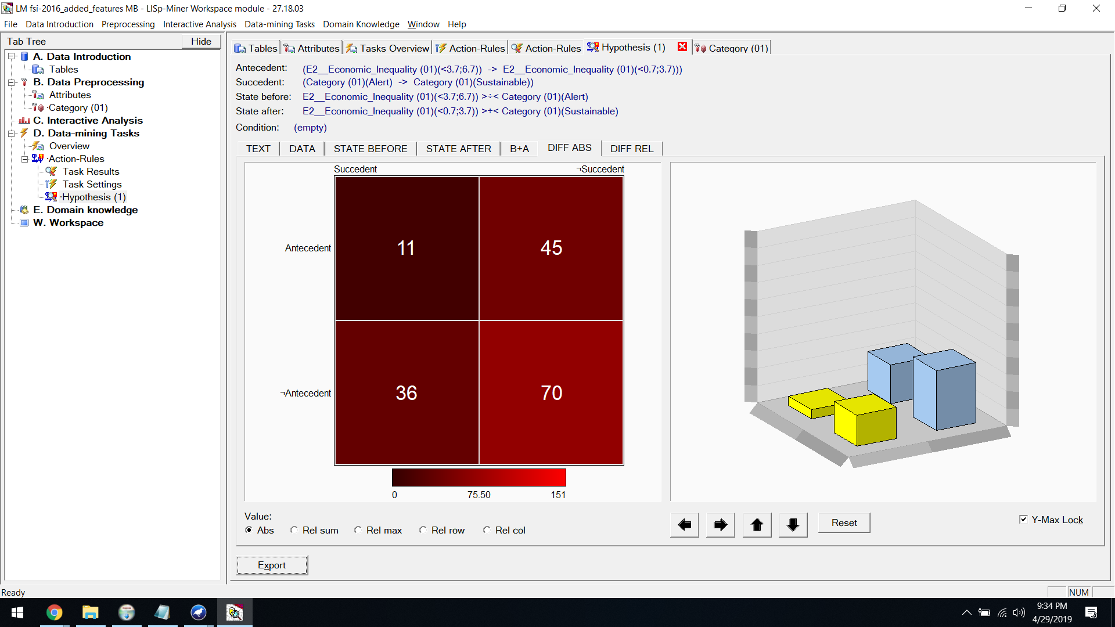

**Diff Rel:**

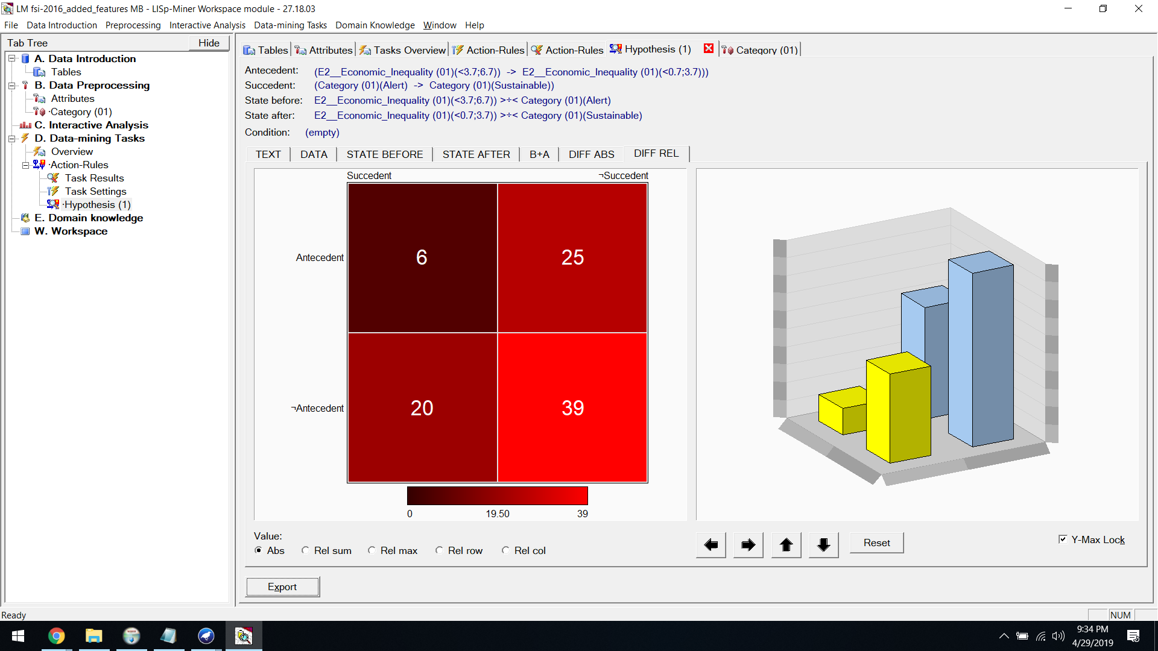

**ACTION​ ​RULES​ ​FOR​ ​2016 ​:  [Alert to Stable]**

Then we​ ​set​ ​the​ ​decision​ ​attribute​ ​as​ ​Alert​ ​to​ ​Stable

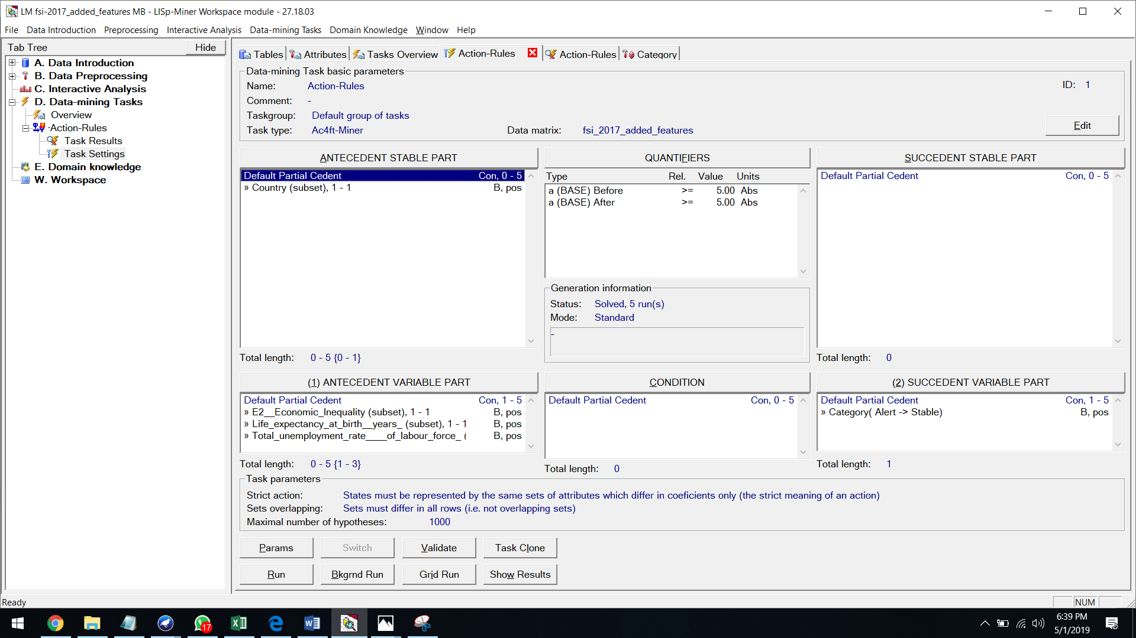

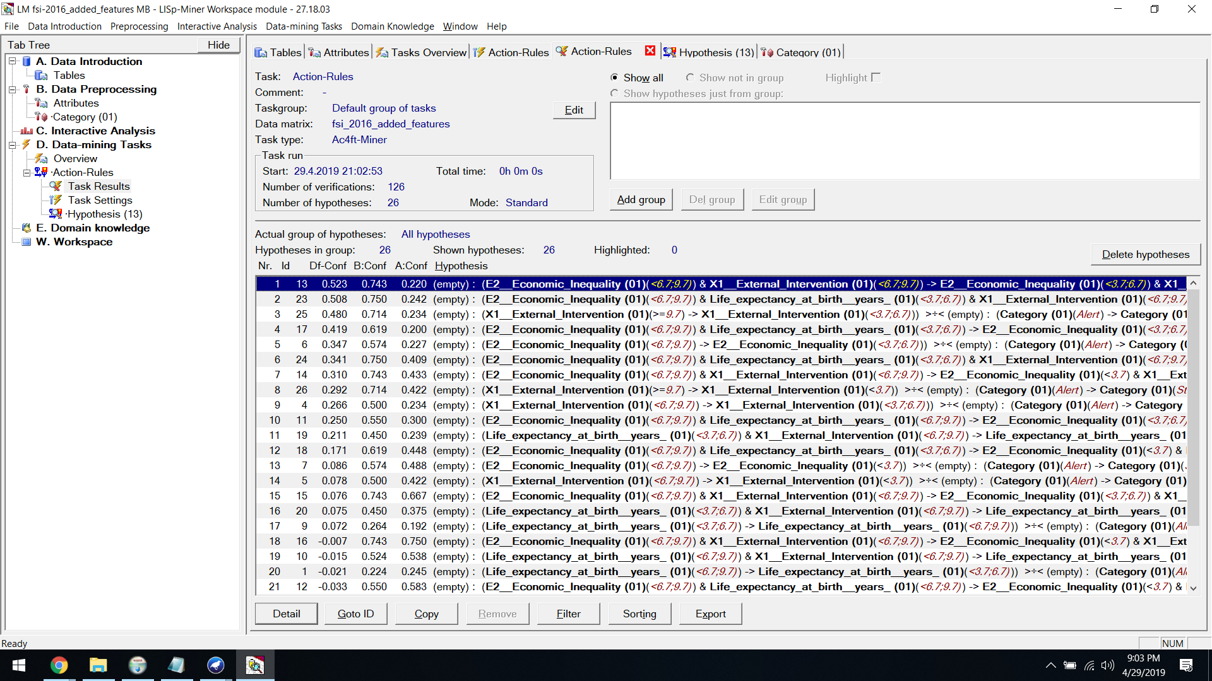

**Hypothesis:**



**State Before:**

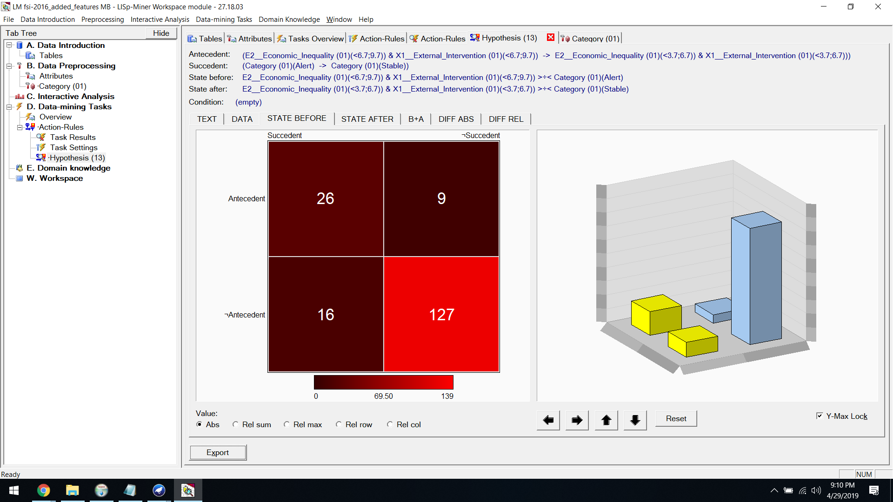

**State After:**

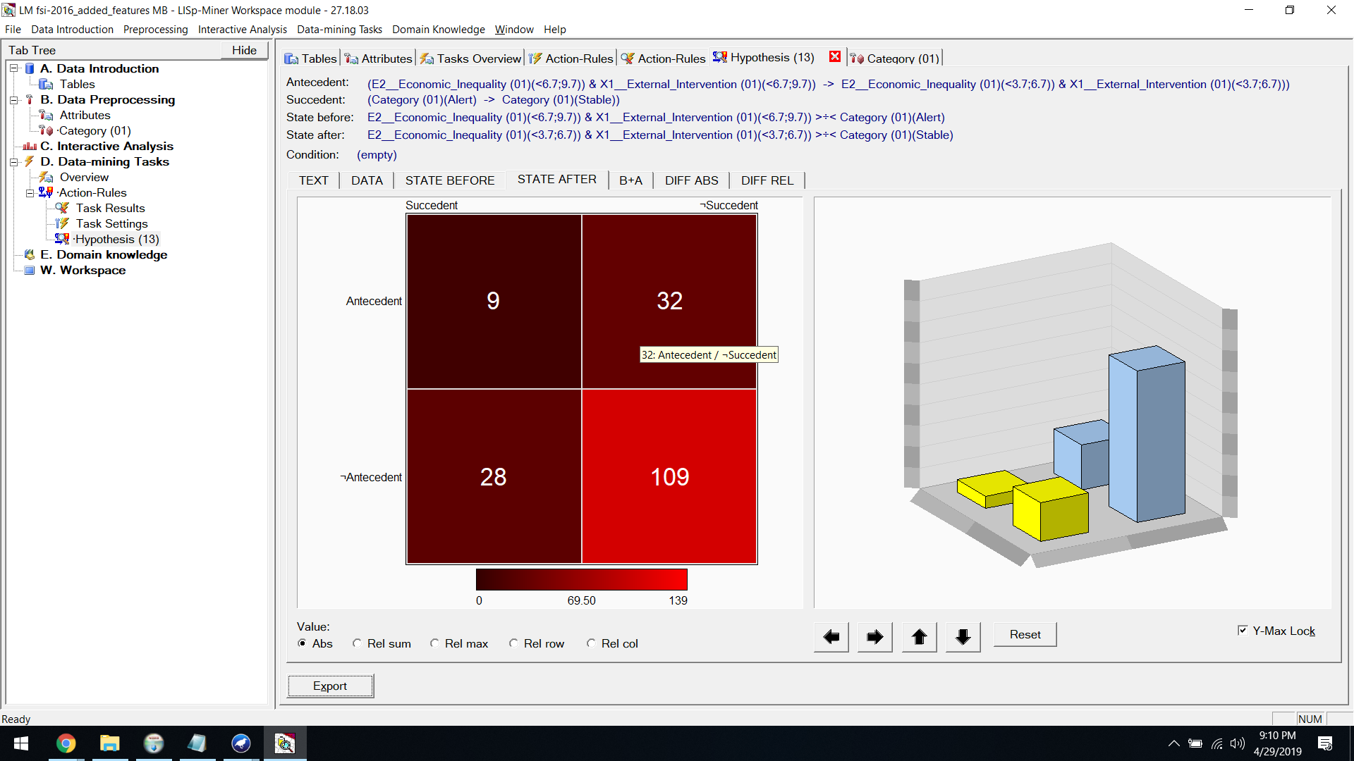

**B+A:**

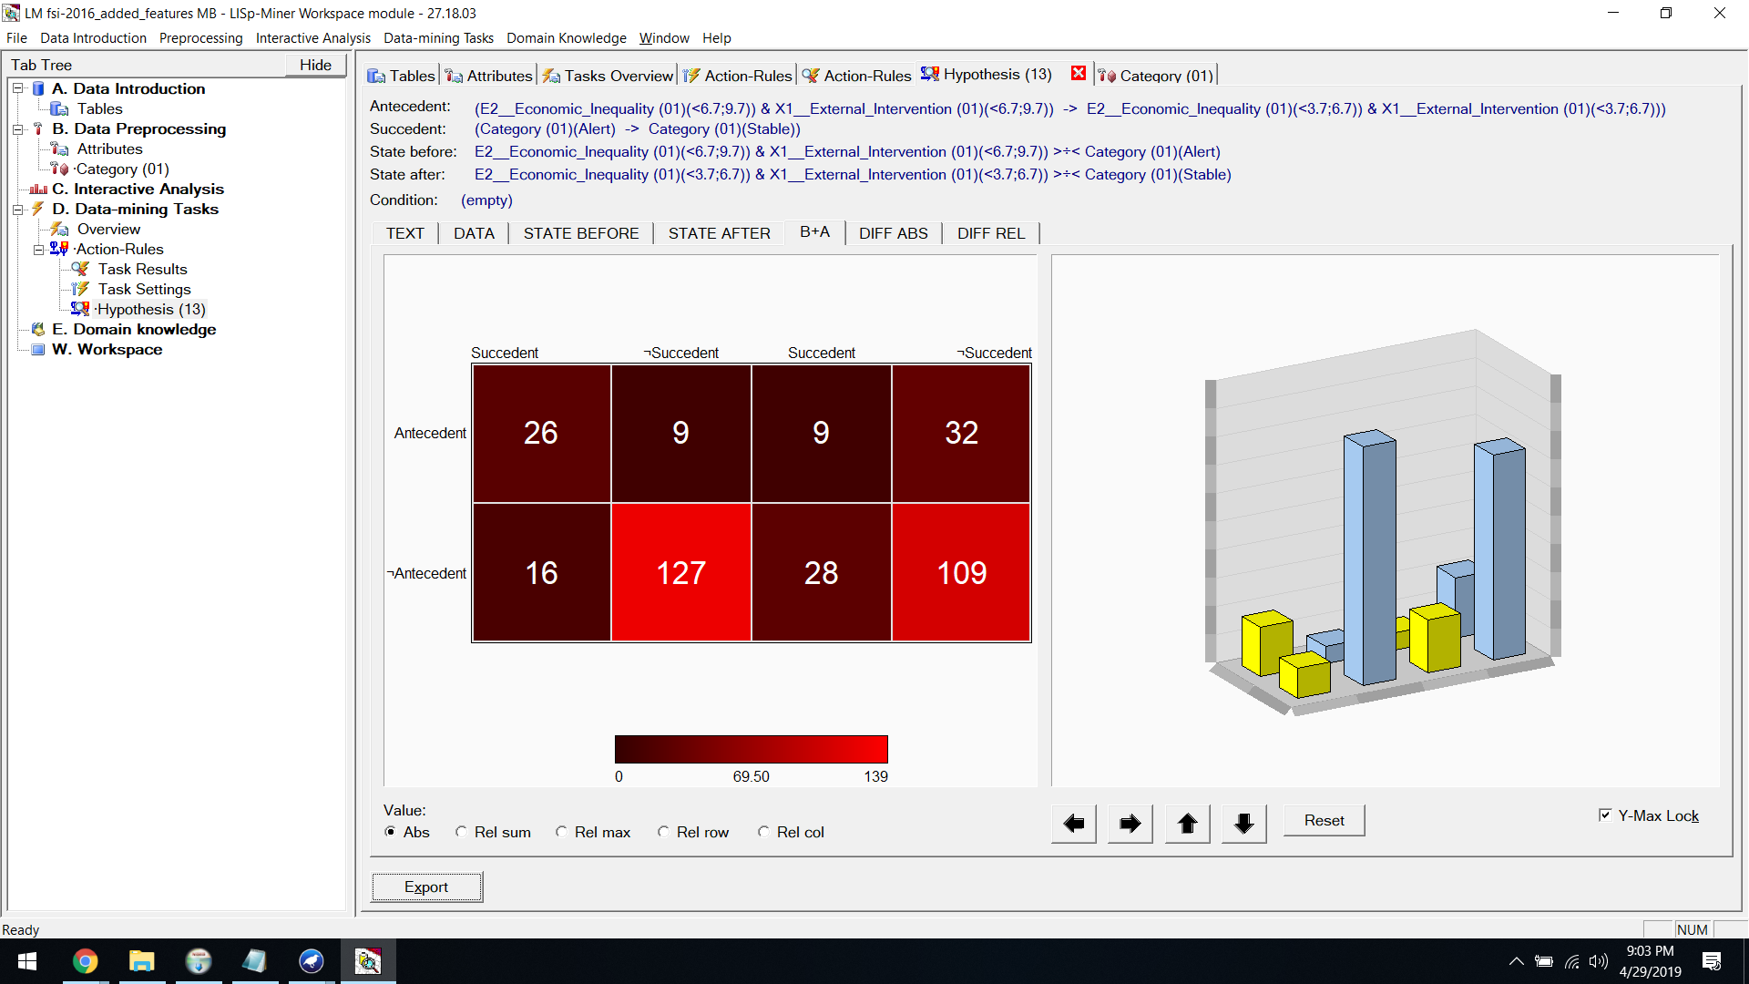

**Diff Abs:**

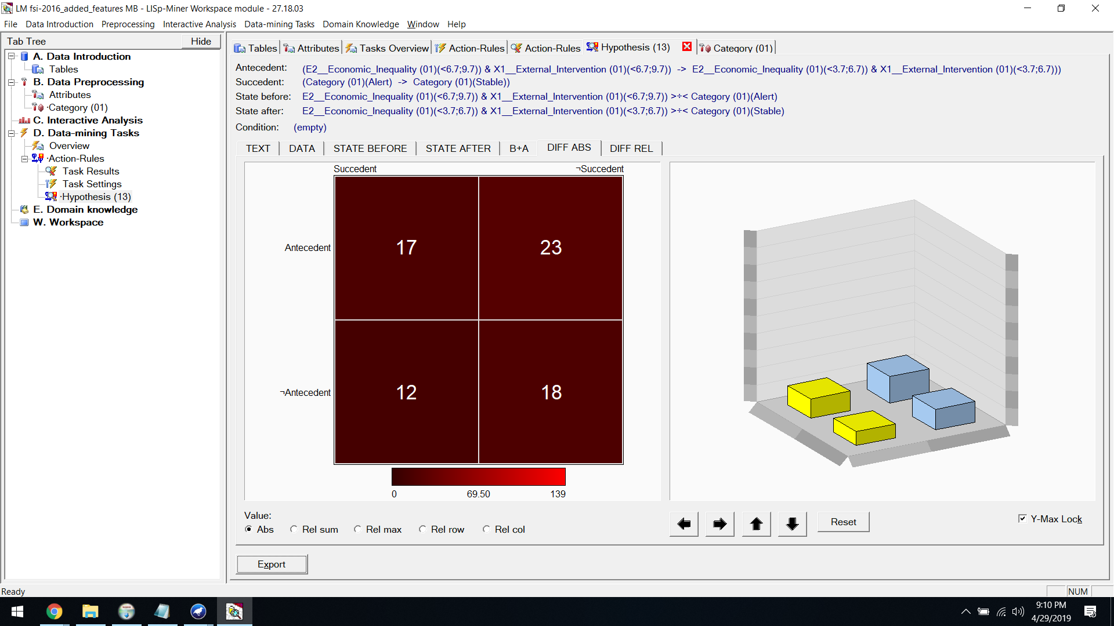

**Diff Rel:**

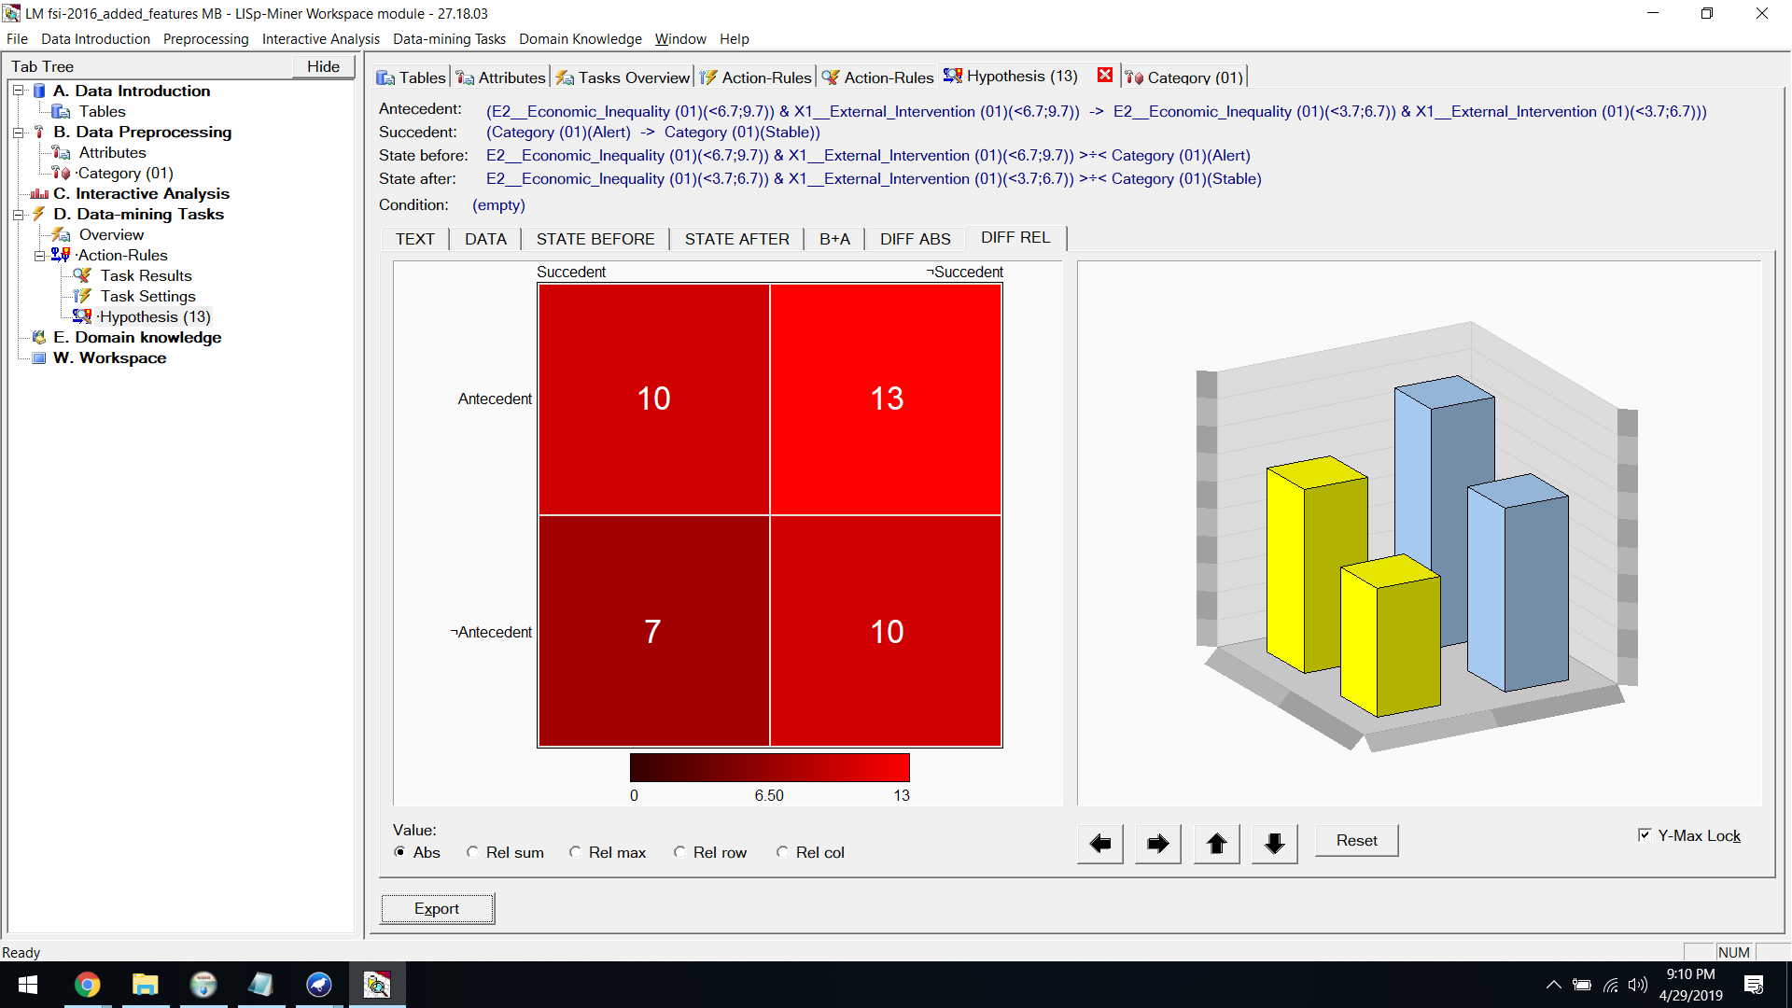

**ACTION​ ​RULES​ ​FOR​ ​2016 ​:  [Stable to Sustainable]**

Finally we​ ​set​ ​the​ ​decision​ ​attribute​ ​as​​ ​Stable to Sustainable

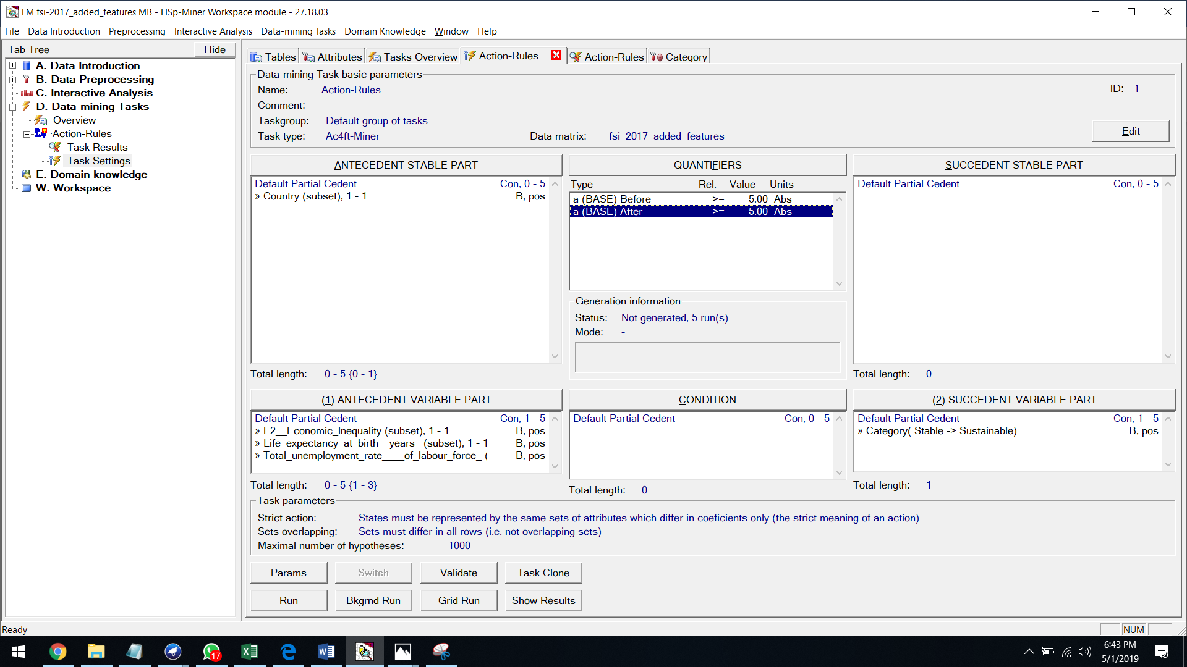

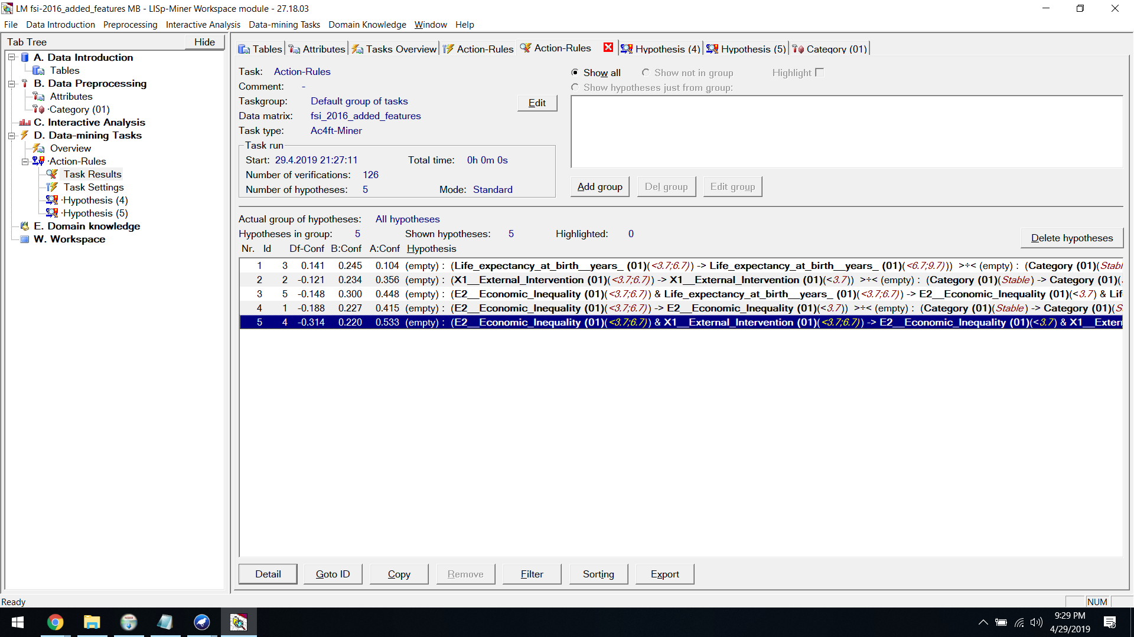

**Hypothesis:**



**State Before:**

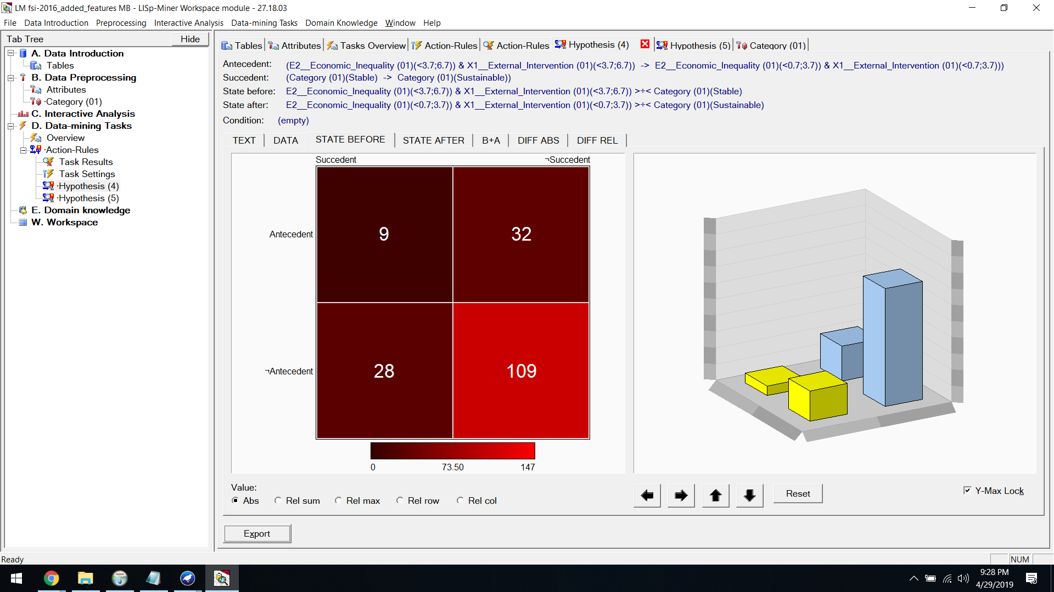

**State After:**

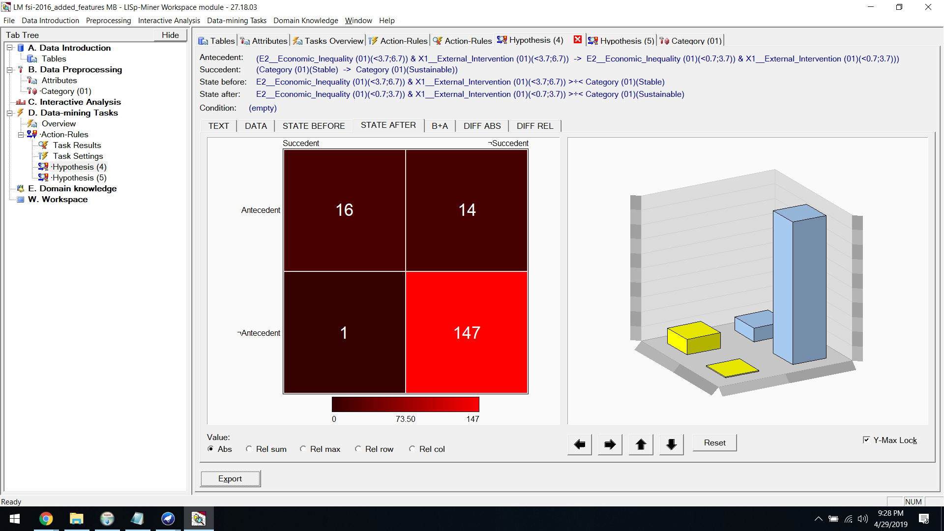

**B+A:**

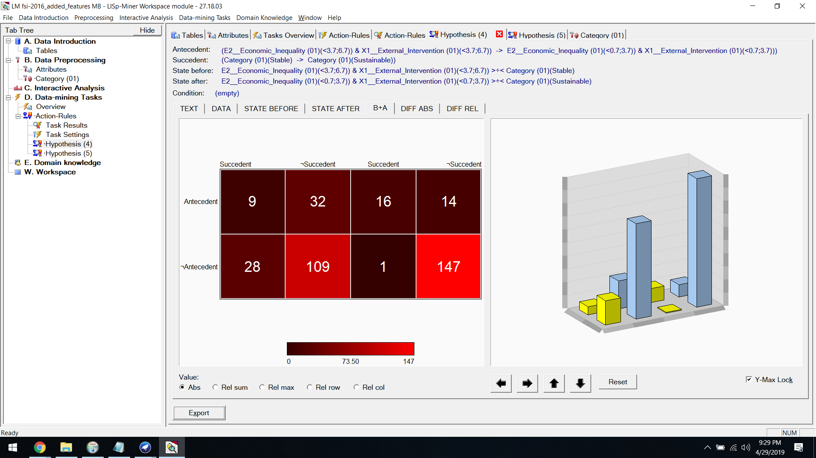

**Diff Abs:**

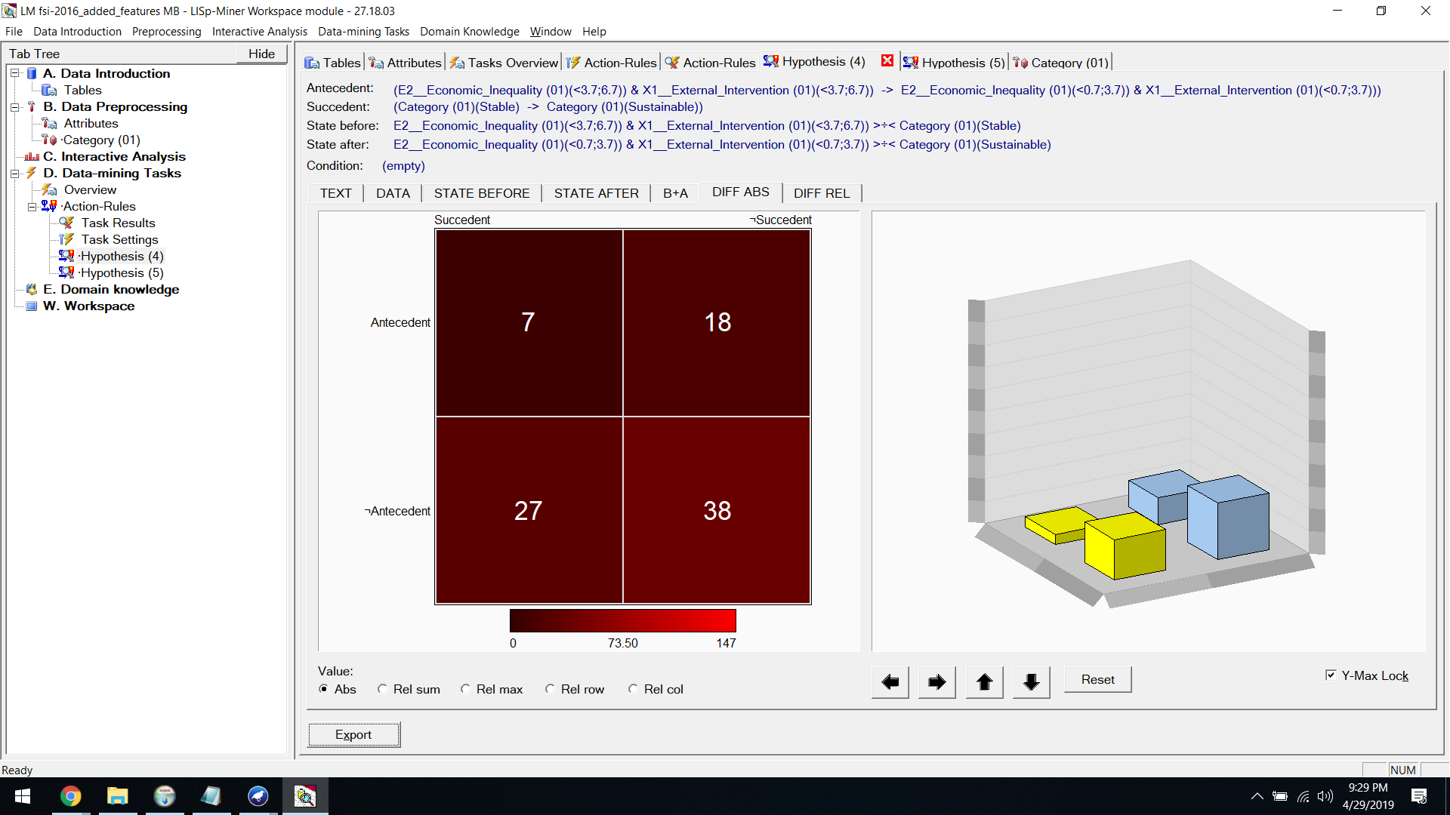

**Diff Rel:**

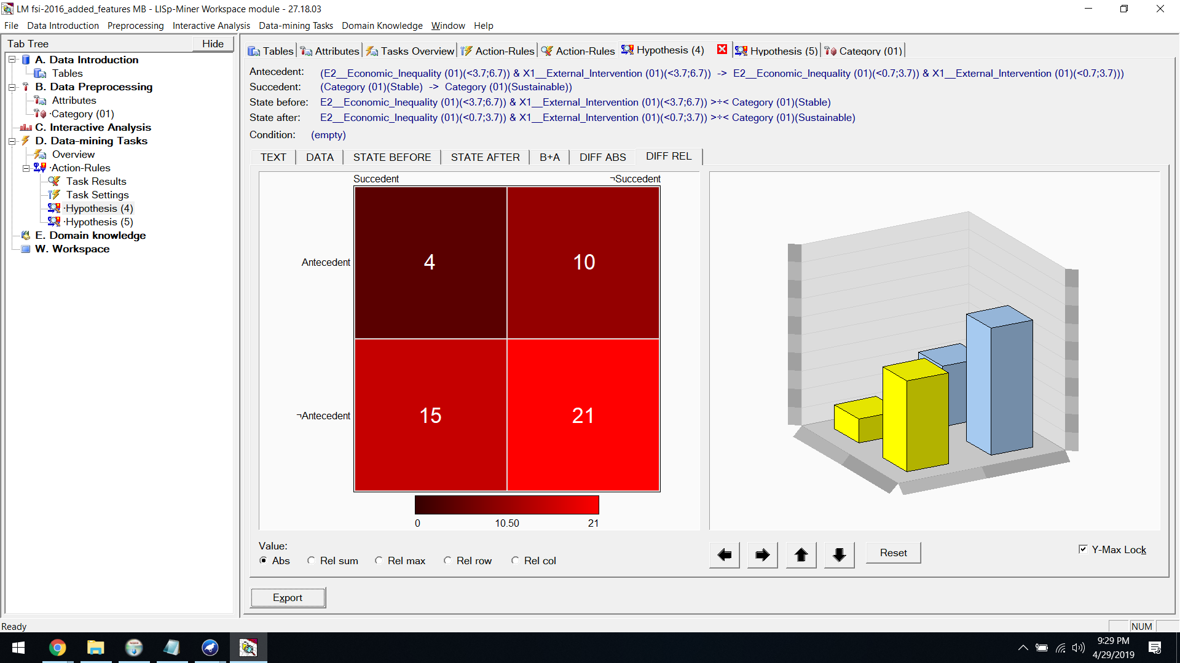

**ACTION​ ​RULES​ ​FOR​ ​2017 ​:  [Alert to Sustainable]**

First we​ ​set​ ​the​ ​decision​ ​attribute​ ​as​ ​Alert​ ​to​ ​Sustainable



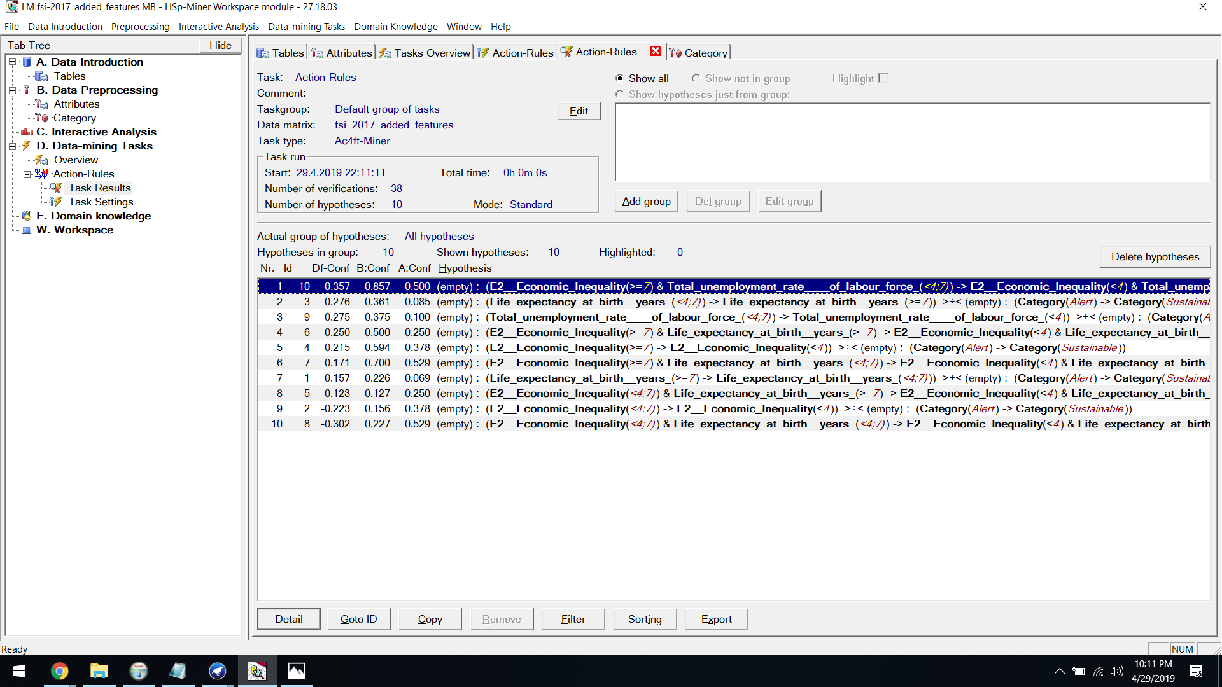

**Hypothesis:**



**State Before:**

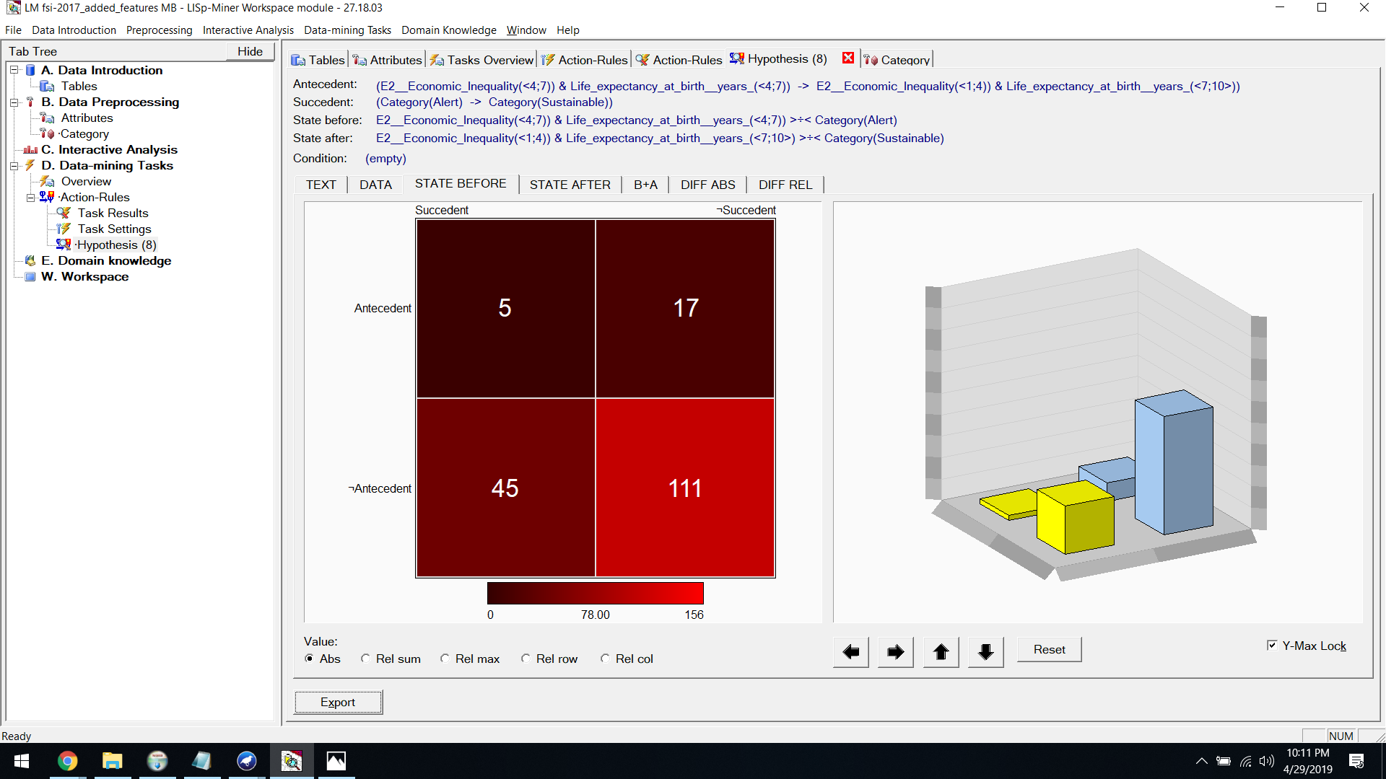

**State After:**

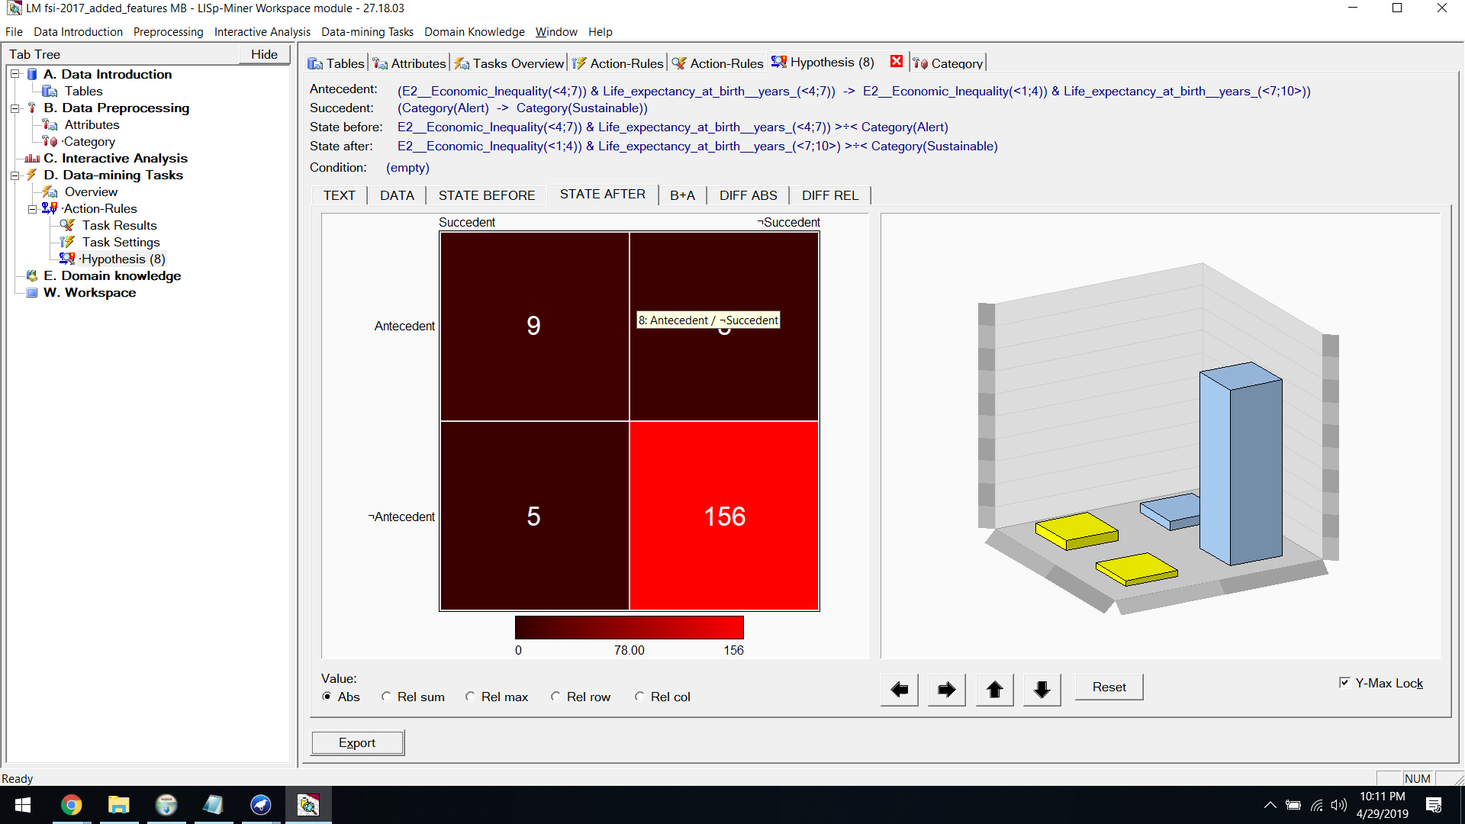

**B+A:**

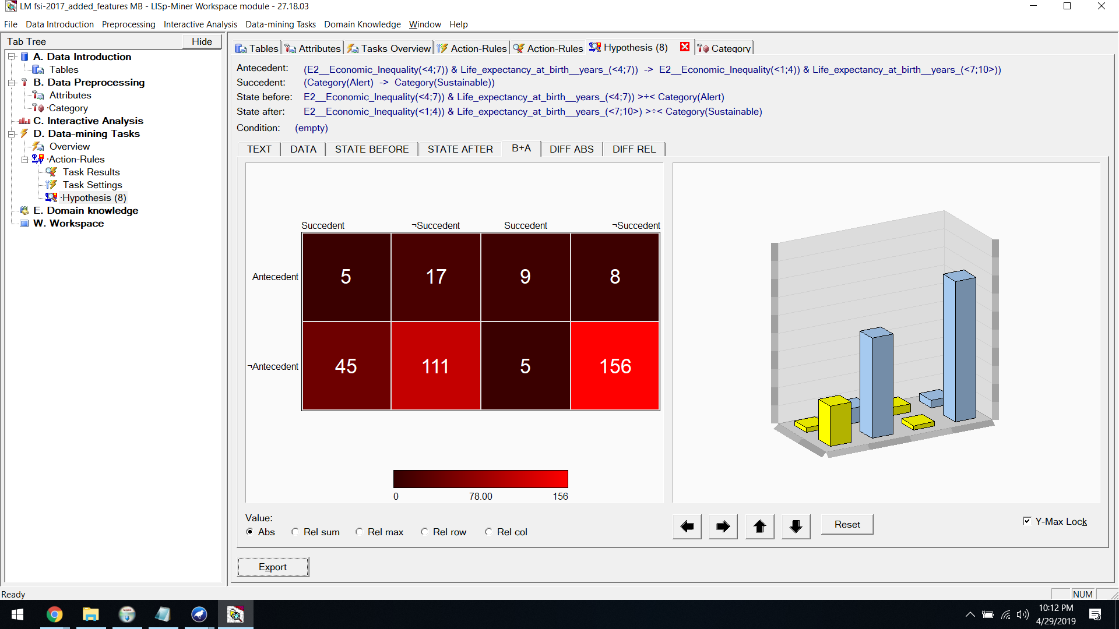

**Diff Abs:**

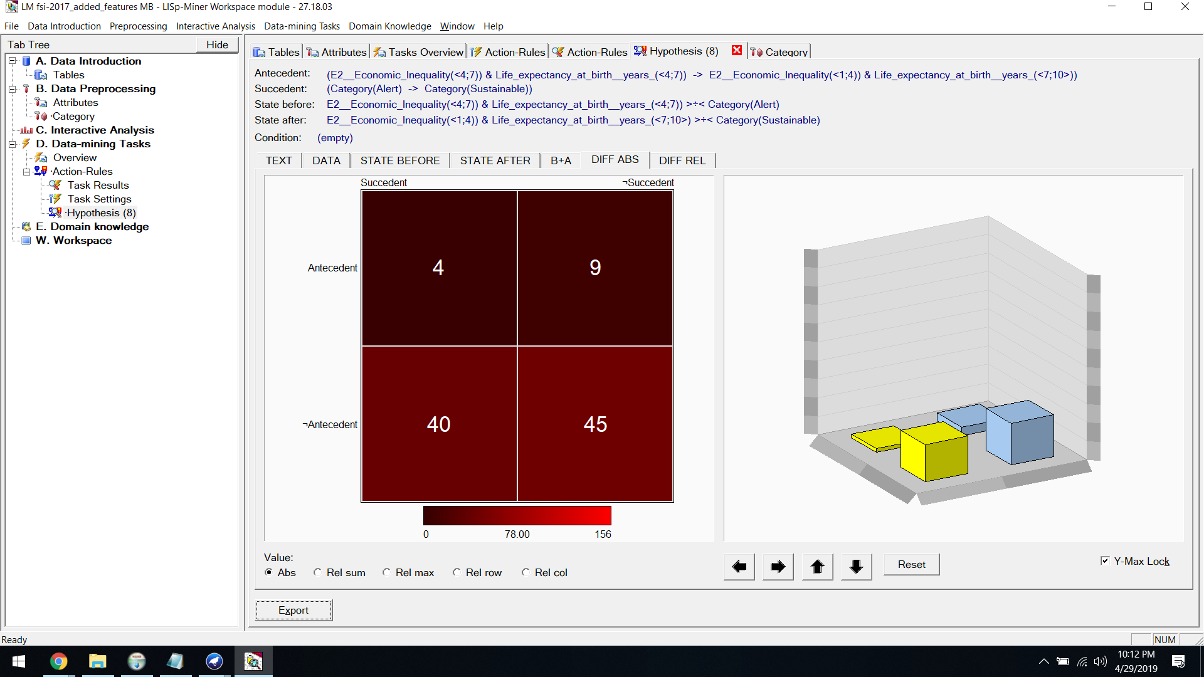

**Diff Rel:**

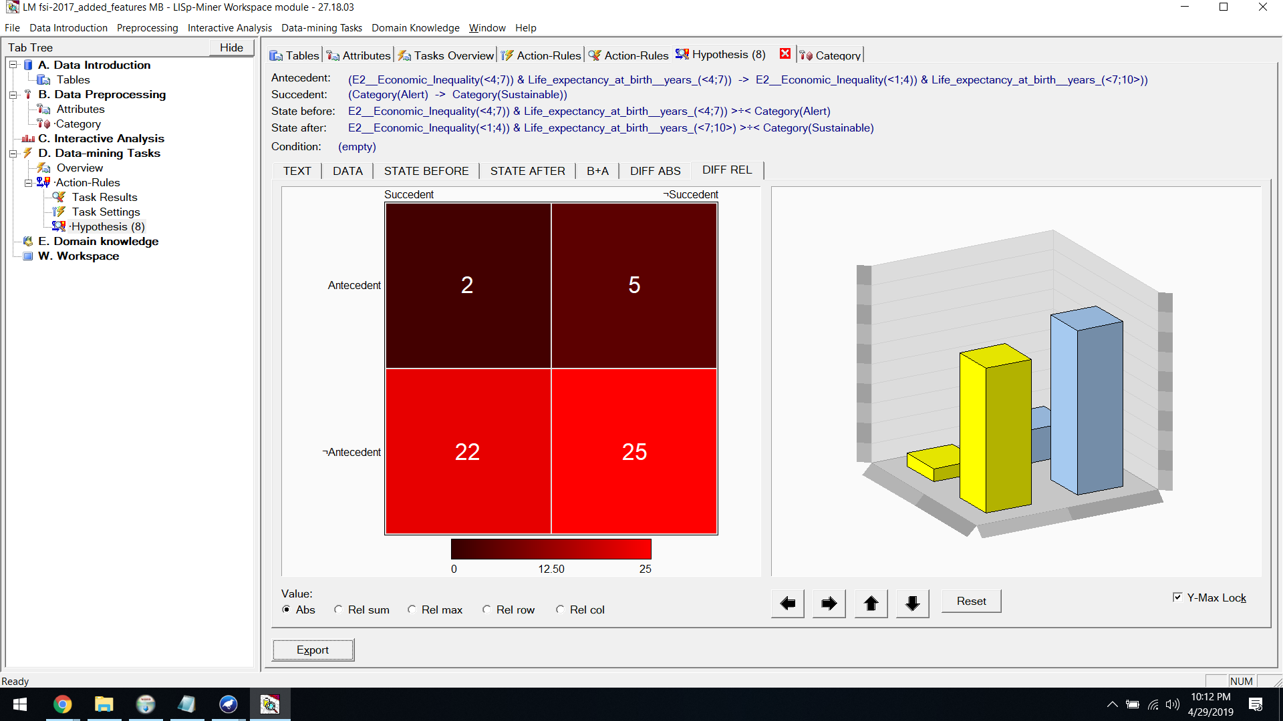

**ACTION​ ​RULES​ ​FOR​ ​2017 ​:  [Stable to Sustainable]**

Then we​ ​set​ ​the​ ​decision​ ​attribute​ ​as​ ​Stable​ ​to​ ​Sustainable



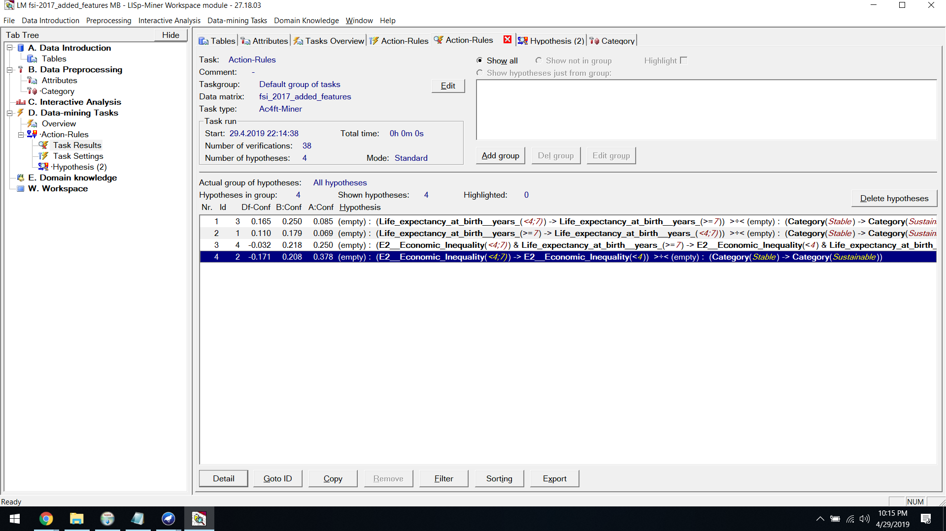

**Hypothesis:**

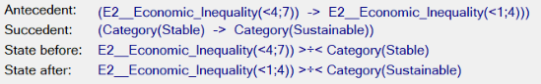

**State Before:**

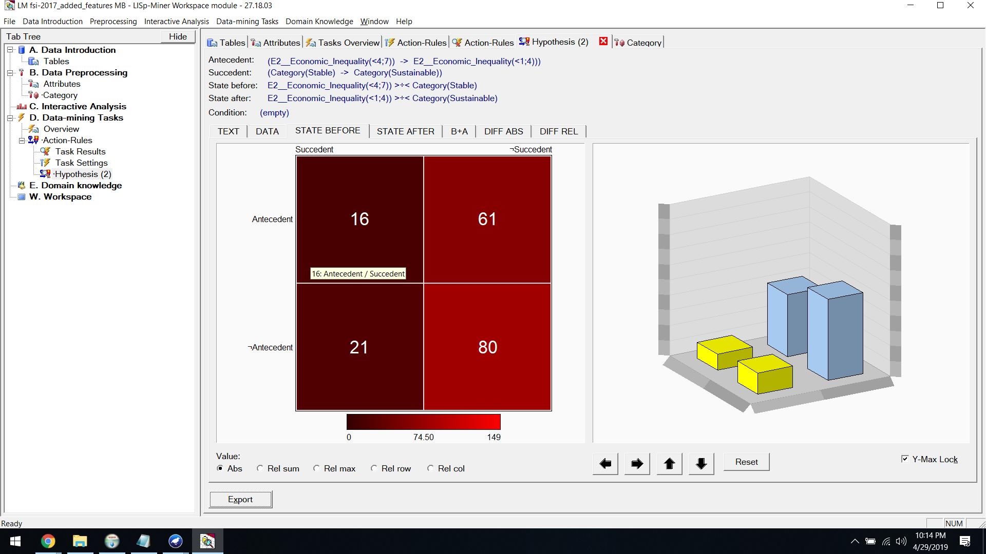

**State After:**

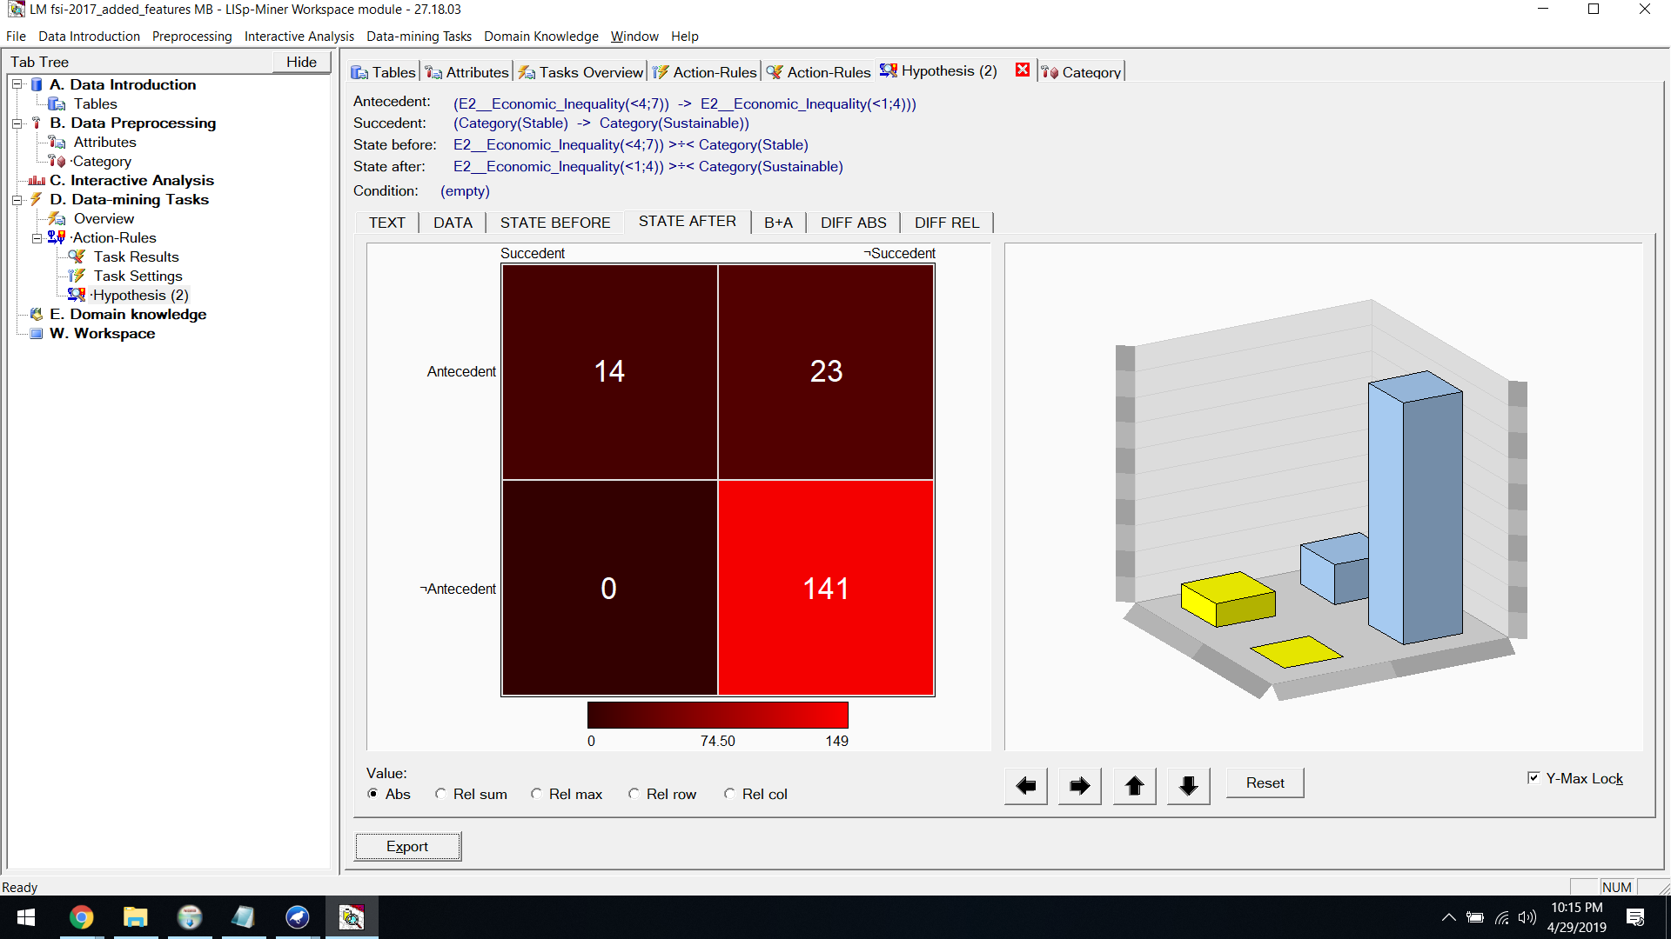

**B+A:**

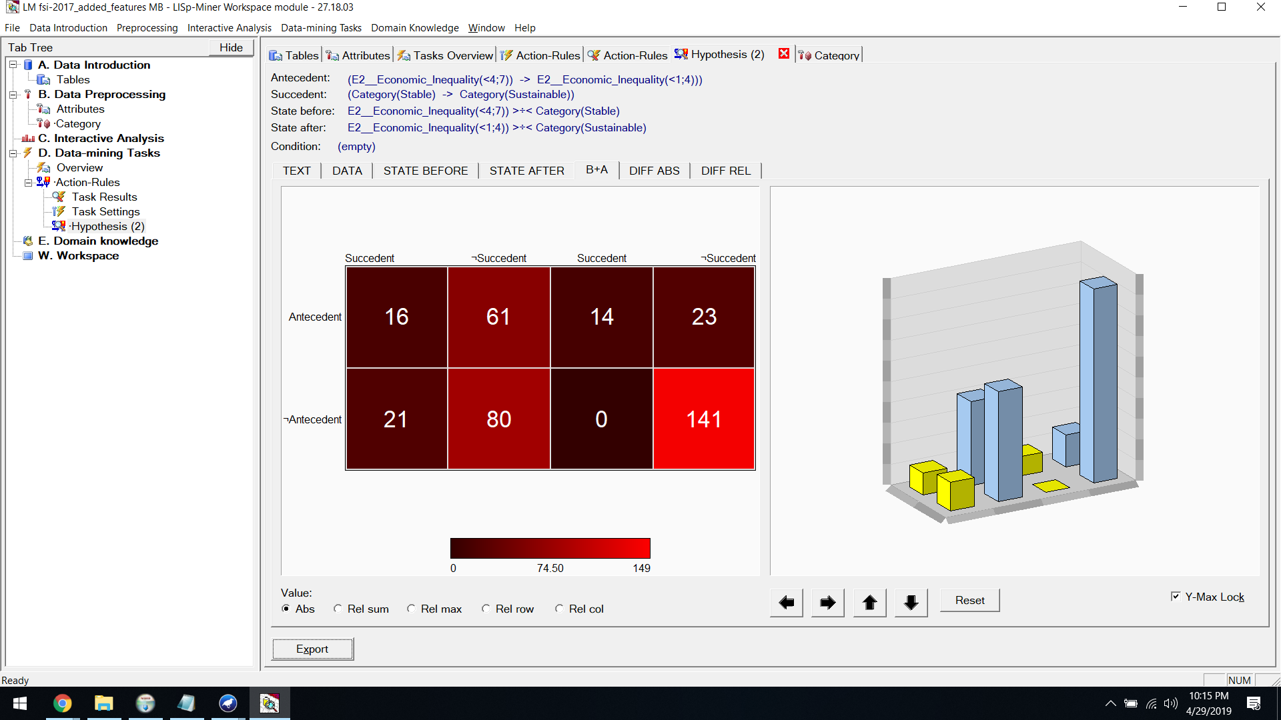

**Diff Abs:**

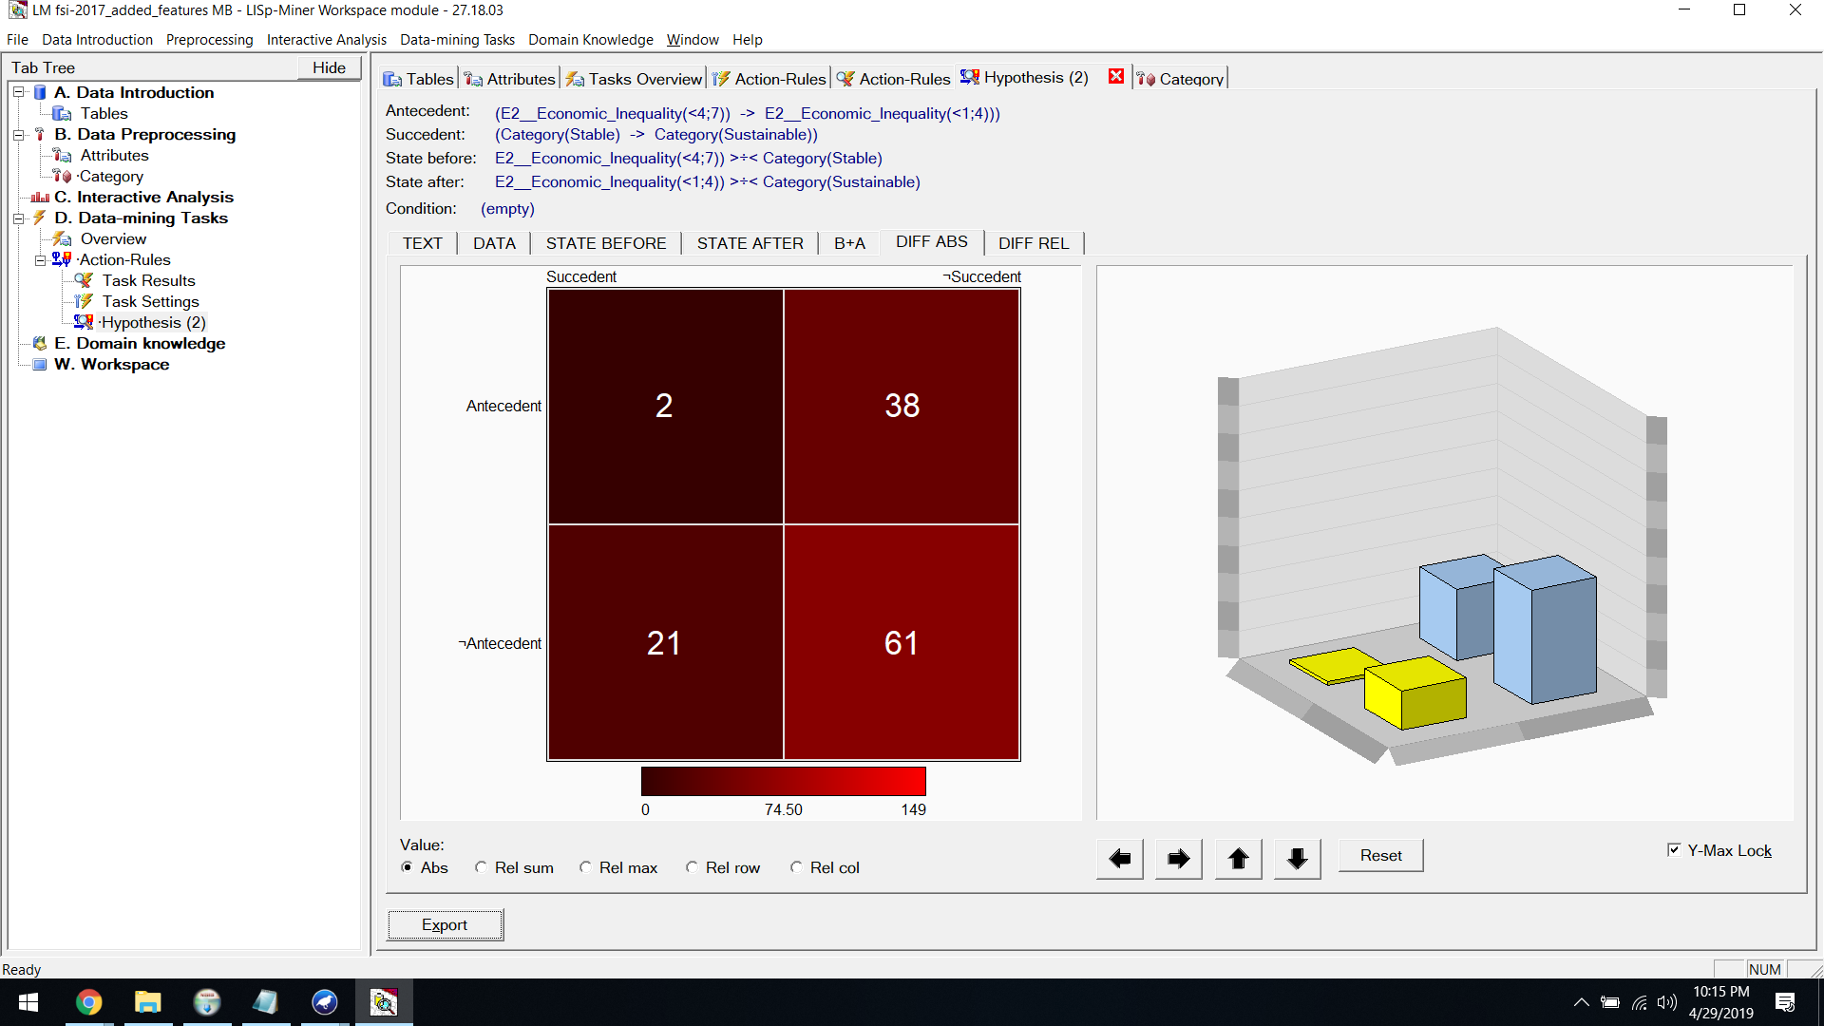

**Diff Rel:**

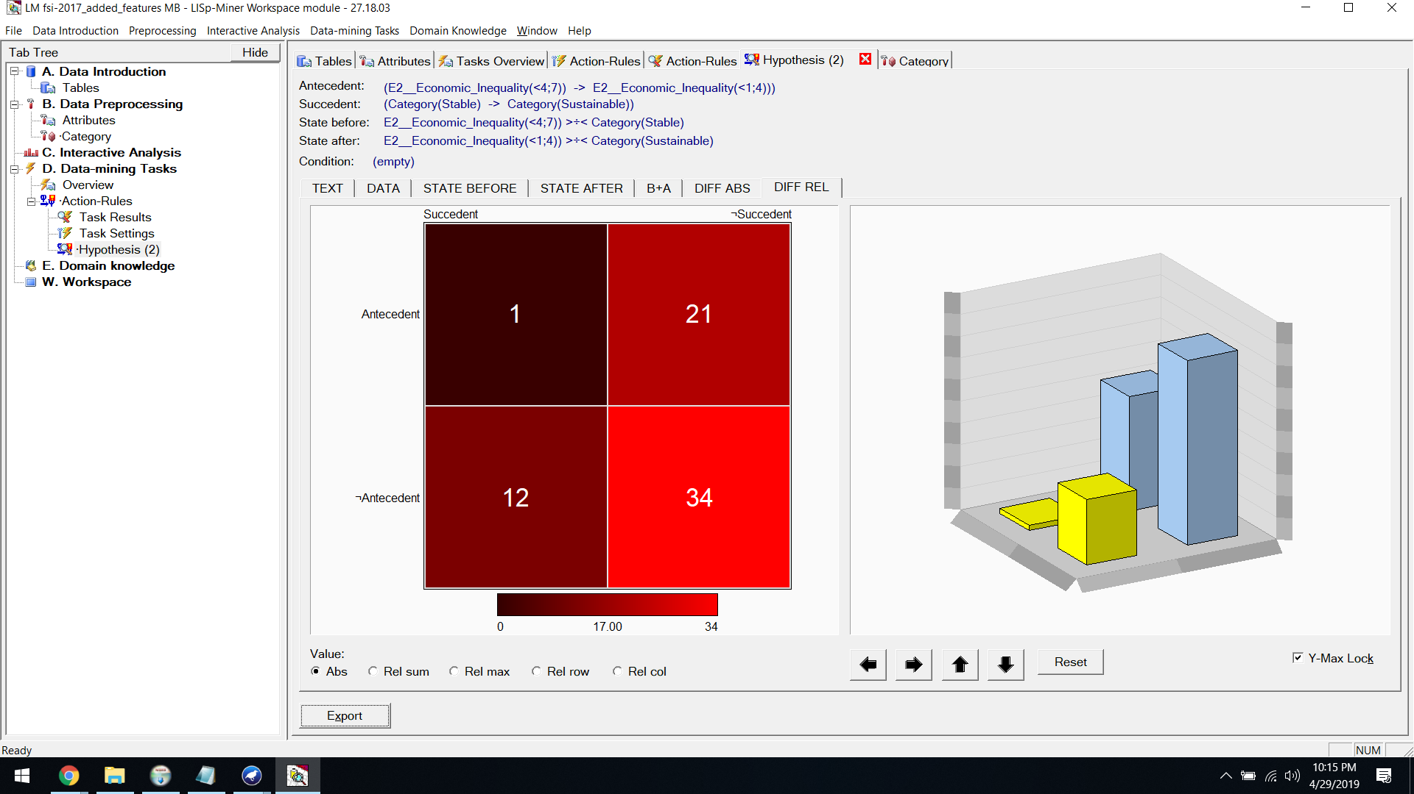

**ACTION​ ​RULES​ ​FOR​ ​2017 ​:  [Alert to Stable]**

Finally we​ ​set​ ​the​ ​decision​ ​attribute​ ​as​ ​Alert​ ​to​ ​Stable



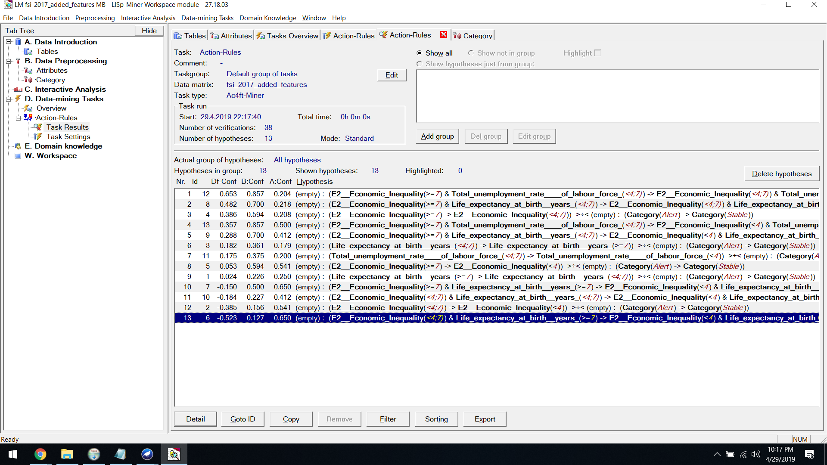

**Hypothesis:**



**State Before:**

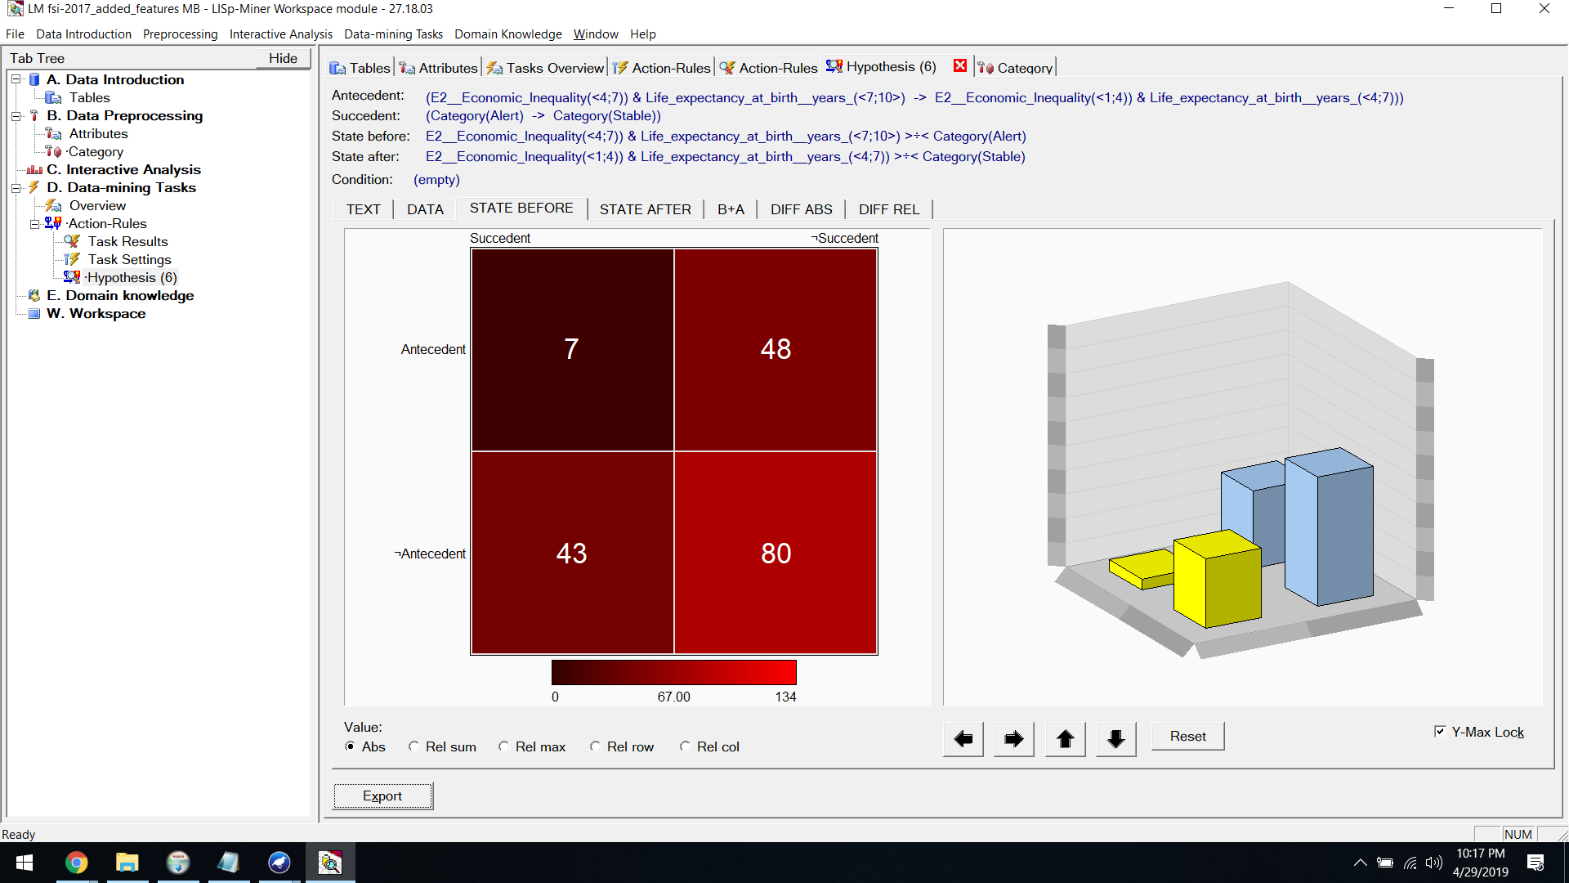

**State After:**

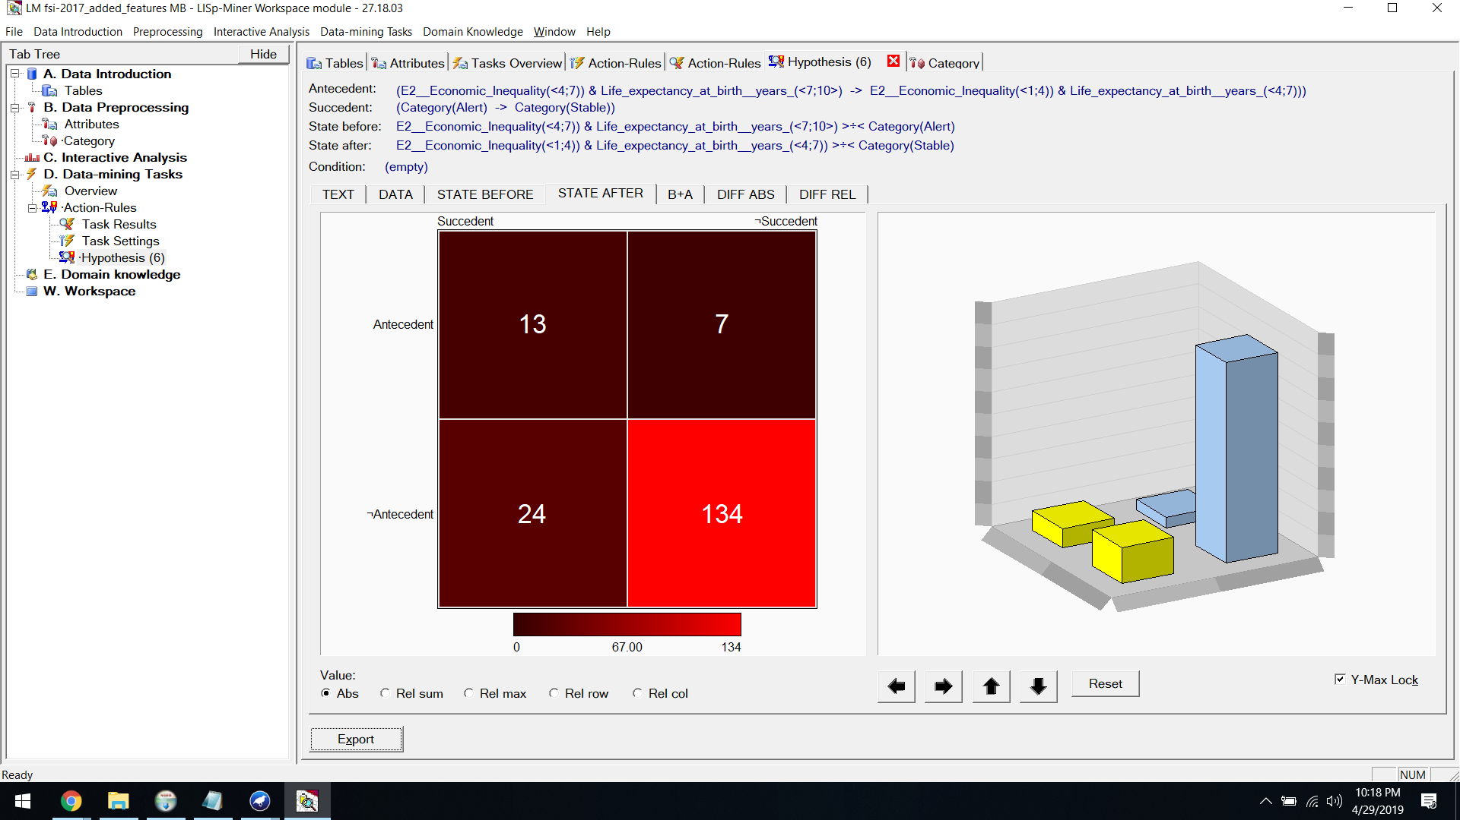

**B+A:**

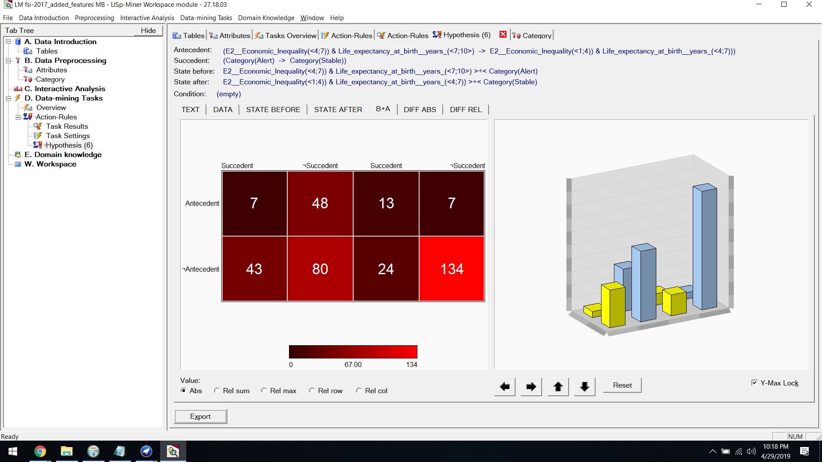

**Diff Abs:**

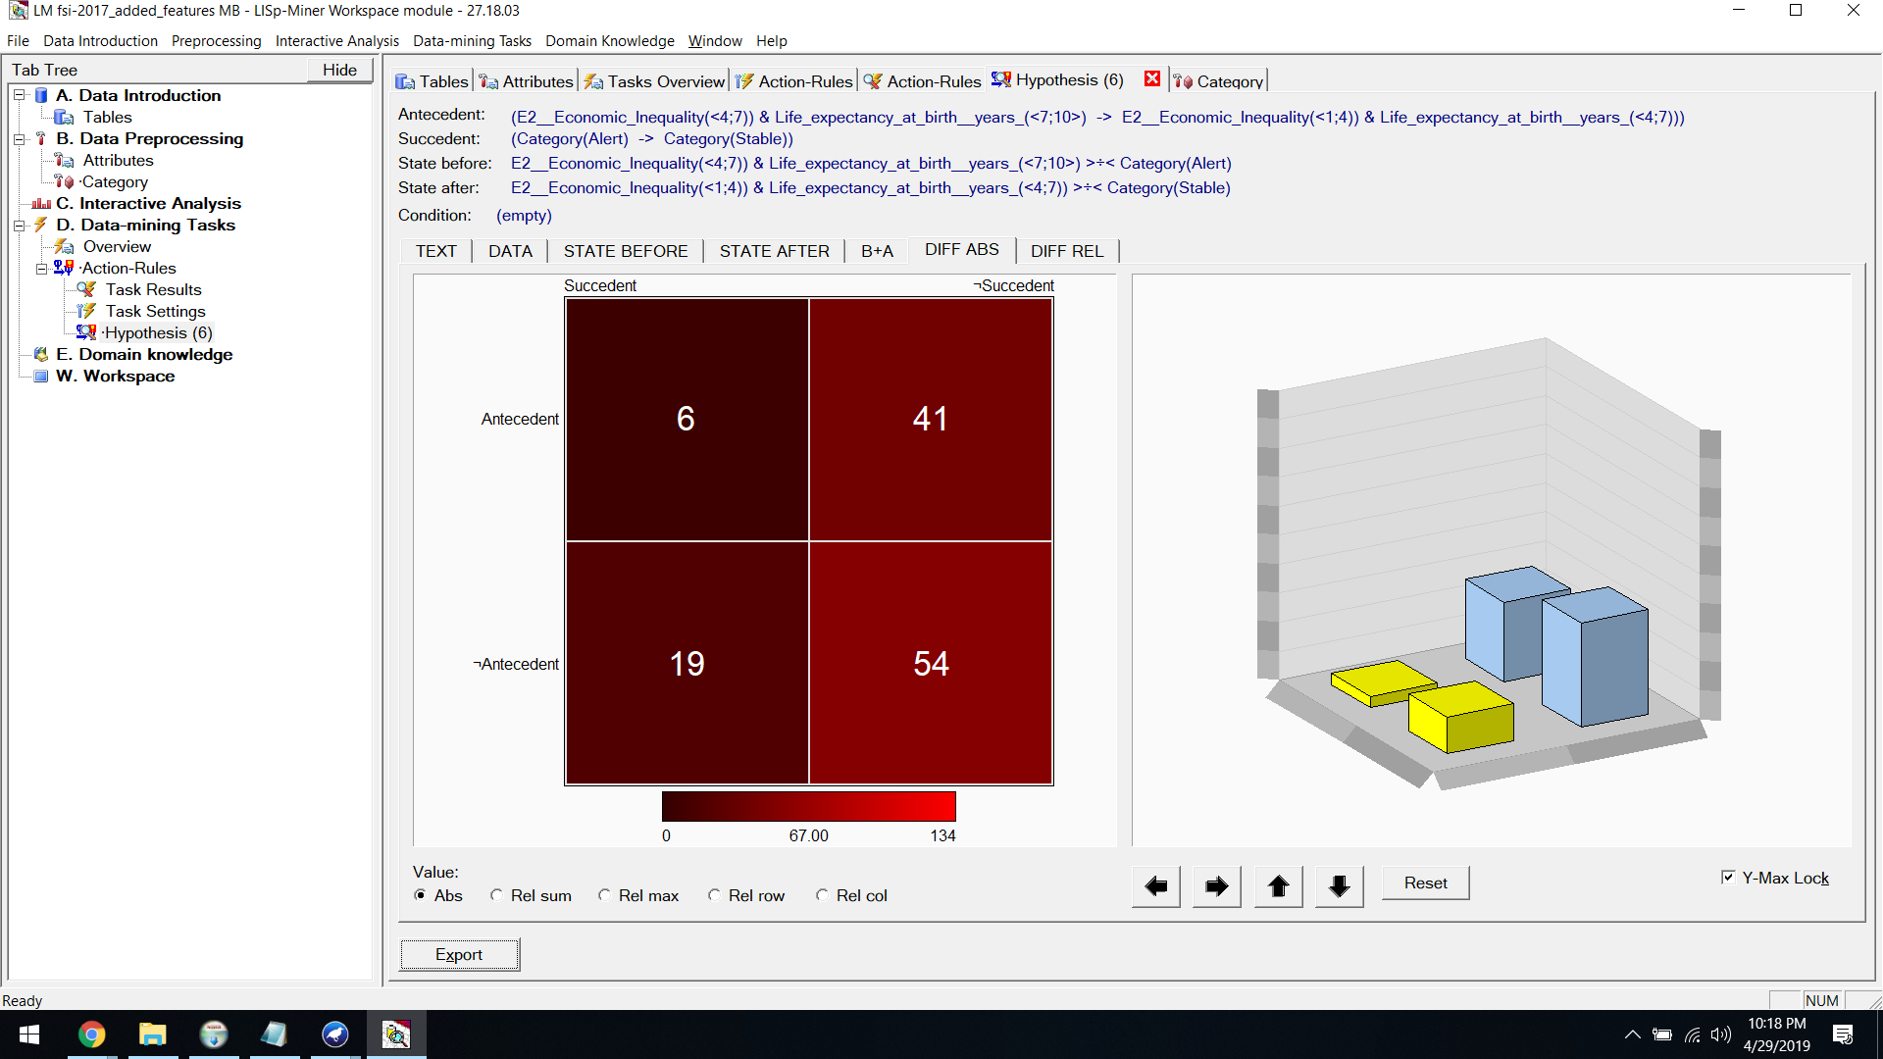

**Diff Rel:**

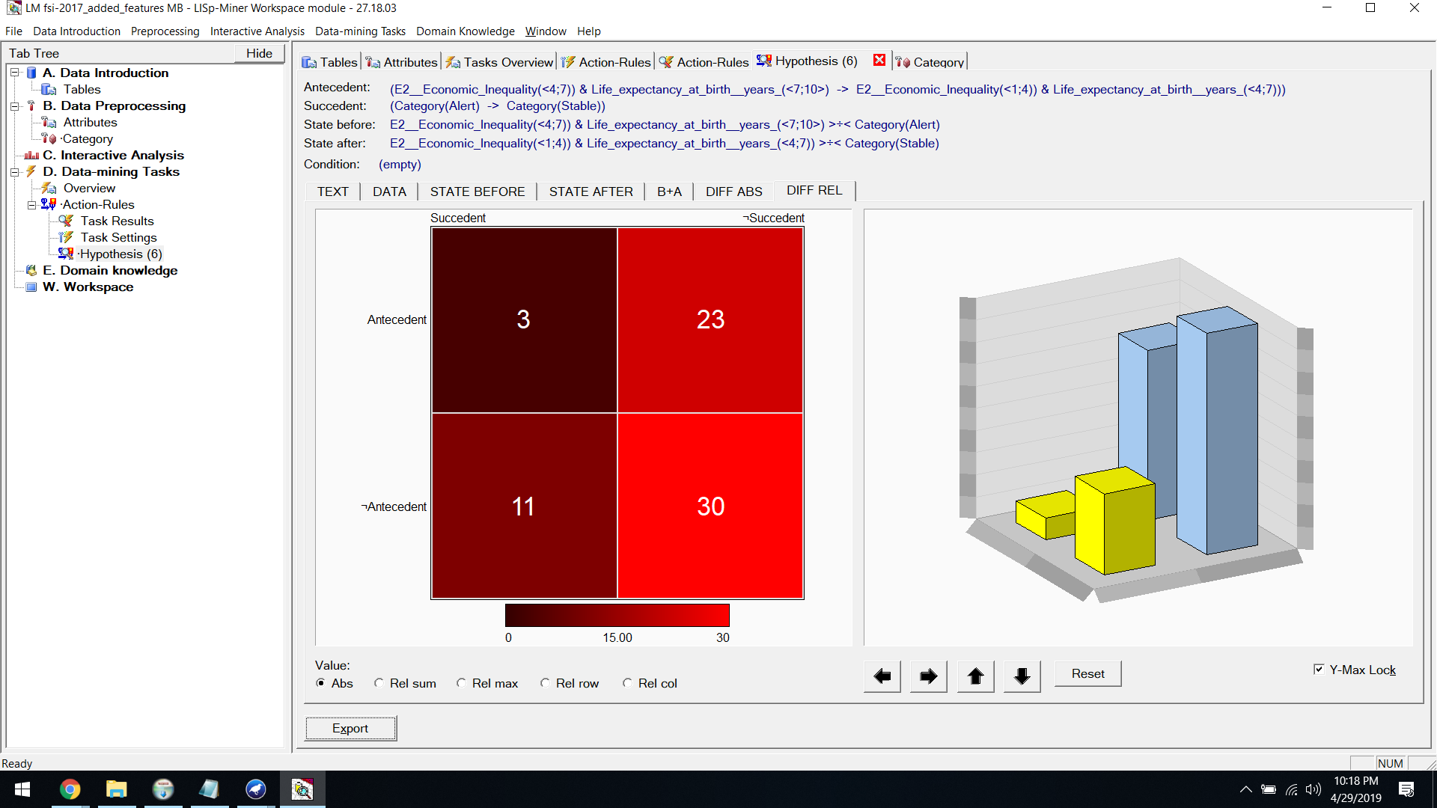

**ACTION​ ​RULES​ ​FOR​ ​2018​:  [Alert to Sustainable]**

First​ ​we​ ​set​ ​the​ ​decision​ ​attribute​ ​as​ ​alert​ ​to​ ​Sustainable





**Hypothesis:**



**State Before:**



**State After:**



**B+A:**



**Diff Abs:**



**Diff Rel:**



**ACTION​ ​RULES​ ​FOR​ ​2018​:  [Alert to Stable]**

Then we​ ​set​ ​the​ ​decision​ ​attribute​ ​as​ ​Alert​ ​to​ ​Stable





**Hypothesis:**



**State Before:**



**State After:**



**B+A:**



**Diff Abs:**



**Diff Rel:**



**ACTION​ ​RULES​ ​FOR​ ​2018 ​:  [Stable to Sustainable]**

Finally we​ ​set​ ​the​ ​decision​ ​attribute​ ​as​​ ​Stable to Sustainable





**Hypothesis:**



**State Before:**



**State After:**



**B+A:**



**Diff Abs:**



**Diff Rel:**

